What is a computer?

A computer is a machine or an electronic device that works under the control of stored programmes automatically accepting, processing data, storing, and produce results or output information.

A computer is a general-purpose machine that performs tasks in response given to it and it stores information.

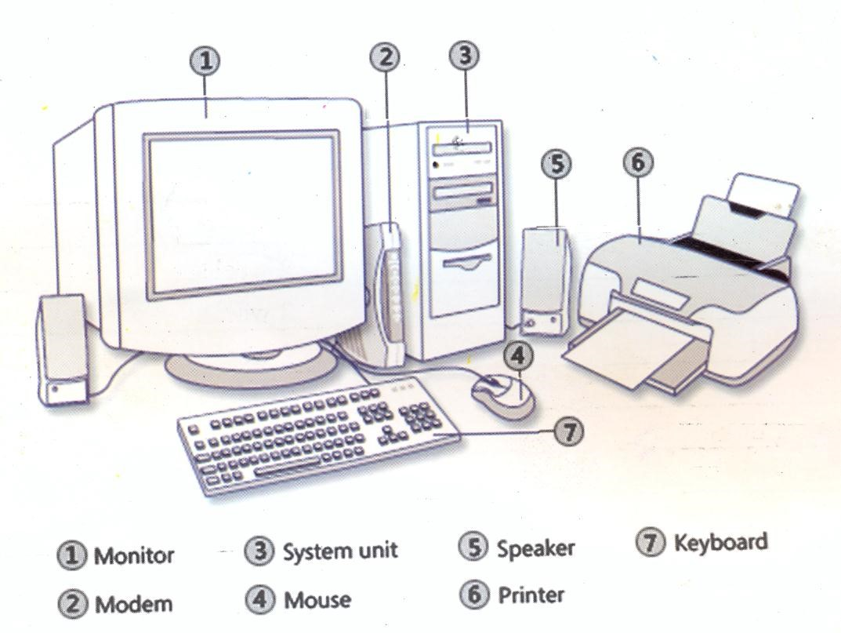

**N.B:**

1. *A computer is given instructions and these instructions are known as* ***Commands.***
2. *A computer is capable of storing vast amount data and carry out data processing or manipulation very fast.*
3. *The operational speed of a computer is measured in Millions Instructions per second (MIPS) in Megahertz(MHz) or Gigahertz (GHz)*
4. *A computer is capable of receiving data, processes it and send the feed back.*
5. *A computer can perform a task easier and faster than a person can.*
6. *A computer is different from other machines because it has artificial intelligence.* ***Artificial Intelligence*** *refers to the ability of computers to reason like human beings. A human being has natural intelligence.*

# REASONS FOR STUDYING COMPUTER STUDIES

1. To acquire general knowledge and skills in the use of computers and related technologies.
2. To use the acquired knowledge in computer studies to enhance learning other subjects.
3. To understand important issues of a technology based society and exhibit them using computers.
4. To exhibit basic computer skills that are required for employment.
5. To acquire knowledge as a foundation for further studies in computer technology.
6. To use a variety of computer technologies to assess, analyse and interprete information.

# THE COMPUTER PROCESS

|  |  |  |  |  |  |  |  |
| --- | --- | --- | --- | --- | --- | --- | --- |
| |  | | --- | | **Input** | |  | |  | | --- | | **Computer** | |  | |  | | --- | | **Output** | |

(Raw Data) (Processing) (Information)

# N.B

1. ***Data****: These are raw facts and figures presented but could be presented into meaningful information. They are facts to be processed.*
2. ***Information****: This is presented data coming out as output after processing from the computer.*
3. ***Input****: Is any data or instructions entered in the memory of a computer.*
4. ***Output****: Is data that has been processed into useful form called information.*

## PLACES WHERE COMPUTERS ARE USED

Noteworthy is that, computers are used in all walks of life for example: (a)In banks.

1. Homes
2. Supermarkets
3. Offices of all types.
4. Companies for billing
5. Institutions of learning
6. Aeroplanes
7. Post offices. e.t.c

## COMPUTER MODELS

They include among others;

1. Dell
2. Compaq
3. Macintosh
4. Wwang
5. IBM(International Business Machine
6. Gateway
7. Toshiba
8. Meccer
9. Mercury
10. Viglen
11. Samsung e.t.c

(l)

## BASIC PARTS OF A COMPUTER (PERSONAL COMPUTER)

Monitor

Screen

Visual Display Unit

(

)

CD/DVD Drive

System Unit

Mouse

Keyboard

***Fig: Desktop comp***

***uter***

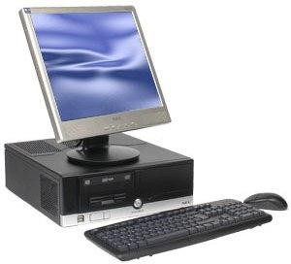

**N.B**: *A personal Computer* ***(PC****) is the computer most used by business*

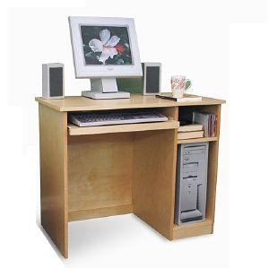

*professionals.*

Monitor

Speakers

Keyboard

CD/DVD Drive

Floppy diskette drive

System unit

**Fig: Tower computer**

**A COMPUTER SYSTEM**

A computer system consists of the following:

1. **A computer professional**. This a person in a profession involving computers who has had formal education in the technical aspects of a computer. An example is a computer programmer.
2. **A user**: Is some one without much technical knowledge of computers but uses computers to produce information for professional or personal tasks, enhance learning or have fun.
3. **ComputerHardware**: This comprises of the electronic and electromechanical parts of the computer. (Tangible components)
4. **Software**: Is a series of instructions that tells the hardware how to work. (Programs)

Hard ware + Software = A working Computer system

### *N.B*

1. *People in business and the professional generally must be computer literate of computer competent.*
2. *Computer Literacy is having an understanding of what a computer is and how it can be used as a resource.*
3. *Computer competence is applying some skills using a computer to meet your information needs and improve your productivity.*

# THE HISTORY AND EVOLUTION OF COMPUTERS

Few historians can agree on who was the first inventor or what was the first computer because of a number of categories of machines, which were being invented. However, certain advancements were so outstanding.

**Simple calculating devices:**

1. **Abacus**: Before the 19th Century, the early Babylonians invented Abacus which was used as a mathematical instrument. The abacus is listed to as the first computation device. It was used for volume of computing in China and Japan for thousands of years before Christ.
2. **Napiers’bones**: John Napier developed the first logarithm tables. He published his log tables in 1614.

Napiers‟ bones were rectangular rod with readings written on them that led users to do division and multiplication by adding number position bones.

1. **SlideRule**: In 1620, An English Mathematician William Oughtred developed the first analog device and it was based on the concept of logarithms. This was a ruler with numbers written on it and can do some simple math by sliding a bar to a from.

## Early Discovery – Mechanical Era

In the 17th Century, two further significant developments took place. Computers composed of mainly movable parts i.e wheels and axles.

1. **Pascal’sArithmeticMachineorCalculator**: In 1647, A Frenchman Blaise Pascal is given credit for the first mechanical adding and subtracting machine that used a system of gears and wheels. It had digits arranged from 1-9 on wheels similar to odometer on a motor car.
2. **Leibnitz’SteppedReckoner**: In 1694, Coltfried William Leibtniz a German Mathematician improved

Pascal‟s design to create Leibnitz‟s calculator that could perform arithmetic operation of addition, subtraction and Multiplication, division and subtraction.

**Start of the computer age:**

In the 19th Century, other developments were outstanding in computing. Computers that are electronic and movable parts.

1. **Babbage’sAnalyticalEngine**: Charles Babbage of England (1792-1871) developed the analytical engine. The analytical engine was recognized as the milestone signifying the start of the computer age Charles Babbage as the father of modern computing.

This machine introduced the idea of memory for storing results and the idea of printed output. It could also follow programmed instruction to perform mathematical operation.

A lady called Ada Lovelace was the first person to come up with the idea of programming loops.

1. **Jacquardweavingloom**: Joseph Jacquard invented a machine for controlling the weaving process when making complex patterns. This system could use metal cards punched with holes in storing data. This machine could store programs or instructions using the hole and non-hole method.
2. **Hollerith’sTabulator**: Herman Hollerith invented a tabulating machine that used punched cards to store and tabulate data. The U.S government in the 1890‟s census first used this machine. He started a tabulating machine company and sold machines all over the world. This company merged with other to form the popularly known as **International Business Machine (IBM)**

## Gallery of first computers

ENIAC EDVAC

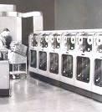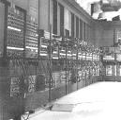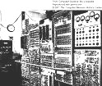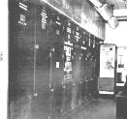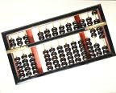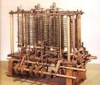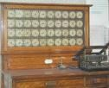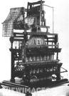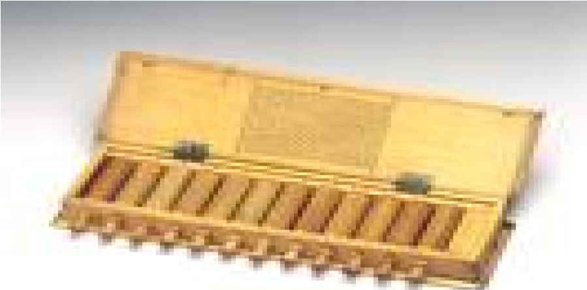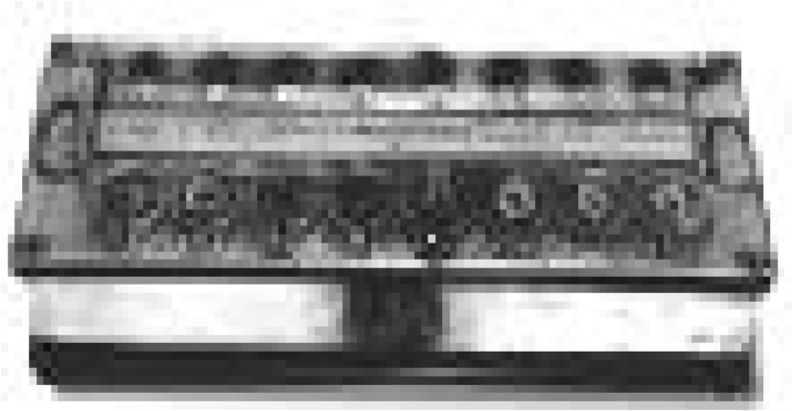

UNIVAC

EDSAC

BABBAGE ANALYTICAL ENGINE ABACUS

HOLLERITH TABULATOR

JACQUARD WEAVING LOOM

NAPIER‟S RODS PASCAL‟ ARITHMETIC MACHINE

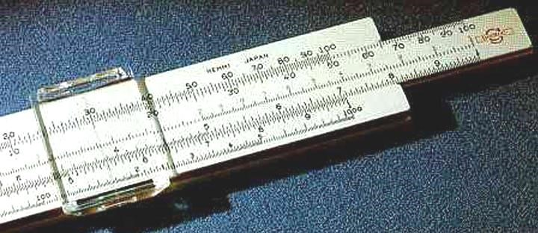 LEIBNITZ CALCULATOR SLIDE RULE

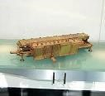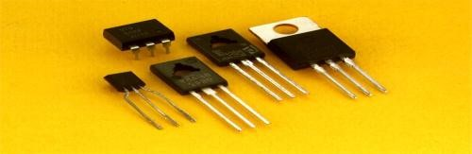

Transistors

**ELECTRONIC COMPUTER GENERATIONS:**

Computer generations refer to the advancement of computer technology over years. In the 1950‟s, first widely operational computers came in and we divide them into generations. Each generation is characterized by dramatic improvement over:

1. technology used to build the computer.
2. Internal organization of the computer.
3. Programming languages.

## FIRST GENERATION COMPUTERS (1946 – 1956)

### Technical developments or innovations

1. The first generation of computers relied on **Vacuum tubes** to store and process information.
2. They used magnetic drum memories.
3. The maximum memory size was approximately 2000bytes (2kilobytes)
4. Used punched cards for input and output.
5. Programming was done in machine language.

**Setbacks include:**

* + Limited primary memory.
  + Consumed great quantities of electricity and generated a lot of heat.
  + They were short lived and needed a standby technician.
  + They were expensive and few people could monopolize computers.

**Examples of computers in First generation:**

* + 1. ENIAC (Electronic numeric integrator and calculator)
    2. EDSAC (Electronic Delay Storage Automatic Computer)
    3. EDVAC (Electronic Discrete Variable Automatic Computer) invented by Dr. John Von Newman
    4. UNIVAC (Universal Automatic Computer)
    5. IBM 650

## SECOND GENERATION COMPUTERS (1957-1963)

The second generation of computers relied on **transistor technology**.

**Key characteristics:**

1. Use of transistors for internal operations.
2. Computers were built from individual transistors and connected by wires.
3. Memory size expanded to 32kilobytes of Ram memory.
4. Speeds reached 200,000 to 300,000 instructions per second.
5. The second generation of computers used magnetic core memories.
6. Introduction of high level programming languages e.g FORTRAN, COBOL e.t.c
7. Introduction of super computers e.g Livermore Atomic Research Computer (LARC) and IBM 7030
8. Computers became less expensive, gave less heat and were smaller, increased in processing speed and reliability. E.g IBM 1401
9. Transistors were much more stable and reliable than vacuum tubes.
10. They generated less heat and consumed less power.
11. The transistorized computer contained 800 transistors and was built by Bell laboratories in 1954. **Examples of second generation computers include:** 
    * NCR 501
    * IBM
    * CDC6600 Mainframe Computers

## THIRD GENERATION COMPUTERS (1964-1979)

The third generation of computers used **Integratedcircuits** (ICs) which are made by combining several transistors together with integrated circuits or IC semiconductor devices with several transistors built in one physical component.

1. Magnetic disks were developed during this period for storage purposes.
2. Computer memory expanded to 2 Mega bytes of RAM.
3. Speed accelerated to 5 million instructions per second. (5MIPS)
4. This period also saw the production of the first Micro computers (in 1974) (e)Use of parallel processing.
5. Introduction of operating systems e.g Multics.
6. Introduction of simpler programming languages like BASIC.
7. Low cost, high reliability, small size, low power made computers popular.
8. The third generation of computers consisted of fast mainframe such as IMB 360, IBM 370, PDP-11 e.t.c (j)Introduction of networking of computers.

## FOURTH GENERATION COMPUTERS (1979-1989)

Computers of the fourth generation used **LargeScaleIntegration** (**LSI**) and **Very Large scale Integration (VLSI**) circuits.

1. Both deal with the number of electronic components that can be placed on the computer chip e.g 803876 chip contained 275,000 transistors (LSI). Pentium Pro chip contains about 5,000,000 transistors (VLSI)
2. Memories used included magnetic disks, bubble memories and optical speeds to 50MIPS. This made the faster fourth generation that included powerful mainframes such as IBM 308, Amdah 580 as well as 16 bits and 32 microcomputers.
3. Limited Artificial intelligence and expert systems.
4. Development of microprocessors.
5. Development of microcomputers.
6. Introduction of a wide variety of software.
7. Computers became more powerful and cheap enough that schools and homes were able to purchase them.

**Examples of 4th Genaration computers:**

- 8088, 80286, 80386, 80486, Pentium 1, Pentium II, Pentium III, e.t.c..

## FIFTH GENERATION COMPUTERS (1990-Present)

1990 to present is the merging of Telecommunication and computing technology. The technology currently used and under research during this generation include:

* Parallel Architectures.
* Three-dimensional circuit design. - Super conducting material.

These technologies have led to the development of extremely fast computers referred to as super computers with speeds in the range of 1 GIGA to 1 TERA instructions per second.

In addition to this, the development of computer networking has reached a level that turning the world into one single village ( **World Wide Web**)  **Summary**

|  |  |
| --- | --- |
| **Generation** | **Major Innovation** |
| Generation one | Vacuum tubes |
| Generation two | Transistors |
| Generation three | Integrated circuits |
| Generation four | Large scale integrated circuits |
| Generation five | Three dimensional circuit design |

## FAMILY PACKAGE OF TODAY

In many parts of the world, family package computers are sold for the entire family form junior to father. Companies like IBM, HP and Dell are now hitting the Global Market. Family computers are fully equipped with a monitor, keyboard, printer, CD ROM, speakers, Microphone and a Joy stick.

In conclusion computers are becoming increasingly more smaller, more powerful and less expensive.

**INFORMATION TECHNOLOGY:**

This is the combination of computer and communication technologies to process data into information.

## APPLICATIONS OF IT

### In everyday life

1. Payment by phone services at home.
2. Payroll system in a factory.
3. Electronic funds transfer system in a bank.
4. Traffic control system in transportation.
5. Point of sale system in a super market.

**At home:**

1. Budgeting and financial management.
2. Entertainment (Listening to music, watch movies and videos, play games) (c)Research and education.

## ADVANTAGES OF USING COMPUTERS FOR PROCESSING INFORMATION

1. Computers with communicating capability can share data and information with other computers.
2. Tasks can be completed faster because computers work at amazing speed.
3. Computers can store enormous amounts of data for future use.
4. The high reliability of components inside the modern computers enables computers to produce consistent results.
5. Efficiency and productivity can be raised.
6. Running cost becomes higher in the long run.
7. Tasks can be completed with little human intervention. i.e automatic.
8. Overall security can be raised due to less human intervention.
9. The management can observe new information and new trends more quickly.
10. Customer services can be improved due to more efficient management and operations.

## DISADVANTAGES OF USING COMPUTERS FOR PROCESSING INFORMATION

1. Initial investment cost can be high. (Setting up)
2. Extra costs is required to employ specialized staff to operate and design the data processing (c) Some jobs may be lost due to computerization and thus lower the morale of staff members.
3. Some staff has to be trained or retrained.
4. Easy transmission of viruses via the internet, which may lead to creating untimely costs to the recipient and sender computers.
5. Problems may arise when computers cannot be used either because they are malfunctioning or damaged. This can bring an organization to a halt if no back up exists. (g)Face to face interaction among staff may be reduced (h)High rate of forgery.

## CHARACTERISTICS OF MODERN COMPUTERS

For a device to be characterized as a computer, it must manifest some or all of the following characteristics.

1. **Speed**: Computers are quite fast in their operations in that their speed is measured in millions instructions per second (MIPS) e.g a computer with 15 MIPS is capable of processing 15 million instructions per second.
2. **Accuracy**: Computers are known to be so accurate that they hardly make any mistake. In fact computers are capable of detecting and correcting errors. It follows therefore that if wrong data is fed into the computer, wrong results are expected out of the computer hence the saying **Garbage in Garbage Out (GIGO)**
3. **Storage**: For a computer to be bale to work, it must have some form of work space where data is stored before being processed or information is stored before being output to particular devices. The storage is called **Memory**.
4. **Deligence** (Consistency): Computers have the ability to perform the same task and over for a long time without getting tired. Therefore computing devices must be able to perform the same routines repeatedly. This evidenced in industrial robotics like those in car assembling lines.
5. **Artificialintelligence**: Computers are artificially intelligent. They can respond to requests given and then provide solutions. This is accomplished by its programmability i.e it can be taught to make decisions and function accordingly. An example of this is the washing machine today, which incorporates some form fuzzy logic. Such machines are capable of taking in required amount of detergent and water for washing after assessing the amount of dirt in the clothes.
6. **Automation**: Computers also work automatically, they do not need any supervision in order to perform

programmed routines e.g traffic light, digital watches e.t.c…

1. **Versatility**: With respect to the inputs it can accept, a computer can do computations of different kinds

and can change from one activity to another e.g sounds, image captured, e.t.c….

### LIMITATIONS OF COMPUTERS

1. **Datacorrectness**. All the data that is processed into information is usually correct. However, we al have heard stories or seen movies that tell us how computers have done mistakes. Perhaps the data that is entered contains the mistakes. People enter data and perhaps do make mistakes.
2. **Programcorrectness**. After data correctness, the question of program correctness come up. If the data entered is correct and a program written to process this data has mistakes, once again, the information obtained will be incorrect.
3. **Computerscannotthink**. Unlike the human brain, the computer cannot think but can effortlessly execute all instructions given to them any number of times without errors.
4. **Alternatives**: Human beings know how to try out a new option when one alternative to do a job fails. Computers lack this ability.
5. **Experience**: Computers cannot learn from experience.

## COMPUTER CLASSIFICATIONS TODAY

Computing devices fall into various classes. The basic computer classifications include:

**1**. **ClassificationbyProcess**: In this classification, computers are classified according to how data processed is represented. This classification is majority. It has three categories.

1. **Digitalcomputers**. These perform arithmetic and logical functions. Digital computers are so classified because they process data that is represented in form of discrete values. (Discrete numbers are numbers that can be defined like 1,2, 3 ..). Digital watches are an example. They have a virtual monopoly of commercial applications. Most computers are digital.
2. 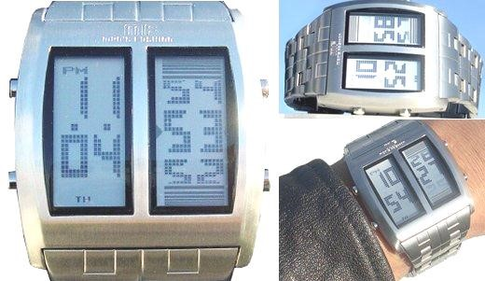**Analogcomputers**: Analog computers process data that is in a continuous form or measurable quantities or units e.g the thickness of steel plates, from strength of electricity currents. They can only be measured by comparing them to other specific units. Their uses are normally restricted to scientific work and to engineering functions such as the control of temperatures. Others examples are; - Voltmeters and speedometers

In computer context, a digital computer uses information in a coded (binary) form represented by two state electronic devices: **ON**=1 **OFF**=0

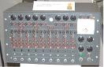 ANALOG

### Differences between Digital and Analog

|  |  |
| --- | --- |
| **Digital** | **Analog** |
| 1. Use binary code to represent information. 2. Have no interference and background noise. 3. Generally fast and cheap. 3. Data does not degrade over time during transmission. 4. Data can be compressed. 5. More Accurate. | 1. Use a changing phenomenon due to environment. 2. Have interference and background noise. 3. Generally slow. 4. Data degrades over time during transmission. 5. Data can‟t be compressed.   6. less accurate compared to digital. |

(c)**Hybridcomputers**. These are those with combined features of both the digital and analog computers. The hybrids are further classified according to the work that they are designed for. They are categorized into two classes.

1. **Specialpurposecomputers**: These are designed to handle only a particular task. Their form of operation is restricted in nature e.g digital watches, pocket calculators. They are designed to perform a particular task and no other. Currently, special purpose computers are employed in devices like missiles.
2. **Generalpurposecomputers**: These are designed to solve a wide range of problems. They can be adopted to perform a wide range of problems. A typical example of this type can perform calculations, keep data and time, word process documents, store databases e.t.c …

**2**. **Classificationby User capacity and Size**: Computer systems van be categorized according to their user capacity and size. The main categories are:

(a)**Mainframecomputers**. These are large general purpose computers with extensive processing, storage and input and output capabilities. They are expensive and powerful computers that handle thousands of connected users at the same time.

### Characteristics of mainframes

(i) They are very large computers with very high capacity of main storage. (ii) Mainframes can process large amounts of data very quickly, and are therefore used by governments, big companies and banks.

1. They support a wide range of peripherals.
2. More than one user can make use of the machine.
3. Mainframe computers generally require special attention and are kept in a controlled atmosphere.
4. They are multitasking and generally used in areas where large databases are maintained e.g government departments and the airline industry. (vi) They are capable of operating with 500 to 1,000 users at a time. They can be linked into a network with smaller departmental computers, micro computers or with each other.
5. Each user works separately with a separate keyboard and monitor but they all use the same processor(Central Processing Unit)
6. Specially trained operators and programmers are required for its operation.

**Examples of mainframes include:**

* + IBM 4381
  + ICL 39 Series
  + CDC cyber series

1. **Miniframecomputers**: These are often used in situations where a micro computer is not powerful enough. They posses the same working principles as the mainframe except that are a bit smaller. Users range from 50-500 at a time. They are mostly used in medium sized organizations.
2. **Microcomputers**: A microcomputer is a computer that can perform all of its input, process, output and storage activities y itself. Microcomputers are smaller than mini computers and are a single user capacity. The keyboard, system unit and monitor can be used by one person at a time. They are mostly used computers in day-to-day work.

Microcomputers are often called **Personal computers (PC).** The new processor is not only cheaper, it is faster, smaller, more energy efficient, reliable and more modular. Microcomputers include the following:

* 1. **Desktopcomputers**: These are designed so that the system unit, input devices, output devices and any other device fit entirely on a desk or a table. They are standard PCs. The development of other PCs have evolved from these.
  2. **Notebookcomputers**: These are also called **Laptop computers**. They are personal systems designed for mobile computing. They are small enough to fit on the lap such that even if one is in a bus or plane, they can still work like they are on a desktop. Earlier laptops had fewer resources like hard disks than the desktop but with advancement in technology. More and more features are being incorporated.

*Fig: laptops*

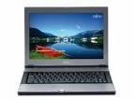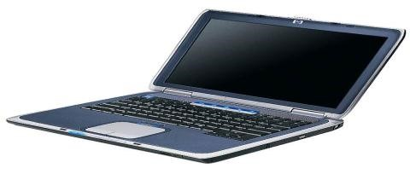

### Characteristics

* They are portable due to their size.
* Have limited support of peripheral devices.
* Fast in processing information.

1. **Palmtops/Handheld devices**: These are also called Personal digital Assistants (PDAs). They are handheld devices designed for people who are ever on the move. They can easily fit in a shirt, pocket and one can check for email at any time, take few notes, keep schedules and appointments. Modern PDAs have been integrated with mobile cellular phones.

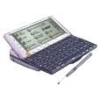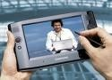

***Fig: Hand held devices*** 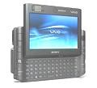

1. **Internet appliance**. Is a computer with limited functionality whose main purpose is to connect to the Internet from home. E.g Desktop, laptop, tower e.t.c..

***N.B:***  *Personal computer (PC) is a microcomputer designed primarily for independent use by an individual at work or in the home.*

(d) **AsuperComputer**: Is the fastest, most powerful and most expensive computer used for applications that require complex and sophiscated mathematical calculations. Typical tasks carried out by super computers include: - weather forecasting

* Space exploratory space
* Complex and sophiscated mathematical calculations and weapon research.

**Examples** of super computers include; CRAY T3D AND NEC-500

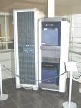

*Fig:*

*A super computer*

**3. Classification by processor power**: Due to rapid changes in technology, processing power in also rapidly increasing. The higher the processing power, the better the computer. First computers had a processing power less than 0.4MIPS but today 15MIPS is the minimum. The common types of processor power include;

* + 80286
  + 80386
  + 80484
  + Pentium I (80556)
  + Pentium II
  + Pentium III
  + Pentium IV
  + Pentium V

**USES OF MODERN COMPUTERS:**

Computers are used in day today accomplishment of a number of tasks. Their uses cannot be imagined by the users. They include the following:

1. **Scientificresearch**: Computers have made advancements in scientific research. New drugs have been introduced. Exploration into space is possible even in places where human beings cannot go.
2. **Business environment**: Very many businesses have realized the benefits of computers. With most money markets (stock exchange), you only need to sit infront of your computer anywhere and share trade with various centers world wide. Today, e-commerce (electronic commerce) has been more feasible with computers.
3. **Architecture**: With the help of a computer, it is possible to look at a house you plan to build, furnished with flower gardens and pass ways. All these can be manipulated on a computer top. This enables one to furnish a house of his or her taste.
4. **Recreational purposes**: One can kill boredom by playing various games on a computer(s) for example golf, cards, car racing e.t.c.. There are many computer games some of which exists free while other need a license to learn them.
5. **Educational purposes**. Computers have led to the emergency of internet. Many local institutions have linked up with big universities and libraries overseas. This has led to the creation of **Virtual universities**. (These are Unversities with no physical buildings or lecture rooms or halls or residence but giving necessary lectures on computers via the Internet thus the term “Virtual reality”).

# THE COMPUTER LABORATORY

This is a place where computers are set for a particular task. While in the laboratory a teacher should work closely with students to see that they master basic techniques.

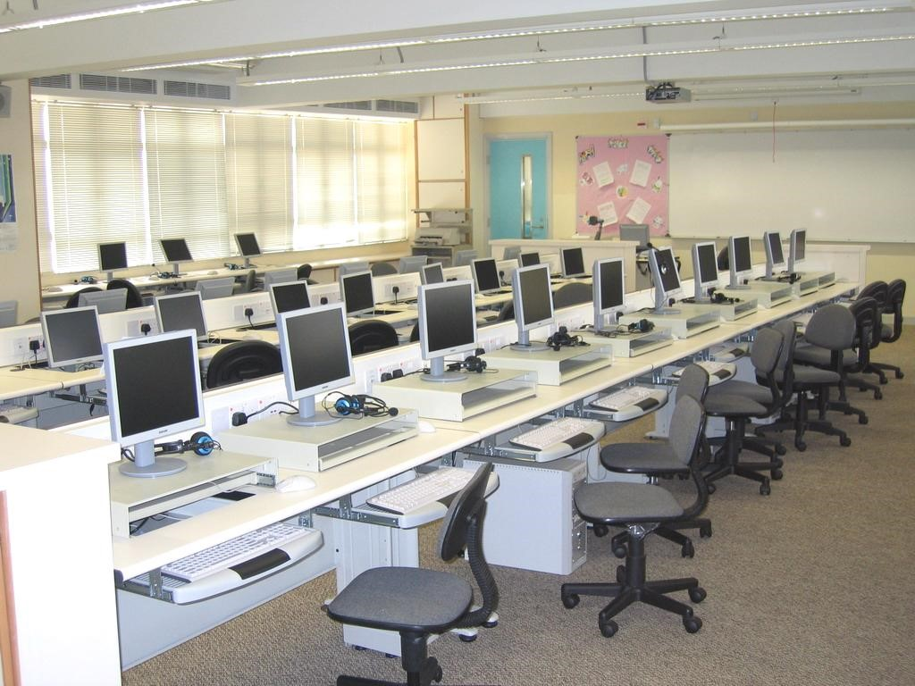

*Fig:*

*Typical computer laboratory*

## GENERAL OPERATION OF A COMPUTER

**Starting a computer.**

* Switch on the mains.
* Switch on the stabilizer/backup/UPS (in case you have one)
* Switch one the system unit because most of the parts including the power supply unit are in it.
* Switch on the monitor or Visual display unit reason being that what it displays comes from the system unit.

As the computer is switched on, it does the **Power On Self Test (POST).** The post consists of RAM check, CMOS check, HDD controllers then an appropriate message is displayed on the screen. Sometimes, an error code is displayed with the message or an abnormal number of beeps are sounded and this is called booting.

**N.B**: *Most microcomputers are switched on by the switch on the system unit*

*and the monitor.*

**BOOTING:**

This is the process of starting or resetting a computer, which involves loading an operating system into memory. They are two ways f booting.

1. **Cold booting**: A computer is cold booted by turning on the power switch off and then on id the computer was already on. In other words, it is the turning on the power switch.
2. **Warm booting**: A warm boot is the process of restarting or resetting a computer that is already turned on. Sometimes, the stops working or responding to the commands given by he user. In such a case, we need not to switch the power off to restart the system, we can restart the system by pressing **ALT+CTRL+ DEL** keys together. On some computers, Reset switch is there. In warm booting, ROM does not test RAM or the peripherals.

## SHUTTING DOWN A COMPUTER

* Close all applications (Active window)
* Click on the start button and then click on shut down or turn off computer. A dialogue box will appear from which;
* Select the option shut down or turn off and ok or yes. - Finally switch off the system unit and monitor.

-

**N.B**: *If your computer does not turn off automatically a message appears when you can safely turn off your computer.*

## UNINTERRUPTIBLE POWER SUPPLY (UPS)

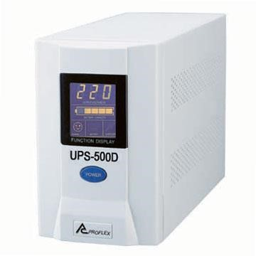

Momentary power interruptions of fluctuations often cause micro processor based instruments to re-initialise themselves and computer to crash. The main causes of power disruption are;

* Amplitude fluctuation - Power line noise - low voltage surges.
* High voltage surges.
* Voltage spikes.
* Wave from distortions and frequency variation.

The potential danger with power disruptions may include damage to storage devices and critical data as well as loss of information that had not been saved prior to the power disruptions.

All the power quality defects are largely eliminated by the use of a power correction equipment known as uninterruptible power supply (UPS) and other utility power conditioning equipment e.g Line conditioners (surge suppressors, voltage stabilizers), standby UPS (Battery backups)

## PC CONFIGURATIONS

The hardware and software specifications required for PC or any other type of computer is term as the computer configurations. A typical configuration is given below; -Micro Processor Pentium series.

* Hard disk in the range of gigabytes.
* Floppy disk drive (3.5, 1.44mb) -104 keyboard
* 14” or 17” colour digital monitor.
* Desktop version of an inkjet printer.
* Multimedia kit which consists of: CD ROM drive, DVD drive , Speakers, sound card e.t.c - 3 button mouse with a rolling button.
* System software with the latest version.
* Application software with the latest Ms office version.

## CARING FOR MICRO COMPUTERS

Like all electronic equipment, microcomputers need to be serviced regularly to maintain their operability. Some of the measures that should be taken are:

1. Avoid abrupt switching off and on the computer system. Use the normal way of shutting down or closing down all the programs the shut down the computer from the start button.
2. Avoid making connections when the computer is on power e.g keyboard connections, mouse, printer, monitor e.t.c…..
3. Place the microcomputer in a dust free environment with good ventilation. Dust covers should be used to cover the microcomputers when not in use if you use polythene covers, do not cover immediately after switching off as it will trap heat.
4. The microcomputer should not be exposed to direct sunlight.
5. Food and drinks should not be allowed near the computers.
6. The computers should be regularly serviced, atleast once a year or more frequently if the environment is dusty. The service should normally include.
   * Blowing dust from the system unit.
   * Cleaning the floppy drives, keyboard including all the keyboard contacts.
   * Also clean the monitor externally and the computer equipment regularly with a wet cloth. Make sure you do not drop water in the computer system. If water drops accidentally, do not use the computer immediately until water has completely evaporated.
7. Do not open the computer for inside cleaning, this should handled by a qualified personnel.
8. It is a good practice to keep a record of the daily condition in case of computer failure.
9. In areas where the power fluctuates, it is important to use either a stabilizer or UPS to ensure a steady input power to the computer system.
10. The floppy disks used for the installation of programs and back ups should be kept safely in disk banks and kept away from sunlight and magnetic media.
11. The peripheral devices such as printers and mouse should be regularly serviced.

**SOFT WARE CARE:**

The vital part of a computer system is the data. In fact, data is exposed to a number of risks and great care should be adopted to protect against them. The risks to data are; - Accidental loss.

* + Accidental damage or corruption.
  + Theft
  + Deliberate damage or corruption.
  + Authorised disclosure.

To guard against the risks, the operator must make sure that;

1. Makes backup copies of data regularly. Before backing up, make sure that data is error free otherwise; you might take a back up copy of corrupted data.
2. Minimize the number of visitors to your computer installations and do not allow any one to your server except the network administrator.
3. Avoid diskettes from different installations as your system might contract viruses.
4. If you have unwanted printouts, please destroy them because data is not supposed to fall in unauthorized hands.
5. Save data regularly as an abrupt power cut off may corrupt your data, if you have no UPS.

BASIC COMPUTER PARTS

**1. MONITOR OR VISUAL DISPLAY UNIT.**

This looks like an ordinary television screen. It is the one, which works as the yes on the computer. Without a monitor, it is very difficult to see what you enter into the computer. The situation will be similar to someone writing in the book when the eyes are closed.

## 2. KEYBOARD

This is a primary input and control device of a computer. Data and commands are entered via (through) the keyboard. It has the following parts.

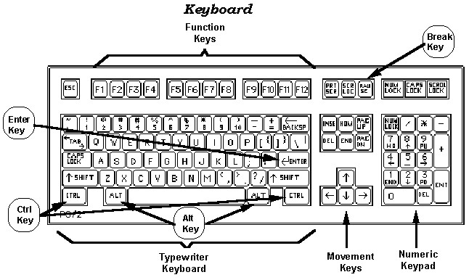

***Fig: Standard computer keyboard***

1. **Typewriter area**. This is a part that looks like or similar to a typewriter keyboard.
2. **Function keys**. These are labeled F1- F12 that have different functions in different programs.
3. **The numeric keypad**. This is similar to a calculator and can be utilized as an adding machine once the num lock (number lock) is on. It is usually located on the right side of the keyboard.
4. **Special keys**. On the computer keyboard, we have keys which are not found on a typewriter keyboard. These keys are the ones called special keys. They include; Alt(Alternate), Ctrl(Control) e.t.c
5. **Cursor Control keys**:

**A Cursor:** A cursor is a blinking bar on the screen which indicate where text should be. When the

cursor fails to come, you can‟t enter data in the computer. Cursor control keys include:

* + Home
  + End
  + Page down
  + Page up
  + Insert - End
  + Arrow/Movement keys which drives the cursor across the screen.

## 3. MOUSE

This is a handheld device that controls the movement of a pointer on the screen. It is an extension of your hand since you cannot touch inside the computer.

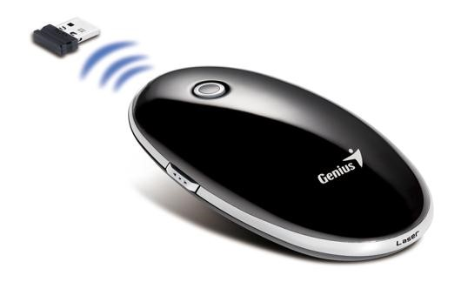 ***Fig: Deskto mouse Fig: Cordless mouse***

In addition to the keyboard, a mouse performs for actions namely;

1. **Pointing**: This means positioning a pointer over an item.
2. **Clicking**: This means pressing and releasing a mouse button one time. You can select items or objects on your screen by using one of the buttons on your mouse.
3. **Double clicking**: This means to press and release a mouse button twice in a quick succession. (d)**Dragging**: this is the moving of items around the screen.

### Steps of dragging

* Position the pointer over an item.
* Press and hold down the left mouse button.
* While still holding down, move the mouse to the desired place. - Release the button.

## 4. SYSTEM UNIT

This is the part of the computer which works as the head. It houses many items in it e.g the brain of the computer (CPU). If the computer is to be a multi-user, it means that each user has to be with a monitor, a keyboard and a mouse but all connected to one system unit. Inside the system unit, there are the following;

1. **Main memory**: This often referred to as Random Access Memory (RAM)and it is a primary storage device i.e where data goes when you are entering it in the computer.
2. **Central Processing Unit**. This handles the processing of information that takes place in the computer. It has two important units i.e Arithmetic logic unit and control unit.
3. **Power supply Unit**. The role of a power supply unit is to:
   * Step down the incoming power.
   * Converts the alternating current (AC) from Direct current (DC)
   * Distribute power to other parts of a computer. Each and every part inside the computer has to receive power e.g memory chips, data buses, e.t.c so when the power supply receives power, it reduces it, converts it to direct current and finally distributes it to other parts of a computer.
4. **Data Buses**: These are highways on which data travels (moves) to go to different parts of a computer. Using data buses, data can move from the keyboard, to the main memory, from here to the monitor so that it can be observed by the user.
5. **Disk Units**. Still inside the system unit, there are disk units and this one to manage disks in case where they need to be used. Without disk units, it would be difficult to perform the process of storing the work permanently as it would be remaining the main memory.

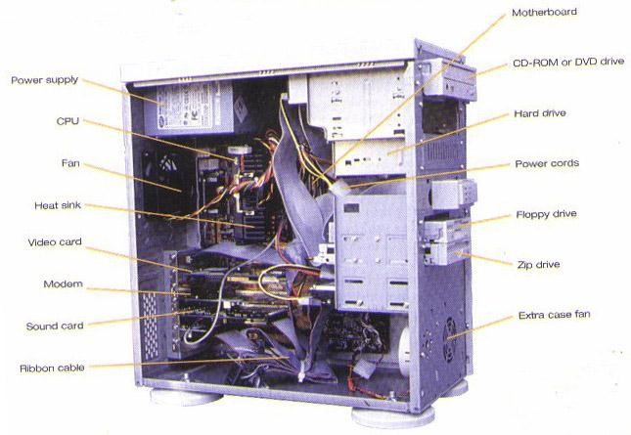

***Fig:***

***Inside a typical system unit***

## THE COMPUTER SYSTEM

A computer system is a set of interrelated components working in union to process data. It consists of those elements that make the computer work towards goal oriented behavoiur.

A computer system is mainly composed of these parts, which are;

1. Computer hardware
2. Computer Software
3. Computer humanware or liveware

## HARDWARE PARTS OF A COMPUTER

Hardware are physical parts of a computer system i.e the parts which can be seen, touched or felt. Computer hardware is broken into five major parts.

1. System Unit
2. Input devices
3. Monitor (Visual Display Unit)
4. Output devices e.g a printer
5. Power supply e.g Stabiliser and backups.

**(1) THE SYSTEM UNIT.**

As earlier described, the computer work as follows;

As one enters data into the computer through the input device like a keyboard, through specific instructions known as programs, the computer holds data and instructions in some space known as the main memory (RAM)

The CPU executes or controls the execution of a program and various circuits performing the operation (carry all data processing)

Finally, the computer results are obtained from compute memory through output devoice like a printer.

**The Central Processing Unit:**  This handles all the processing of information that takes place into the computer. The CPU has two important units:

* **Arithmetic and logic unit (ALU**). This unit manages arithmetic and logical operations. It calculates and compares data.
* **Control Unit**. This is the part of the central processing unit which controls all the activities when the computer is performing (executing) its duties

### Functional organization of the CPU

Instructions Instructions

Results of processing Data to be

processed

Data input output data

Output to be stored Data to be processed

**Control Unit**

Gives instructions to each devoice after

Interpreting program instruction

**Arithmetic and Logic Unit**

Calculates and compares data

**Main Memory**

Stores data and instructions to be

processed temporarily

**Secondary Storage Devices**

Stores data and instructions to be processed

permanently

Input Unit

Output Unit

### N.B:

1. *On a personal computer, the CPU is usually contained on a single chip and is often called a* ***Microprocessor****.*
2. *A microprocessor usually contains the control unit, the arithmetic and logic unit, registers and system clock.*
3. ***Decoding****: This is the process of translating the instruction into commands that the computer understand.*
4. ***Executing****: This the process of carrying our the commands.*
5. ***Storing****: This is the process of writing the results to memory.*
6. ***Registers****: These are temporary high-speed storage locations used to hold data and instructions.*

### 2. MICRO INPUT DEVICES (PERIPHERALS)

These are attachments or devices through which data is entered or captured into the computer. The input device translates data from the symbols of low language to symbols of higher language inside the machine.

An input device is any hardware component that allows a user to enter data and instructions into a computer. Input devices can be classified into manual input devices and automated input devices. Examples of input devices include;

* Keyboard
* Mouse
* Trackball
* Joystick
* Touch screen
* Light pen
* Digital camera
* Optical character Recognition reader
* Microphone
* Voice recognition device
* PC camera
* Web Cam
* Sensor and Remote censor
* Terminal

**1. THE KEYBOARD**: This looks like the keyboard of an ordinary typewrite but with some additional keys e.g the functions keys, escape, delete, control e.tc

### Functions of keyboard buttons

1. **Space bar**: It is used to create space with in words in a word document.
2. **Backspace**: It erases data on the left of the cursor and any highlighted data.
3. **Enter/Return key**: - Used to go to a new line

- Used to select items on the menu

1. **Delete**: Erases data on the right of the cursor and any highlighted data.
2. **Shift**: It is held down to turn on capital letters and some symbols like ?, !, >, < e.t.c (f)**Capslock**: This turns on capital letters and vice versa (upper case and lower case) (g)**Num lock (Number Lock**: It makes the number pad active and vice versa.
3. **Tab/TAB**: - Used to create space in word document

- Use to navigate in a group of icons, short cuts, menu items e.t.c

1. **End**: takes the cursor to the end of a line or when pressed together with ctrl takes the cursor to the end of text.
2. **Home**: Takes the cursor to the beginning of a line or hence pressed with ctrl takes the cursor to the beginning of text.
3. **Escape (Esc):** Terminates a process i.e cancels commands in most situations.
4. **Alternate (Alt):** 
   * + Alternates between two things e.g activating and deactivating a menu.
     + Used in combination with other keys to produce certain results e.g **Alt+Ctrl+ Delete** restarts the computer.
5. **Control (Ctrl):** It is used in combination with other keys to produce certain results.
6. **Page up**: Takes you up the page.
7. **Page down**: takes you down the page.
8. **Insert**: Allows the insertion of characters or text between a word or replacing of a text or a word. When the insert mode is on, characters can be inserted to replace others and when off, characters add to the existing text.
9. **Print screen**: Allows you to print all the contents of the screen.
10. **Scroll Lock**: Allows you to control the scroll bar.
11. **Pause/Break**: Allows you to stop recursive information being displayed on the screen.
12. **Function keys**: These perform specific functions depending on the application package or programme e.g. most applications use F1 for help.

**Advantages of using keyboards for data input.**

* + It is not necessary to buy additional equipment because most computer systems are normally supplied with keyboards.
  + Entering data and instructions with keyboards is generally faster than pointing devices.
  + Keyboards are more reliable and usually produce fewer errors that other input devices such as voice input and optical character recognition.

***N.B****: On a notebook computer and many handheld computers, the keyboard is built on the top of the system unit.*

#### Disadvantages of using keyboards

* It takes a lot of time to practice in order to type quickly and accurately.
* Typing speeds are still very low when compared with computer speeds.

**2. MOUSE:**

This a handheld device that act as an electronic finger to select applications and icons. Some have two buttons while others have one. Each of the these buttons have a particular to play. The three types of mice are;

* 1. **Desktop mouse**: This is commonly with desktop computers and has two push buttons on top and a ball on the underside. Moving the mouse on the surface cause the pointer to change the positions.
  2. **Track ball mouse**: this is common in laptops. In this type, a rolling ball and buttons are embedded with in the keyboard.
  3. **Touch Pad mouse**: This is a small, flat, rectangular pointing device that is sensitive to pressure and motion. The movement of a finger on the pad causes the mouse pointer to change position accordingly. They are common on notebook computers.

***N****.****B****.* ***An optical Mouse*** *uses devices that emit and sense light to detect the mouse’s movement.*

***A cordless mouse*** *(either mechanical or optical) transmits data using wireless technology such as radio waves.*

#### Advantages of using a mouse

* A mouse is user friendly for computer beginners.
* A mouse is easy and convenient to use with graphical user interface.
* Using a mouse to select items or move to a particular position on the screen is faster that using a keyboard.
* A trackball is good for limited desk space because the user does not have to move the entire device.

➢

#### Disadvantages of using a mouse

* It is not easy and convenient to input text with a mouse.
* Issuing commands by using a mouse is slower than by using a keyboard.
* It needs some practice in order to control mouse properly.
* A mouse is not accurate enough for drawings that require high precision.

#### 3. JOYSTICK

This is a pointing device with a vertical lever mounted on a base. The lever usually includes buttons called **triggers**, which activate certain events when pressed. Joysticks are mainly used for computer games and ultra sound scanners in hospitals and military science.

##### Advantages

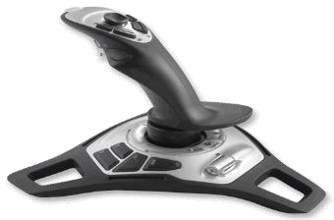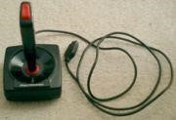

➢A joystick allows fast interactions required in most games.

How ever, it is difficult to select objects accurately on the screen.

#### 4. TOUCH SCREENS

A touch screen is a touch-sensitive display. These are screens that can sense when a particular part of the screen is touched on pressed and hence respond accordingly. They are commonly used by security systems and can read fingerprints of individuals.

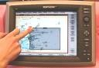

##### Advantages

* No extra peripherals are needed except a monitor.
* A touch screen allows easy access to commands which are usually identified by words or symbols on the screen.

➢

##### Disadvantages

* Touch screens are not suitable for inputting a large amount of data because they require a lot of arm movements.
* Only items on the screen can be selected.

#### 5. LIGHT PEN

A light pen is a pointing device that can detect the presence of light. Light pens are used by health care professionals (Doctors and dentists) and design work.

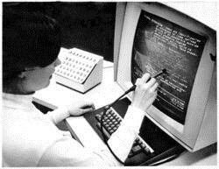

##### Advantages

* Using a light is more direct and precise that using a mouse.
* It is also convenient for applications with limited desk space.

**Disadvantages**

* Light pens normally require a specially designed monitor to work with.

#### 6. STYLUS AND GRAPHIC TABLET

**A stylus** is a pen-like pointing device which uses pressure to write vtext and draw lines.

**A graphic table**t is a flat, rectangular electronic plastic board on which stylus writes or draw. It can be used to digitise drawing with great accuracy. Stylus and graphic tablet are mainly used for computeraided design and drafting by architects, map makers, artists and designers.

#### 7. DIGITAL CAMERA

These take photographs like normal cameras only that they don‟t create images on a film. The images are stored and later loaded onto a PC for further editing and printing.

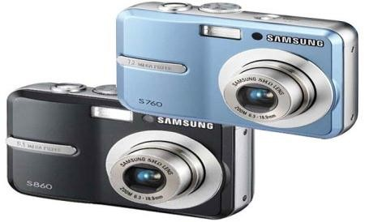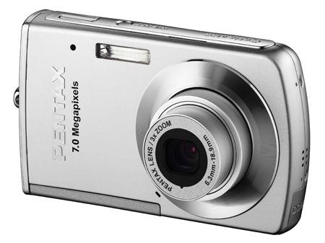

**8**

**. OPTICAL SCANNER**

This looks like a photocopier. It is used to copy photographs, designs or text from paper into the computer. The quality of a scanner is determined by its resolution and colour depth.

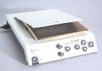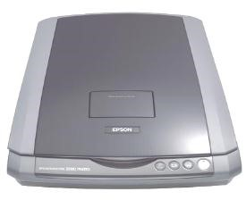

**Disadvantages of using scanners** ➢A scanner is best for dimensional objects only.

➢Scanned images usually take up a lot of storage.

#### 9. VOICE RECOGNITION DEVICES

Voice recognition or speech recognition is the computers capability to distinguish spoken words. It also includes all types of microphones used in communication like Internet and for recording purposes.

##### Advantages

* No typing of data is necessary.
* The system can be used remotely by telephone or by people whose hands are disabled or occupied. ➢They are also ideal for the blind or visually impaired users.

##### Disadvantages

* Error rate is still high at the moment.
* Recognition of words is slow.
* Words sound the same e.g see and sea cannot be distinguished. ➢The system is not suitable for use in noisy places. ➢Many people find it difficult to speak in “writing” style.

#### 10. PC CAMERA

A PC camera is a kind of digital Video camera that allows the home to record, edit and capture videos and still images and to make video phones calls on the internet. PC Cameras can be set to take digital photographs at preset time intervals or whenever it detects motion.

#### 11. MAGNETIC STRIPS RECORDER

These are used to read information contained in the magnetic strips and cards e.g Credit cards. A magnetic strip reader detect the pattern of magnetization and convert it to numeric data.

**Advantages** ➢Reading is accurate and fast.

##### Disadvantages

* The amount of data that can be stored on a strip is limited.
* The magnetic strips can be damaged easily by exposure to a strong magnetic field.

**Other input devices.**

* + Bar code reader used in super markets.
  + Magnetic ink character recognition.
  + MIDI device (Musical Instrument Digital Interface)
  + Web Cam
  + Censor and Remote censor
  + Terminal
  + Digitizer

## OUTPUT DEVICES/PERIPHERALS

An output device is any hardware component that can display information to a user. Output devices are the ones that are used to output information. They receive, accept information from the CPU and produce it in a suitable form. They include the following:

**1. DISPLAY DEVICES.**

A display device is an output device that conveys text, graphics and video information to the user. Information on a display device is called a **Soft Copy** because it exists electronically and displays only for a short period. Display devices can be;

1. Polychromes (Colored)
2. Monochrome (means that information displays in our color on a different background e.g. white and black.

### Advantages of using colors

* Colors make the screen displays attractive.
* Colors can be used to highlight error messages and menu options.

### Disadvantages

* Screens with a lot of colors take long to process. ➢More memory is required to display a lot colors.

Two main types of display devices are CRT monitors and LCD monitors.

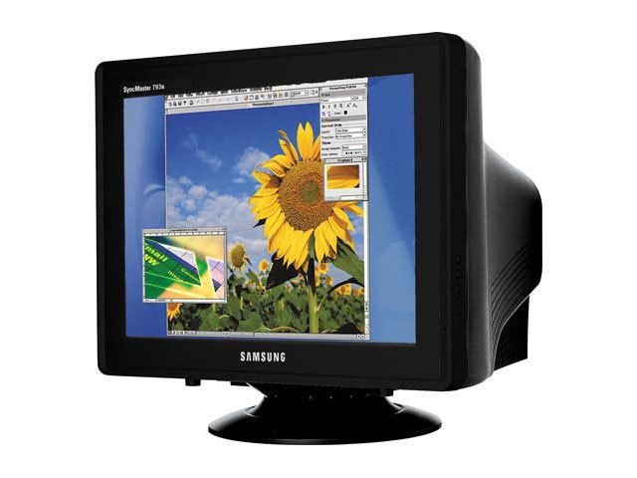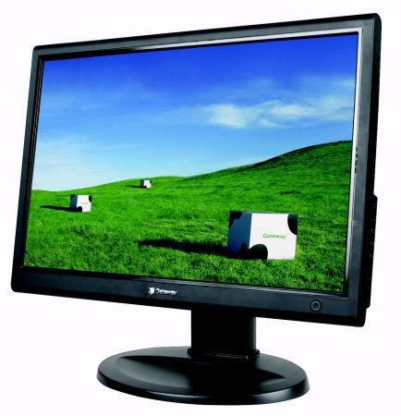

***Fig: CRT Monitor Fig: LCD Monitor***

**CRT monitors** works like a standard television because it also contains a Cathode Ray Tube (CRT). The front of the CRT is the screen, which is coated with tiny dots of phosphor material.

Each dot consists of a red, green, green and blue phosphor and the three dots combine to make up each pixel.

**Advantages of CRT Monitors** ➢Can produce fast and rich color output. ➢Can be viewed from a very wide angle.

* Cheaper than LCD monitors in general.

### Disadvantages

➢Emit higher electromagnetic radiation (EMR) than LCD monitors. ➢Consume more energy than LCD monitors.

**LCD** (Liquid Crystal Display) rather than a cathode ray tube uses liquid crystal to create images on the screen. LCD monitors produce color using either passive matrix or active matrix technology.

### Advantages of LCD monitors

* They require less than one third of the power and take up less space than traditional CRT monitors. ➢Radiation emitted by LCD monitors is neglectable.

**Disadvantages.**

* They are usually more expensive than CRT monitors. ➢They can only be viewed from a very narrow angle.

### TYPES OF DISPLAYS

They are two types of displays; **(i) Character:**

* Displays character as a dot pattern.
* Needs less memory than graphics.

#### (ii) Graphics

* Use a technique called BIT mapping in which each pixel is stored in one or more bits in memory.
* These screens take up a lot of memory and operate more slowly.

### A VIDEO CARD

A Video card also called a graphics card or video adapter converts digital output from the computer into analog video signal that is sent through a cable to the display device. It is required to display colour on a monitor.

The number of colours that a video card can display is determined by its bit depth.

**Types of Video display cards/Graphic adaptors.**

1. **CGA** (Colour Graphics adaptors) displays 320 x 200 pixels in 4 colours.
2. **EGA** (Enhanced Colour Graphic Adaptor) displays 640 x 480 pixels in 16 colours later changed to extended EGA (320 x 200) pixels in 256 colours.
3. **VGA** (Video Graphic Array) took the place of EGA
4. **SVGA**. Today every monitoe supports the super video graphics Array standard.

**N.B**: ***Resolution*** *describes the sharpness and clearness of an image. The higher the resolution, the better the image quality. Resolution is often expressed in dot per inch (****dpi****)*

**Advantages of display devices** ➢Time to display the image is fast.

* Screen displays can include text, graphics and colours.
* Display devices are usually quite.
* No paper is wasted for obtaining the output.

#### Disadvantages of display devices

* Information produced on the screen is only temporary and will be lost when the power of the display device is turned off.
* Unsuitable for users with visual problems.
* Needs a separate device to produce a hard copy.

**2. PRINTER.**

A printer is an output device that produces text and graphics on a physical medium such as a paper. Printed information is often referred to as a Hard copy because the information exists physically and is more permanent form of output than that presented on a display device.

Printers are grouped into two categories.

(a)**IMPACT PRINTERS**: Impact printers form characters and graphics on apiece of paper by striking mechanism against an ink ribbon that physically contacts the paper. Examples of impact printers include;

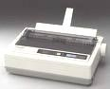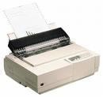 (i) **Dot Matrix printers**. A Dot matrix printer is an impact printer that produces printed images with a print head striking mechanism. Dot matrix has a head with 9-24 pins which can pushed out to hit on the paper through a ribbon. A higher number of pins on the print head means more dots are printed, which results in higher print quality i.e a 24 pin printer has better print quality than a 9 – pin printer.

***Fig: Dot matrix printers***

The speed of a dot matrix printer is normally measured by the number characters per second it can print.

#### Advantages of dot matrix printers

* Dot matrix printers can print multipart forms.
* They can withstand dust environment, vibrations and extreme temperatures. **Disadvantages**
* They are generally noisy because of the striking mechanism.
* Print quality is not as good as those from inkjet and LaserJet printers.

(ii) **Daisy wheel printers**: This is an impact printer that uses a wheel as a print head. As the wheel rotates, a hammer strikes the backside of the spoke and presses it against the paper to print a character.

**Advantages**

➢It can print letter quality characters.

#### Disadvantages

* The printing speed is very slow.
* It cannot print graphics.

1. **Ball Printer:** A ball printer is an impact that uses a rotating ball as a print head. The printing characters are on the surface of the ball, which strikes a ribbon to transfer the character onto a paper.
2. **DeskJet printers**: This has a head which is pushed against the paper to produce characters or graphics. Its performance is relatively similar to inkjet printers.

**(b) NON IMPACT PRINTERS.**

These use chemical lasers to form images that eventually become characters. They form characters and graphics on a piece of a paper without actually striking the paper. Examples include:

(i) **Laser Jet Printers**. Laser jet printers are also known as page printers because they process and store the entire page before they actually print it. The mechanism of how a laser printer works is similar to a

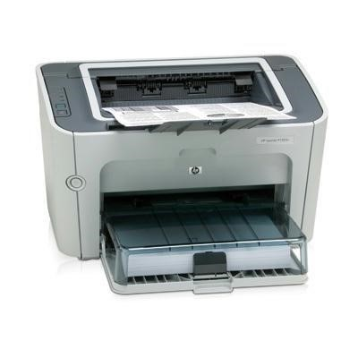

photocopier.

#### Advantages

* Laser printers are generally quite and fast.
* They can produce high quality output on ordinary papers.
* The cost per page of toner cartridges is lower than other printers.

**Disadvantages**

* The initial cost of laser printers can be high.
* Laser printers are more expensive than dot-matrix printers and inkjet printers.

**(ii) Ink Jet printers**: An ink jet printer is a non-impact printer that forms characters and graphics by spraying tiny drops of liquid ink onto a piece of paper. Ink jet printers can produce letter quality text and graphics in both black and white and colors.

The speed of ink jet printers is measured in pages per minute (**ppm**)

#### Advantages

* They are generally quite.
* They can produce high quality colour output.

➢

**Disadvantages.**

* Specialised papers are required to produce high quality colour output.
* The ink cartridges and specialized papers are expensive. ➢The ink may smear when printed on ordinary paper.

#### A comparison of Impact and Non-impact Printers

|  |  |  |
| --- | --- | --- |
|  | **Impact printers** | **Non impact printers** |
| **Advantages** | 1. Ideal for printing multipart forms because they can easily print through many layers of paper. 2. Can normally withstand dusty environment, vibrations and extreme temperature. | 1. Generally much quieter than impact printers because there is no striking mechanism. 2. Can produce high quality output |
| **Disadvantage**  **s** | 1. Generally noisy because of the striking activity. 2. Produce near letter quality (NLQ) print only, which is just suitable for printing mailing labels, envelopes or invoices | 1. Cannot print multipart forms. |

### LESS COMMON TYPES OF PRINTERS

1. **Line printer**: This is a high impact printer that prints an entire line at a time. Line printers are often used with mainframes, minicomputers or with a network in applications such as manufacturing, distribution or shipping.
2. **Thermal Printer**: A thermal printer generates images by pushing electronically heated pins against heat sensitive paper. Standard thermal printers are inexpensive but the print quality is also low.
3. **Plotter**: A plotter is a sophiscated printer used to produce high quality drawings that can be quite large (e.g with width up to 60 inches). Two basic types of plotters are pen plotters and electrostatic plotters.

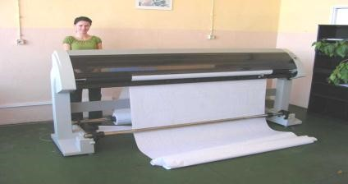

1. **Photo printer**: A photo printer is a color printer designed to produce photo quality pictures directly from the digital camera.

**PRINTING METHODS:**

The printer is an output device by which we can get hard copy of the output i.e on a paper.

1. 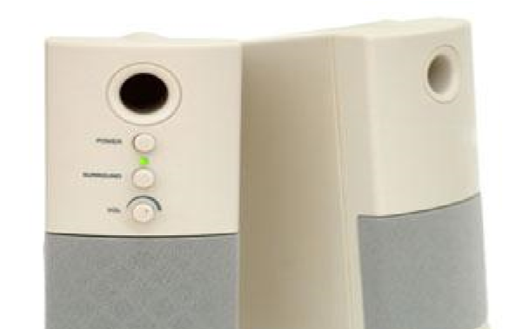**Line printing**: In this type of printing, the printer prints line by line. The paper used on line printers is called continuous stationery though varieties of paper can be used.
2. **Character printing**: In this type of printing, the printer prints one character at a time. The printer or serial printer is slower than the line printer and also cheaper e.g dot matrix printer.
3. **Page printing**: In this type of printing, the printer outputs page by page e.g laser jet printer.

#### Common factors to consider when buying a printer

* Page per minute (ppm)
* Memory of atleast 2mb ➢Price of the cartridge or toner ➢Availability of cartridges.
* Purpose for which the printer is going to be put to use.
* Printer drivers. Most printer drivers are installed before a printer can print some work for you.

1. **AUDIO OUTPUT DEVICES.**

Audio output devices are the components of a computer that produce music, Speech or other sounds. Two commonly used audio devices are speakers and headsets. Most personal computers have a small internal speaker that outputs only low quality sound.

Users who need higher quality sound output may use a pair of stereo speakers and subwoofers connected to ports on the **sound card.**

1. **DATA PROJECTOR.**

A data projector takes the image that displays on a computer screen and projects it onto a larger screen so that people can see the image clearly.

**An LCD projector** which uses liquid crystal display technology can produce lower quality images only.

**A DLP (Digital Light Processing) projector**, which uses tiny mirrors to reflect light can produce much better images even in a well-lit room.

**Other output devices include:**

* Facsimile (fax) machine
* Multifunction machine
* 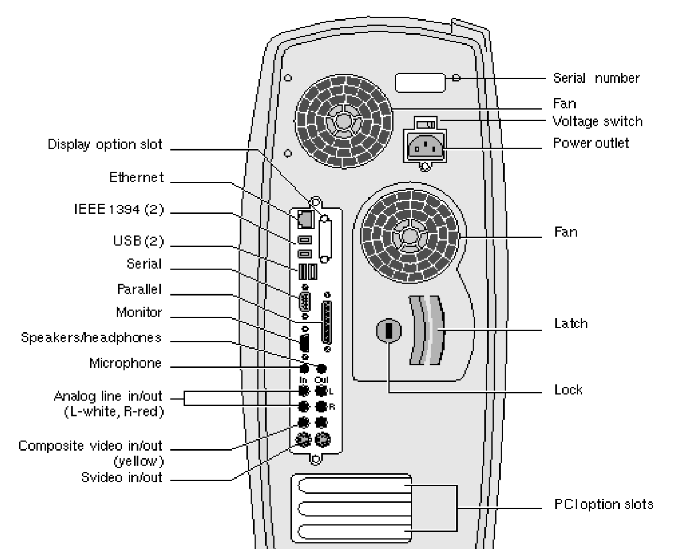Terminal **N.B**

1. ***A PORT:*** *This an outlet for data to the computer peripheral e.g printer, monitor, modem, flsh disks e.t.c Most computers today have three ports. They are;* 
   1. ***Serial port (Com1, Com2).*** *A serial port transmits data one bit(s) at a time and usually connects devices that do not require fast data transmission.*
   2. ***Parallel ports (LPT1 LPT2)*** *: Used by many printers and send out 8 bits or 1 byte at time. The newer types of parallel ports are the enhanced parallel port (EPP) and the Extended capabilities port (ECP)*
   3. ***USB port (Universal Serial Bus)*** *can theoretically connect up to 127 different peripheral devices daisy chained to one general purpose port. USB also supports hot plugging as well as plug and play. Devices connect to the system unit using USB port include keyboard, mouse, scanner, disk drive and digital camera. The newer USB 2.0 can run 40 times faster than the earlier version.*
2. ***NETWORK CONNECTORS****: These act as an interface in networking (linking) computers, so that one can access data or information on another computer on the network card.*
3. ***EXPANSION SLOTS AND BOARDS***

*Expansion slots are places where new boards or cards can be added to customize the computer.*

*Boards/cards are control devices to add special functions or more power to the computer e.g Tv card, sound card e.t.c …*

*Among the types of expansion cards are expanded , memory, display adapter, graphics adapter cards. E.t.c …*

1. ***BUS:*** *This is an electronic channel that allows the various devices inside and attached to the system unit to communicate with each other.*
2. ***A port*** *is also the interface or a point of attachment to the system unit. Other types of ports include;* 
   * + *SCSI port*
     + *1394 port*
     + *MIDI port*
     + *Ir DA port*
     + *Video Adapter game*
     + *Game ports*

***A MIDI (Musical Instrument digital interface)*** *port is designed to connect the system unit to a musical instrument such as the electronic keyboard. MIDI is a standard of the music industry.*

*An IrDA (Infrared Data Association) port allows wireless devices to transmit data via infrared light.*

## STORAGE DEVICES

These are devices that hold data or information on a file when it is needed for processing. Processed data may also be put onto external storage devices. Most computers have a backing storage. Backing storage is necessary because memory is volatile and usually limited.

### ADVANTAGES OF MEMORY

➢Memory is fast because it is accessed electronically and no mechanical components are involved.

#### Advantages of backing storage

* Backing storage is non-volatile and contents stored is relatively more permanent when compared with memory.
* Backing storage provides cheap and almost unlimited amount of storage.

#### Disadvantages of Memory

* Most memory (except ROM, flash memory, and CMOS) is volatile and contents must be transferred to backing storage before the computer is turned off.
* Memory is expensive and its storage size on a computer system is usually limited when compared with backing storage.

**Disadvantages of backing storage**

* Backing storage is slow because of the mechanical components involved.

### N.B

1. ***A Storage Medium.*** *This is a physical material on which a computer keeps data, instructions and information for future use.*
2. ***Storage capacity.*** *This is the number of bytes (i.e characters) a storage medium can hold. Common types of storage media are:* 
   * *Floppy disk*
   * *Hard disk*
   * *Compact disk*
   * *Tape*
   * *Zip drive*

-

***Others include:***

* + *Mo card* - *PC card*
  + *Smart card*
  + *Micro film and microfiche*
  + *Online storage*

*A storage device records and retrieves items to and from a storage medium.*

1. *Storage devices act as input devices when they read and act as output devices when they write.*
2. ***Reading****. This is the process of transferring data, instructions and information from a storage medium into memory.*
3. ***Writing***. This is the process of transferring items from memory to storage medium.
4. *The speed of a storage device is defined by its access time, which the amount of time it takes to locate an item on a medium*.

#### MAIN MEMORY / PRIMARY STORAGE

This is also called memory, primary storage, and internal memory or Random Access memory. It refers to working storage. Main memory

* holds data for processing.
* Holds instructions for processing the data - Holds data after it is processed.

The contents in the main memory are temporal, meaning that if you turn off the computer before saving your work, you will loose any your latest edits.

It is characterized by fast access to information, low capacity and high costs.

There are two types of main memory in use today: These are;

1. **RAM (Random Access Memory):** This is the primary storage device. It stores information as one is currently working on the computer. A computer will be slow with little RAM.

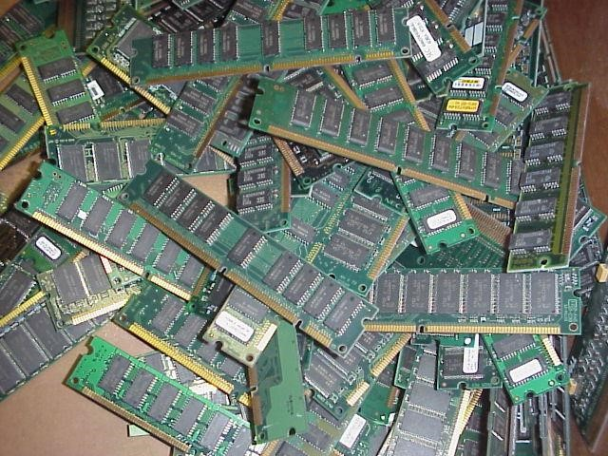

***Fig: RAM chips***

**Characteristics of RAM** ➢It can be changed removed or changed.

➢It is volatile. If you have data in this memory and there is power failure, all your work will be lost.

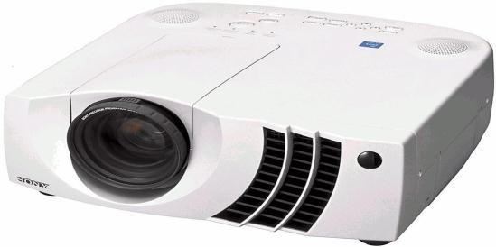To avoid this, you should always save your work on a permanent memory such as a hard disk, flash disk, diskette e.t.c..

1. **ROM (Read Only Memory):** This contains instructions which are permanently recorded in the memory. Its contents can be read but cannot be written during normal computer operations.

##### Characteristics of ROM

* It cannot be changed or deleted.
* Rom is non-volatile. It stores information permanently.

(c)**Registers:** These are high speed staging ideas that temporarily store data and instructions that will be used immediately by the CPU. To process an instruction, the control unit of the CPU retrieves it from memory and places it in a register.

##### Differences between RAM and ROM

|  |  |
| --- | --- |
| **RAM** | **ROM** |
| 1. It is volatile 2. RAM is read and write. 3. RAM is temporal 4. RAM can be increased | 1. It is non volatile 2. ROM is read only 3. ROM is permanent 4. ROM is normally not increasable. |

### N.B

1. ***Volatile memory*** *loses its contents when the computer is turned off. Almost all RAM is volatile.*
2. ***Non-volatile memory*** *does not lose its contents even when the computers power is turned off. Examples include ROM, Flash memory, SMOS*
3. ***ROM (Read only Memory*** *is an example of non-volatile memory. ROM chips containing data, instructions or information which is recorded permanently by the manufacture are known as* ***Firm ware***
4. ***BIOS (Basic Input Output System)*** *is a firmware that contains the computers start up instructions.*

***Variations of ROM chips include***

* 1. ***Programmable Read only memory (PROM).*** *This is a type of ROM chip on which permanently items can be placed.*
  2. ***Erasable Programmable Read only memory (EPROM)****. Or Electronically Erasable programmable read only memory (EEPROM) are Rom chips designed to be modified by the user.*

1. ***BIOS*** *Rom contains the Basic input out system . It is a sequence of instructions that a computer follows to load the operating system and other files when the computer is turned on.*
2. ***Flash Memory*** *also known as Flash Rom or Flash Ram is a kind of non-volatile memory that can be erased electronically and reprogrammed. It is used to store programs and data on personal computers.*
3. ***CMOS (Complementary Metal Oxide Semiconductor).*** *This is used to store configurations about the computer which includes;* 
   * *The amount of memory*
   * *Type of disk drives* ➢*Current data and time.* ➢*Keyboard and monitor*

*CMOS chips use battery power to retain information even when the computer is turned off. Unlike Rom, information stored in cmos can be changed. The cmos chip is updated when ever new components are installed.*

**HOW CAPACITY IS EXPRESSED?**

In a computer system, data is represented using the binary system. Combinations of binary digits (bits). They are only two binary digits.

1 (“on”) and 0(“off”)

These digits can be arranged in such a way that they represent characters, digits and other values.

1. **Bit**. This is the smallest unit of measurement of information. In binary system each 0 or 1 is called a bit, which is a short form for a binary digit.
2. **Byte**. A group of 8 bits is called a byte and a byte represents one character, digit but the figure is commonly rounded.
3. **A Kilo Byte. (KB**) is about 100bytes (1024 bytes)
4. **A Mega byte: (MB)** is about 1 million bytes (1,048,576 bytes)
5. **A Giga byte: (GB)** is about 1 billion bytes. (1,073,741,824 bytes)
6. **A Tera byte (TB)** is about 1 trillion bytes (1, 009, 511, 627, 776)

**Summary:**

|  |  |  |  |
| --- | --- | --- | --- |
| Unit | Abbreviation | Exact amount (Bytes) | Approximate no. of  pages of text |
| Kilobyte  Megabyte  Gigabyte  Terabyte | KB  MB  GB  TB | 1,024  1,O48,576  1, 073, 741,824  1, 099,511,627,776 | ½  500  500,000  500,000,000 |

A byte is eight bits grouped together as a unit, and provides enough different combinations of 0s and 1s to represent 28 = 256 individual characters that include numbers, letters and symbols.

A byte is the basic storage unit in memory and each byte is placed in a precise location in memory called **an address**.

#### BINARY CODING SYSTEM

Letters, numbers and special characters are represented with in a computer system by means of binary coding schemes i.e off/on 0s and 1s are arranged in such away that they can be made to represent characters, digits and other values. Two binary coding schemes are:

1. **ASCII** (American Standard Code for information interchange)
2. **EBCDIC** (Extended Binary Coded Decimal Interchange Code)

ASCII is typically used to represent data for microcomputers, and EBCCDIC is used on larger computers.

### SECONDARY STORAGE

Secondary storage **(Auxiliary storage**) is any storage device designed to retain data and instructions in a relatively permanent form. Secondary storage is non-volatile meaning that saved data and instructions remain intact when the computer is turned off. The following are the forms and elements of secondary storage: - Diskettes

* Hard disks
* Flash memory
* Compact disks
* Optical tape
* Punched cards
* Magnetic tapes

-

(a)**Floppy Diskette**: This is a thin circular, flexible plastic disk with a magnetic coating enclosed in a square-shaped plastic shell. A floppy disk drive (FDD) is a device that can read from and write to a floppy disk. If the computer has two drives, the first drive is usually designated drive A and then the second B ie (A:)

(B:)

The most widely used floppy is 3.5 inches which might either be high density(HD) or Double density(DD). Before anything can be written on a new floppy disk or hard disk, it must be formatted.

*Fig: A floppy diskette*

**N.B *Formatting*** *is the process of preparing a floppy disk or hard disc for reading and writing by organizing the disk into storage locations called* ***tracks***  *and* ***sectors****. For reading and writing purposes, sectors are grouped into* ***Clusters****.*

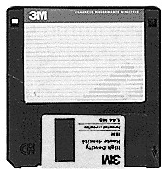

#### CARING FOR DISKETTES

* Never expose the diskette to direct sunshine.
* Never bend or sit on it in your pocket.
* Do not expose it to moisture.
* Do not expose it to magnetic field e.g by placing it on top of a monitor or radio.
* Never touch the circular plate.
* Never pull out the diskette from the drive when light is on.
* Never format a disk that is not yours or one that still holds important information. ➢Keep diskettes in a safe place preferably in a locker in a water proof container.

##### Advantages of floppy diskettes

* Floppy disk is portable and inexpensive.
* Data on a floppy can be accessed randomly
* Data on a floppy disk can write protected from being changed accidentally.
* Floppy can be used to transfer data from one computer to another.
* Their storage capacity is quite considerably bigger compared to previous media like punched cards.

##### Disadvantages

* Since they are external, they are vulnerable to harsh conditions of storage like temperatures, moisture, bending, breaking e.t.c which might cause life being unreliable.
* Access time of floppy disk is slow (about 84ms).
* Data can easily be lost once the magnetic media is exposed to a magnetic field.

(b)**Hard disk/Fixed disk**: This is a metallic media which reside inside the computer for storing computer programs and data. Disk space is measured in Megabytes or Gigabytes. Typical size is 540mb, 1.2gb, 6gb, 10gb, 20gb, 80gb e.t.c. The capacity of a hard disk is much higher than that of a floppy diskette.

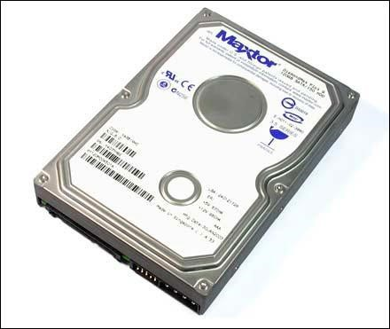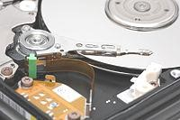

*\*

*Fig: A hard disk*

##### Advantages

* Since they reside inside the computer, they can‟t easily be stolen or misplaced and data is secure. ➢The speed and time of data access is very fast and convenient.
* Though disks have been known to fail with very long periods of non use, the data life of a hard disk is quite long once in use.

##### Disadvantages

* Hard disks are susceptible to virus attacks especially in unprotected systems thereby causing vital data loss.
* They are not portable since they reside in a computer.
* These disks may fail due to violent shaking (vibrations)
* They are metallic and expand depending on changes in temperature. This may cause loss of data. Use of air-conditioned rooms is therefore recommended.

##### Comparison between a floppy and hard disk

|  |  |
| --- | --- |
| **Hard disk** | **Floppy disk** |
| 1. Has bigger storage than a floppy 2. Fixed with in a system. 3. Has greater speed in saving information than a floppy. 4. Fixed in a system unit from environmental hazards. 5. Organises data in a combination of tracks called cylinders | 1. Low storage 2. Is portable 3. low storage space 4. More expose to hazards. 5. Organises data in a single concentric circles called tracks. |

***N.B*** *Advantages and disadvantages plus definitions can serve as characteristics.*

(c)**A compact Disk (CD):** A Compact disk is a flat, round, portable storage medium that is usually 4.75 inches in diameter and less than one twentieth of an inch thick. Most of the computer software today is supplied on CD‟s. It is capable of storing large amounts of information.

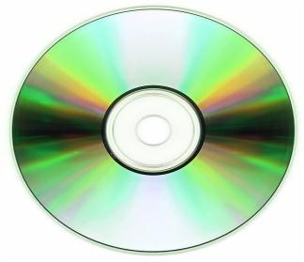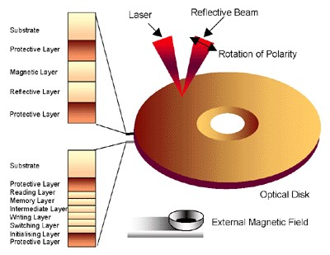

*Fig: A compact CD*

The drive designation of a compact disk drive usually follows alphabetically after that of a hard disk i.e if the hard disk is C: then the compact disk is drive D:

**Variations of Compacts Disks designed for Use with Computers include:**

##### (i) CD-ROM (Compact Disk Read Only Memory)

This is a disk that uses the same laser technology as audio CDs for recording music. A CD Rom can how ever contain graphics, video and sound. The contents of CD ROMS are written or recorded by the manufacturer and cannot be modified by the user.

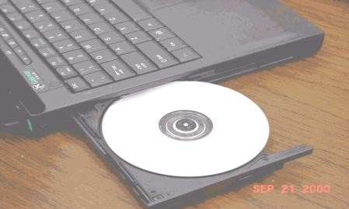

A CD-ROM drive or CD Rom player is required to read items on a CD ROM. It can hold up to 650MB of data, instructions and information.

##### (ii) CR-R (Compact disk – Recordable)

This is a technology that allows a user to write on CD using a computer. CR-R is a “write once, read many” technology. A user can write on the disk in stages – writing on part of it one time and writing on another part at a later time. However, the user can write on each part only one and cannot erase it. CD-R software and a CD drive are required in order to write on a CD-R. **Advantages of CD-R**

* It is more portable than a hard disk.
* The storage capacity of a compact disk is very much larger than that of a floppy disk. ➢The average access time of a compact disk is faster than that of a floppy disk.  **Disadvantages**
* Some kinds of CDs are read only (CD ROM and DVD ROM)
* The average access time of a hard disk is slower than that of a hard disk.

##### (iii) CD-RW (Compact Disc-Re-writable)

This is an erasable compact disk that can be written on multiple times. A CD-RW acts like a floppy disk or hard disk, allowing data, instructions and information be written onto it multiple times. CD-RW software and a CD-RW drive are required in order to write and re-write on a CD-RW. One problem with a CD-RW is that they cannot be read by all CR ROM drives.

##### (iv) DVD-ROM (Digital Video/Versatile Disk- ROM)

This is an extremely high capacity disk capable of storing from 4.7GB to !7GB. A DVD Rom drive or DVD player is required to read a DVD ROM. Although the size and shape of a DVD Rom and a CD ROM are similar, a DVD Rom uses the following techniques to increase its storage capacity.

* Making the disk denser by packing the pits together.
* Using two layers of pits, which double the capacity of the disk.
* Some are double sided, which means that they can be removed and turned over to read the 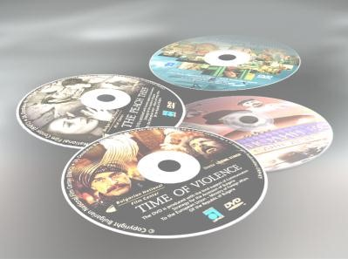other side.

1. **DVD-RAM**. Is a recordable and r e-writable versions of DVD Rom which allows items to be erased to be recorded on it multiple times.
2. **DVD-R.** is the recordable and rewritable versions of DVD ROM which can be written once and read (play) for many times.
3. **DVD-RW** is the recordable and re-writable versions of DVD ROM which can be written and read (play) for many times. A DVD-RW is similar to a CD-RW except, it has storage capacities up to 4.7GB. (viii) **Photo CD** is a type of CD that contains digital photographic images saved on a photo CD format developed by Eastman Kodak.

#### CARE FOR COMPACT DISCS

Most manufacturers guarantee that a properly cared for compact disk will last up to 50 years. Pay attention to the following points for taking care of compact disks.

* Always store the compact disk in a jewel box when not in use.
* Always hold a compact disk by its edges.
* Never touch the under side of the compact disk.
* Never stack disks on top of each other.
* Never expose the disc to excessive heat or sunlight.

**(d)Magnetic tapes:**

These came into use because of the failure of punched cards. They comprise of magnetically coated ribbon of plastic with magnetic surface onto which data is recorded. The disadvantage was that, they were bulky and required more storage space.

##### (e) Punched cards

Among the first forms of storage devices in computers were the punched cards. They were flat cards, which consisted of rows of numbers and letters neatly arranged in columns. To store data, the card was inserted in a computer drive and then a computer punched a series of holes in the rows of characters to represent data stored. In the read process, a computer made out words in order of the holes.

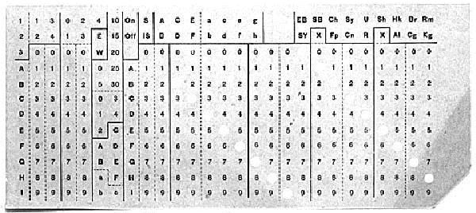

##### Disadvantages

* Cards were made out paper and could easily be destroyed by moisture, rats or tear.
* They were small rectangular cards of about 5x10cm and only few sentences would be stored on hence limited storage capacity.
* Their data life was rather limited because paper depreciates with time. **Other types of storage media include:** 
  + Zip disk
  + Mo Disk
  + PC Card
  + Smart card
  + Online storage
  + Microfilm and Microfiche.

-

1. **The System clock**. This controls how fast all the operations with in a computer take place or are performed. Speeds are measured in Megahertz (MHz)

#### RAM Chips. These are chips that temporally hold data and instructions that will be needed shortly by the CPU. These chips are plugged into THE SYSTEM UNIT

The system unit is a rectangular case that houses the electronic components inside the computer. The system unit contains the electrical components that make a computer work. Specifically, it contains the following.

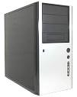

* The power supply
* The motherboard
* The CPU
* Specialized processor chips
* The system clock
* RAM chips
* Expansion slots and boards
* Bus lines
* Ports

1. **Power Supply**: The power supply is the component in the system unit that coverts the wall outlet AC into DC power to run the computer. It can generate a lot of heat; therefore a fan inside the system unit keeps the powers supply (and other components) from getting too hot.
2. **Motherboard**: The motherboard or system board is the main circuit board in the system unit. The motherboard main circuit inn the system unit, which houses the CPU chip, main memory chips, and expansion slots into which other circuit boards can be inserted for the expansion of the computer system.

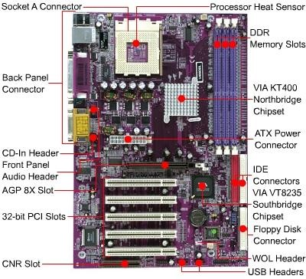

*Fig: Motherboard*

For a desktop computer, the electronic components and most storage devices such as floppy disk, hard disk and CD ROM drive reside inside the system unit.

For a laptop computer, the system unit houses almost all of its components including keyboard, pointing devices and monitor.

1. **Central Processing Unit (CPU):** This is the electronic device that interpretes and carries out instructions that tells the computer how to work. The CPU microchip is the “brain” of the computer. On a personal computer, the CPU is usually contained on a single chip and is often called a **microprocessor.** The two principle architects or designs for microprocessor are CISC and RISC.

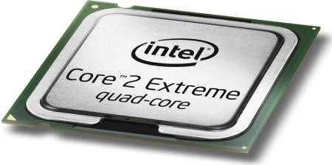

**CISC (Complex instruction set computing)** chips that are mostly used in personal computers and conventional mainframes can support large number of instructions, but at relatively low processing speeds.

**RISC (Reduced Instruction set computing)** chips that are used mostly in workstations eliminate a great many seldom-used instructions, result in working up to 10 times faster than most personal computers.

Recently copper has replaced aluminum to create the electronic circuitry of CPUs. - Integrated CPUs

* + Micro controller
  + MMX technology.
  + Parallel processing ▪Co-processor ▪Heat sink.

***N.B:***

***PROCESSING DEVICES****: These process data which is sent to the output devices or stored in secondary memory. The CPU is the main part(brain) of the computer has two main parts:*

1. ***Control Unit****: directs and coordinates most of the system activities.*
2. ***Arithmetic and logic Unit****: performs arithmetic and logical functions and controls the speed of these operations.*
3. the motherboard.

## COMPUTER SOFT WARE

Software is a collection of programs. The term software is used to describe the complete range of computers programs that convert the general-purpose computer system into one capable of performing a multitude of specific functions.

**Program**: This is a set of instructions, commands that are arranged in a logical way which can run a computer.

**N.B**: *If you compare a computer with a human being, the body is similar to hardware of the computer. What is inside i.e the spirit or life within a human body is similar to software as regards the computer.*

Software is used in contrast to hardware to enable the computer run all the programs installed on a computer.

### CATEGORIES OF SOFTWARE

Computer software can be broadly classified into two categories.

System

application

Software

Program 1

Commands

Commands

Commands

Program 2

1. **System software**. This is software responsible for the operation of a computer. It is usually supplied by the manufacturer of the computer. Some of the programs reside inside the ROM and are known as **Firmware**.

System software consists of the following:

* + 1. Operating system.
    2. Programming languages.
    3. System utilities/Utility programs

System software acts as an interface between the user, application software and hardware. Two types of system software are the operating system and utility programs.

1. **Application software**. These are programs developed to solve the users problems e.g typing a document, internet, designing and graphics e.t.c. These programs include: word processors, spread sheets, accounting programs e.t.c. Application software which handles the needs of the end user fall into two main categories.
   1. **Special purpose packages**. These are also called custom made packages which are written to meet specific needs of an organization that cannot be usually satisfied by other sources of software.
   2. **General purpose packages**. These are also called off the shelf packages which may be used for a wide variety of purpose such as word processors, spread sheets, databases, and presentation software e.t.c

**N.B**: *An application service provider (ASP). This is a third party organization that manages and distributes software and services on the web.*

### SOFTWARE CLASSIFICATIONS

System

Application

Operatin

g

Utilities

Programi

ng

Low

High

OS for stand

alone

OS for

networked

Custom

package

Off the

shelf

#### OPERATING SYSTEMS

An operating system is a program which enables a computer to deal with input and output, keep a track of what is going on and allocate storage space.

You as user in most cases, you are dealing with exterior parts but when you are using a computer, you can‟t look inside to see what is going on but this remains the work of an operating system.

When you are storing on diskettes, you can‟t know whether its is full by looking at it but it is the operating system to tell that the disk is full by giving you information on the screen.

There fore operating system (OS) is a set of programs containing instructions that coordinate all activities among computer hardware devices.

### EXAMPLES OF OPERATING SYSTEMS

1. **DOS (Disk Operating system)** This refers to several single user operating systems that were developed in the early 80s for personal computers. The two more widely used versions of DOS were PC-DOS and MS-DOS both developed by Microsoft.
2. **Windows 3.x** refers to early three versions of Microsoft windows: Windows 3.0, Windows 3.1 and 3.11
3. **Windows 95** is a true multitasking operating system that does not require DOS to run.

**Advantages:**

* + An improved graphical user interface.
  + Most programs run faster under the OS.
  + Supports a more efficient form of multitasking
  + Supports networking plug and play, longer file names and e-mail. - Take advantage of 32-bit processors.

#### 4. Windows NT workstation

5. **Windows 98** is an upgrade to Windows 95 operating system.

##### Advantages

* More integrated with Internet.
* Includes the active desktop interface options.
* Provide faster system start up and shut down.
* Better file management.
* Supports new multimedia technologies such as DVD and WEB TV.
* Supports the Universal serial bus.
* Like Windows 95, 98 can also run 16 and 32 bit software.

1. **Windows 200 professional** is an upgrade of Windows NT operating system.
2. **Windows ME (Windows Millennium)** is an update version of windows 98 for the consumer that that uses a computer to surf the internet or for entertainment, windows millennium is designed mainly for home users.
3. **Windows XP home i**s an upgrade of windows millennium. Added features of windows XP home edition includes internet explore 6, acquire, organize and share digital pictures, download, store and playback highquality music through windows media player.
4. **Windows XP professional** is an upgrade of windows 200 professional.

Added features include

* + All the capabilities of windows xp home edition.
  + Remotely access a computer, its data and its files from any other computer anywhere.
  + Support for secured wireless network access.
  + Simpler administration of groups of users of computers.

10 **Mac OS** was the first commercially successful user interface.

1. **Windows NT server** is designed for client server networks. The server uses a version called NT server.
2. **UNIX**. Is a multi user, multitasking operating system developed in the early 1970s by scientist at Bell laboratories. A weakness of UNIX is that it has a command line interface and many of its commands are difficult to remember.
3. **Linux**. Linux is a popular, free UNIX like multi-tasking operating system. Some versions use command line interface while others use graphical user interface. The two most popular GIUs available for Linux are

GNOME and KDE

1. **Windows CE** is a scaled-down windows operating system designed for use on wireless communication devices and handheld computers.

### FUNCTIONS OF AN OPERATING SYSTEM

1. **Memory management**. It allocates and assigns items to areas of memory called **buffers**, while they are being processed to monitor carefully the contents of these items in memory, and to clear these items from memory when they are no longer required by the CPU.
2. **Spooling of print jobs**. With pooling, the print jobs are placed in a buffer instead of being sent immediately to the printer. As soon as the print jobs are placed in a buffer, the CPU is available to process the next instruction and the computer can be used for other tasks.
3. **Configuring devices**. In thes past, installing a new device often required setting switches and other elements on the motherboards. Most of the operating systems today support plug and play and can configure devices automatically.
4. **Monitoring system performance**. A performance monitor is a program that access and reports information about various system resources and devices. The information in such reports helps a user identify problems with the resources.
5. **Administering security**. The multi-user system requires each user to log on. Both successful and unsuccessful log on attempts are often recorded in a file so the system administrator can review who is using or attempting to use the computer. Some operating systems allow the user to assign passwords to files so that only authorized users can open them.
6. **Managing storage media and files**. Most operating systems include a file manager program that performs functions related to storage and file management.

### N.B

1. ***Log on****. This is the process of entering a user name and a password into the computer.*
2. ***Password****. A password is a combination of characters associated with the user name that allow a user to access a computer or a network. Passwords should be easy to remember but not to obvious so that one can guess it easily. Longer passwords provide greater security than shorter ones.*

***Do use:***

* + *At least eight characters if supported by the system.*
  + *A combination of mixed case letters and digits.*
  + *A password that can be typed easily without looking at the keyboard.*

***Do not Use:***

* + *Your name, birth day, ID card number or telephone number* - *A password of all digits or the entire same letter.*

***Tips for safeguarding your password.***

* + *Do not share your password with others.*
  + *Do not write your password.*
  + *Change your password frequently.*

1. **A File manager**. This is a program that performs functions related to storage and file management.

#### Functions of a file manager

* Formatting and copying disks.
* Displaying a list of files on a storage medium.
* Checking the amount of used space on a storage medium. - Copying, renaming, deleting, moving and sorting files.

#### CLASSIFICATION OF OPERATING SYSTEMS

Based on the number of computers, an operating system can act as an interface. Two types of operating systems have been identified namely:

1. **Single User systems**. An operating system, which act as an interface for only one user. It is therefore a single user system. Ideally all stand alone machines (Computers which are not connected to any other) use this operating system. An example is Ms Dos.
2. **Multi-User systems**. The concept of multi-user systems is exactly the opposite of the single user. A computer system, when act as
3. an interface for more than one user becomes a multi-user environment system.

Depending on the look of the operating system interface, an operating system interface, an operating system can either be character based or graphical user interface based.

#### GRAPHICAL USER INTERFACE

Graphical user interface allows the user to use menus and visual images such as icons, buttons and other graphical objects to issue commands. Examples; Windows 95, 98, 2000, NT e.t.c. Basic components of GUI system include desktop, Menu bar e.t.c..

##### Advantages of GIU

* It is user friendly because it is easy to learn and work with
* There is no need to type and memorise any command language.
* The interface is similar for any application.
* You are provided with a coloured screen with icons each representing a program. A mouse may be used.

##### Disadvantages

* It requires a faster memory as well as a faster processor.
* It also occupies more disk space to hold all files for different functions. ▪It is difficult to automate functions for expert users.

#### COMMAND LINE INTERFACE

With a command line interface, a user types keyboard or press special keys on the keyboard to enter data and instructions. The set of commands a user uses to interact with the computer is called command language. Examples are DOS, UNIX, Linux e.t.c …

##### Advantages of Command line Interface

* A command line interface takes up little memory and normally does not require very fast processor.
* Operation is fast because commands can be directly through the keyboard.
* Many commands can be grouped together as batch file so that repeatitive tasks can be automated.

##### Disadvantages of Command line interface

* A command language has to be learnt and memorized.
* You are provided with a virtually empty screen with a blinking cursor where commands are keyed and the computer executes them by pressing the enter key.

##### - *N.B*

1. ***A Device driver.*** *This is a small program that tells the operating system how to communicate with the device. Each device on a computer (e.g a mouse) has its own specialised set of commands and thus requires its own specific driver. The operating system loads each devices’s driver when the computer boots up.*
2. ***Data Base Management system (DBMS).***

*A data base is a collection of data organized in a way that allows access, retrieval and use of the data. Common paper data bases include:*

* + *Telephone books.*
  + *Dictionaries*
  + *Recipe cards*
  + *Television guides.*

***Computerized data bases in Uganda include:***

* + *Flight information.*
  + *Phone inquiry system.*
  + *Data base in public libraries.*

•

***Examples of data base software include;*** •*Microsoft visual fox Pro.*

* + *Borland Base*
  + *Lotus approach*
  + *Corel paradox*

*Data storage is looked after by a special program known as Data Base management system (DBMS) and these makes data available fro use in individual application programs.*

#### ADVANTAGES OF ELECTRONIC DATA BASES OVE MANUAL DATA BASES

1. **Reduction of data redundancy**. Storing most of data in one place means less duplication and less required place.
2. **Enhancement of data integrity**. Because data are centralized, fewer updating errors occur and greater accuracy can be maintained.
3. **Ensured data independence**. Data are entered, stored, modified and accessed by methods that are not affected by application programs. Also changes made to data structures usually do not require changes in programs that access the database.
4. **Improvement of access to data**. Data systems allow users to query that database directly without necessarily using an application program.
5. **Facilities of data sharing and integration**. A database system offers users the ability to combine or to cross-reference data in many different ways.
6. **Centralization of security**. It is easier to limit access to information if it is grouped together instead of being kept in several scattered files. Many databases must be protected and kept private.
7. **Reduction of costs**. Data entry, storage and development of new application programs are all made more economical. By eliminating the duplication of data, many organizations can realize substantial savings.

### UTILITY PROGRAMS

These are also called **Service programs**. A utility program is a form of system software that performs a specific task, usually related to managing a computer, its devices or its programs. Popular types of utility programs include:

* File viewer
* File compression utility.
* Diagnostic utility. - Disk scanner
* Disk defragmenter
* Un installer
* Back up utility
* Anti virus utility
* Screen saver

1. **File Viewer**. Is a utility that displays and copies the content of a file. An operating system‟s file manager often includes a file viewer.
2. **File compression utility**. Reduces or compresses the size of a file. A compressed file takes up less storage space on a hard disk or floppy disk, which frees up room on the disk and improves system performance. Compressed files sometimes are called Zipped Files because they usually have a zip extension. A compressed file must be unzipped or restored to its original form before being used.
3. **Diagnostic utility**. A diagnostic utility complies technical information about a computers hardware and certain system software programs and prepares a report outlining any identified problems. Windows XP includes Dr. Watson as a diagnostic utility.
4. **Disk scanner**. Is a utility that detects and corrects both physical and logical problems on a hard disk of floppy disk and searches for and removes unwanted files.

**A physical problem** is one with the media, such as scratch on the surface of the disk. **A logical problem** is one with the data such as a corrupted file allocation table (FAT) Two disc scanner utilities included with windows are **scan disc** and **disc clean up**.

1. **Disk defragmenter**. This is a utility that organizes the files and un used space on a computer‟s hard disk so data can be accessed more quickly and programs can run faster. When the contents of a file are scattered across two or more non-contiguous sectors, the file is fragmented. The process of defragmentation is reorganizing the disk so the files are stored in contiguous sectors.
2. **Uninstaller.** This is the utility that removes an application as well as any associated entries in the system files.
3. **Backup utility.** This allows a user to copy or back up selected files or the entire hard disk onto another disk or tape.
4. **Antivirus utility**. This is a program that prevents, detects and removes viruses from a computers‟ memory or storage devices. One popular antivirus program is Norton Antivirus.
5. **Screen saver**. A screen saver is a utility that causes the monitors screen to display a moving image or blank screen if no keyboard or mouse activity occurs fro a specified time period.

#### Applications of screen saver program

Screen savers were originally developed to prevent a problem called **Ghosting** in which images could be permanently etched on a monitors screen.

* Screen savers can also be used for reasons of security. It prevents unwanted on lookers from accessing information or data on your computer screen.
* Business. (advertisement on the screen)
* Entertainment. Digital photos can be put on your screen as moving pictures.

### PROGRAMMING LANGUAGES

This is a medium used by man to write instructions that command the computer hardware to perform particular tasks. These instructions are written in different languages depending on the place of a manufacturer.

Language is a media to communicate between human beings. Similarly the language used for communicating between human beings and the computer is called computer language or programming language.

Although there are many different computer languages, most fall under one of the four categories. These groups are known as levels of languages because they can be arranged hierarchically.

The highest level is occupied by languages that make it easy for people who are not necessarily programmers to develop computer applications. Going from the lowest to the highest, the classifications are:

1. **Machine language.** This consists of binary numbers that represents instructions, memory locations and data so they can be processed by a specific model. Its own machine language is the only language that can be directly used by a computer. All instructions in a machine code are represented in the binary format. An example of a machine code is 1010000000000001001 a 16-bit machine code.
2. **Assembly language**. This consist of mnemonic symbols that stand for zeros and ones of machine language e.g the above code would be written as LOAD S Assembly language was more meaningful that series of codes.
3. **High-level language**. These are statements in form of instructions or commands given to a computer to generate a considerable amount of machine code. Object codes are used to translate these languages so that they can be used by all computers of the same make. Programming languages help in writing software that can be understood more easily than machine language. Some of the high level languages are;
   1. **BASIC** (Beginning All purpose symbolic Instruction Code). This was developed in 1964 by John Kemeny and Thomas Kutz to teach students how to use computers. It is very easy to learn. It uses very common English words so a basic program can be understood by even a non-programmer. Today is a common language on micro computers.
   2. **FORTRAN**. (FORmula TRANslation). This was developed in 1956 to provide an easier way of writing scientific and engineering applications because of its simplicity, conciseness, standardization, efficiency and numerical precision. It is usually used in business application.
   3. **COBOL** (Common Business Oriented Language). It came into use in the early 1960‟s. It has wide spread application in businesses, commercial data and is noted for its ability to handle the input and output of large volumes of alphabetical data, its machine independence and its English like statements.
   4. **PASCAL.** Was developed in early 1970 specifically for computer scientists. Though it was developed by Nicklaus W at a Technician University in Zurich. It was named in rememberance of the inventor of the “Mechanical calculator”.
   5. **ADA** named in honour of lady Augusta Lovelace worked with Charles Babbage at Cambridge University in English during the first half of the 19th Century on the first commercial computer.
   6. **ALGOL**. It is an abbreviation for Algorithmic language. It is suitable for both scientific and engineering computations.
   7. **PL/M** (Programming Language Microcomputer) was developed purposely for use with Intel microcomputers. It has a compiler.
   8. **LOGO** was developed for educational use in which children can explore and develop concepts through programming the movement of a “turtle” or

pen. It has no commercial purpose.

1. **Application generators** attempt to make it easy as possible for users to tell the computer what they want instead of having to specify exactly how to it. **4GLs** was designed to meet the following objectives
   * + Enable quick and easy amendments and alterations ▪Make language user friendly.
     + Allow non-professional end users to develop their own solutions.

**5GLs.** This type of languages is used in intelligent knowledge based systems (IKBS) such as Robots. Unlike 4GLs which manipulate data, numbers, 5GLs manipulate various facts and rules to reach a conclusion. Therefore, they “think” just like human beings and because of this they are extremely use in artificial intelligence projects like the recent mars explorations.

#### OBJECT ORIENTED PROGRAMMING (OOP)

The current state of the art in programming technology is object oriented programming (OOP). It Uses objects which combine data and behaviour. Examples include Visual **Basic (C++)**

**What makes the language Good?**

* Suitability of the problem.
* Clarity and simplicity.
* Efficiency
* Availability
* Consistency

The above are the criteria to be used when choosing a programming language and then the platform whether windows or DOS based.

#### WEB DEVELOPMENT LANGUAGES

Web pages are used for creating websites on the Internet where all sorts of advertising can be done. The most common used languages for creating web pages on World Wide Web are written using Hyper Text Markup languages **(HTML**) and **JAVA**

**HTML** is one of the main language used to create web pages for the inernet and intranet. This language allows programmers to compose text (Also known as ASCII), data, pictures, sound, animations and video for screen display.

**JAVA** in an OOP that resembles a simplified form of C++. Java codes displays graphics, accesses the network with users via a asset of capabilities known as classes.

***N.B.Debuggers****: These are programming tools which help programmers to detect, locate and remove routine, syntax or logical errors from a program being written.*

### APPLICATION SOFTWARE

Application software refers to programs that perform specific tasks for users. Most application software is available as packaged Software that can be purchased in retail stores or on the web.

**A Cross-platform application** is one that runs identically on multiple operating systems. They often have multiple versions each corresponding to different operating system.

**An application service provider (ASP)** is a third party organization that manages and distributes software and services on the web.

#### FORMS OF SOFTWARE

Software is available in a variety of forms.

1. **Packaged Software**. It is commercial software, which is copyrighted and designed to meet the needs of wide variety of users.
2. **Custom software**. This is a Taylor made software which is developed at a user‟s request to perform specific functions.
3. **Freeware**. This is copyrighted software provided at no cost to users.
4. **Shareware**. Is copyrighted software that is distributed free for a trial period and payment is required for using the software beyond trial period.
5. **Public Domain software**. This is a free software donated for public use and has no copyrighted restrictions.

#### COMMON TYPES OF APPLICATION SOFTWARE

1. Word Processing software
2. Spread sheet software
3. Database software
4. Presentation software
5. Software suit
6. Integrated software
7. Computer aided design software
8. Desktop publishing software
9. Project management software
10. Personal information managers
11. Accounting software
12. Pointing and Image editing software
13. Video and Audio editing software
14. Multimedia authorizing software
15. Web page authoring software
16. Personal finance software
17. Educational software
18. Reference software
19. Entertainment software
20. Communications software
21. Utilities programs

#### CHARACTERSISTICS OF APPLICATION PACKAGES

1. They are targeted to a wide range of users with a popular and common objective.
2. It is user friendly. Many of them have graphic user interface in windows environment which makes it easy to learn and use.
3. It is designed for power and flexibility. This ensures that most of the capabilities of the packages is addressed irrespective of the hardware.
4. The software should be machine independent. The packages are designed to work on a range of computer systems and data can be transferred form one computer to another cheaply.

##### 1. WORD PROCESSING SOFTWARE

Word processing software also known as word processor is used to create, edit, format and print documents that contains text and graphics.

**Creating a document** involves entering text or numbers, inserting graphics and performing other tasks using an input device such as a keyboard or a mouse.

**Editing** is the process of making changes to the existing content of the document. Common editing features include:

* Inserting - Deleting
* Cutting, copying, pasting e.t.c..

**Formatting** involves changing the appearance of a document. Different levels of formatting include; character formatting, paragraph formatting, section formatting, document formatting e.t.c.

**Undo** allows actions that have been performed to be reversed such that if some text was accidentally deleted, then the action can be undone.

**Saving** is the process of copying a document from the memory to storage medium such as the floppy disk or hard disk. Any document that has been saved exists as a file which is a name collection of data, instructions or information. Each file has a file name.

**Printing** is the process of sending a file to a printer to generate output on a medium such a s a paper. A user can choose to print a document either in portrait (vertical) or landscape(horizontal) orientation **A4** is the most popular sized paper used in Uganda.

###### Examples of word processing documents include,

* Letters
* Memos
* Reports
* Mailing labels and news letters.

Many word processing softwares are also capable of creating web pages.

#### POPULAR FEATURES OF WORD PROCESSING SOFTWARE

1. **Word wrap**. This allows a user to type continuously without pressing the enter key at the end of each line.
2. **Replace**. This allows the user to substitute existing characters, words or phrases with new ones.
3. **Spell checker**. This allows a user to check the spelling of a whole document at one time or to check and even correct the spelling of individual words as they are typed (i.e auto correct)
4. **Grammar checker**. Reports grammatical errors and suggests way to correct them.
5. **Thesaurus.** This suggests alternative words with the same meaning (synonyms) for use in the document.
6. **Mail merge.** This creates form letters, mail labels and envelopes. Used when similar letters have to be sent to several people. The names and addresses of each person can be merged with one single standard document and then printed out.
7. **Automatic page numbering** numbers the pages automatically in a document (h)**Tables** allow the user to organize information into rows and columns.
8. **Multi-columns**. This arranges text in two or more columns that look like or similar to newspaper columns or magazines.
9. **Clip Art gallery** allows a user to insert drawing s, diagrams and photographs into a document.
10. **Mathematical formulae typesetting**. This allows a user to typeset complex mathematical formulae with in the program.

##### Popular word processors include;

* Micro soft word
* Lotus WordPro
* Corel WordPerfect
* Word pad

#### ADVANTAGES OF WORD PROCESSING OVER ORDINARY TYPEWRITTER

1. Easy and fast to make changes to the document.
2. Has many features to create documents that look professional and visually appealing.
3. Documents can be previewed before being printed.
4. Documents can e saved for future use for editing.
5. Convenient to create and for letters and mailing labels.

##### 2. SPREAD SHEET SOFTWARE

Spreadsheet software is used to organize data in rows and columns and performs calculation on the data. Before the advent of computers, cash flows and budgets required for business planning had to be done by hand. These days, there is no excuse for not having good information.

###### Using spread sheets

* Sales can be recorded.
* Invoices produced and statements compiled.
* Researchers can compile and analyze their results.
* Teachers can easily create tables of figures and manipulate then quickly as required.

-

A spreadsheet document is often called a **worksheet.** On each worksheet, data is organized vertically in columns and horizontally in rows. Each column is identified by a letter (i.e A, B, C ) and each row is represented by a number (i.e 1, 2, 3, 4…)

A cell is the intersection of a column and a row. Each cell has unique cell address e.g A1, A2, D6 e.t.c to define its location on the worksheet. The upper-left most cell is generally identified as A1.

For relative addressing, the cell addresses e.g (B1+C1) will be self adjusted when the formula is moved or copied to another cell e.g (C2+C2)

A cell can be empty or contain a label, a value (i.e a number or a formula). **Labels** are text that identify the data and help organize the worksheet. **Values** are numbers to be used for calculations.

#### BASIC MATHEMATICAL OPERATIONS USED IN SPREAD SHEETS INCLUDE

|  |  |  |
| --- | --- | --- |
| SYMBOL | DESCRIPTION | EXAMPLE |
| ( ) | Parentheses | =B2*(C4+D5) |
| * | Multiplication | =B2*C4 |
| / | Division | =B2/C10 |
| + | Addition | =(B2+C4) |
| - | Subtraction | =(B2-C4) |
| % | Percentage | =C5*60% |
| ^ | Exponential | =C5^2 |

Spreadsheet programs normally have enormous functions which are predefined formulae to perform common calculations.

|  |  |  |
| --- | --- | --- |
| Mathematical | ABS (number ) | Returns the absolute value of a number |
| INT(number ) | Round to the nearest integer |
| LN(number ) | Calculate the natural logarithm of a number |
| LOG(number base) | Calculates logarithm of a no. to a specified base |
| ROUND(number, no. of  digits) | Round to a specifies number of digits |
| SQRT(number ) | Square root of a number |
| SUM(range) | Calculates the total of range of numbers. |
| Statistical | AVERAGE(range) | Calculate the average value |
| COUNT(range) | Counts how many cells in the range have entries |
| MAX(range) | Returns the maximum value |
| MIN(range) | Returns the minimum value |
| STDEV(range) | Calculate the standard deviation |
| Logical | IF(logical test, value, if true, value if false) | Performs a test and returns one value if the test of the result is true and another value if the result is false |
| Financial | FV(rate, no. of periods, payment) | Calculate the future value of investment. |
| NPV (rate, range) | Calculate the net present value of investment. |
| PMT (rate, no. of  periods, present value | Calculates the periodic payment for annuity. |
|  | PV(rate, no. of periods, payment | Calculates the present value of investment |
| RATE(no. of periods, payment, present value | Calculates the periodic interest rate of an annuity. |
| Date  &  Time | DATE | Returns the current date |
| NOW | Returns the current date and time |
| TIME | Returns the current time |

##### Popular features of spread sheets

1. **Adjusting columns**. This allows the user ability to adjust columns
2. **Date sorting**. Allows the user ability to sort data accordingly e.g descending , ascending
3. **Printing**. Allows the user to print the entire worksheet, portions of a worksheet and several worksheets.
4. **Charting**. Allows the user to display data in graphical rather than a numerical form. Popular chart types include; line charts, bar charts, pie charts e.t.c ..

##### Popular spread sheet software

* Microsoft Excel
* Lotus 1-2-3
* Corel Quattro Pro
* Visicalc
* Super Calc

#### ADVANTAGES OF SPREADSHEET SOFTWARE

1. Easy to make changes and corrections to data on the worksheet.
2. The rest of the worksheet is recalculated whenever data on the worksheet changes.
3. Operation is very fast with the help of built-in functions and macros.
4. Calculation is always accurate, provided that data and formulae entered are correct.
5. Easy to create different kinds of charts or to change chart types.
6. Information on charts is updated automatically whenever related data on the worksheet changes.
7. Electronic spreadsheets are much longer than manual worksheets. Manual worksheets are limited by size.
8. Electronic spread sheets can perform mathematical, statistical and financial calculations quickly and accurately.
9. They can be stored and retrieved for repeated use for example on diskettes, discs, e.t.c rather than searching through endless filing cabinets.

##### 3. DATABASE SOFTWARE

A database is a collection of data organized in a way that allows access, retrieval and use of the data. Common database papers include;

* Telephone books
* Dictionaries
* Recipe books
* Television guides

###### Computerized databases in Uganda include;

* Flight information
* Phone inquiry system
* Database system in public libraries.

A database software or a database management system(DBMS) allows a user to create, access and manage a database.

Most PC databases consist of a collection of tables organized in rows and columns.

**A record** is a row in a table that contains information about a given person, product or event (an individual entry in a table)

**A field** is a column in a table that contains specific piece of information with in a record. ( is a piece of information in a record)

The data type of a field specifies the type of data that the field can contain. Common data types include; (a)**Text type** which may hold letters, numbers or special characters.

1. **Numeric type** which may hold numbers only.
2. **Currency type** which may hold dollars and cents amounts.
3. **Date type** which may hold months, day and year information.
4. **Memo type** which may contain text of any type or length.
5. **Boolean type** which may hold value that is either true or false.
6. **Ole object** (Object linking and embedding) objects, graphics and other binary data. Filed capacity is up to a gigabyte or limited by available disk space.

#### LOOKUP WIZARD

When the value that you need exists in another table or from a list of static values, you use the lock up wizard to help you establish a link to the table or to define the combo box that will display the list of values on a form or report.

**Validation** This is the process of comparing the data entered with a set of predefined rules and values to check if data is acceptable.

#### MANIPULATION OF DATA IN DATABASES INCLUDE

1. **Sorting** is to organize a set of records in a particular order.
2. **Tables a**re the most important objects in a database. Tables are used for data entry and edit. In a table, each record is displayed as a row and each filed is displayed a s a column.
3. **Querying** is to use a specific set of rules (i.e criteria) for retrieving data from the database.
4. **Queries**. Are used to locate specific record with in the table or ask questions to your database. You might want to extract records that meet specific selection criteria (e.g employees who will earn above a certain amount of salary in the accounts department. When you run a query, the results are arranged in columns and rows like a table
5. **Forms.** Provide alternatives to tables of data entry and viewing records. With forms, you arrange the fields as required on the screen. You can design your form to look like the printed forms (invoices, order from e.tc..) that you use.
6. **Reports**. Are used to produce various printed outputs e.g summaries of data in your database. Using

reports, the same database can produce for instance a list of one publisher‟s books in a specific category.

#### N.B

1. **A Flat file database** is made up of only one table.
2. **A relational database** can take information from two or more tables and combine them into a new table or report.

**What a good database should be?**

A DBMS should make efficient use of computer resources, be fast, interface smoothly with existing facilities, be acceptable, provide easy access to authorized users, preserve data integrity and ensure privacy of data.

##### ADVANTAGES OF DATA BASE MANAGEMENT SYSTEM

1. **Reduction of data redundancy**. Storing most of data in one place means less duplication and less required place.
2. **Enhancement of data integrity**. Because data are centralized, fewer updating errors occur and greater accuracy can be maintained.
3. **Ensured data independence**. Data are entered, stored, modified and accessed by methods that are not affected by application programs. Also changes made to data structures usually do not require changes in programs that access the database.
4. **Improvement of access to data**. Data systems allow users to query that database directly without necessarily using an application program.
5. **Facilities of data sharing and integration**. Database systems offers users the ability to combine or to cross-reference data in many different ways.
6. **Centralization of security**. It is easier to limit access to information if it is grouped together instead of being kept in several scattered files. Many databases must be protected and kept private.
7. **Reduction of costs**. Data entry, storage and development of new application programs are all made more economical. By eliminating the duplication of data, many organizations can realize substantial savings.

##### DISADVANATAGES OF DATABASE MAGAMENT SYSTEM

1. **Complexity**. Database systems include sophisticated software packages that may require special hardware. They are difficult and time consuming to develop.
2. **Initial expense**. Primary, because of their complexity and efficiency, database systems can be expensive to set up.
3. **Vulnerability**. Data in a database may be more susceptible to sabotage, theft or destruction. Although in one sense, databases are protected because of centralized security measures, in other senses, they are vulnerable because all eggs are in one basket.

###### 4. PRESENTATION SOFTWARE

Presentation software is used to create presentations, which can communicate ideas and other information to a group of audience. The presentation can be viewed as a **slide show** which usually displays on a large monitor or on a projection screen.

Popular presentation software

* Microsoft power point
* Corel presentation
* Lotus freelance Graphics

Features of presentation software

* Several “Auto” features that makes it easier for you to perform your work e.g auto correct to correct typing errors, auto clip art provide clip art suggestions.
* Style checker.
* Ability to present on screen presentation in colour.
* Using the new animation effects tool bar.
* Presentation conferencing
* Meeting minder

Advantages of Presentation software

1. Presentation software usually provides a wide variety of presentation formats and lay outs for the slides.
2. Multimedia components such as slip art images, video clips and audio clips can be incorporated into the slides.
3. The timing of slides can be set so that the presentation automatically displays the next slide after a predetermined period of time.
4. Special transition effects can be applied between each slide.
5. The presentation can normally be viewed and printed in different formats e.g outline format, audience handout format and notes page format.

###### 5. SOFTWARE SUIT

A software suit is a collection of individual application software packages sold as a single package. A software suit usually includes application software; a word processor, a spreadsheet software, a database software and a presentation software.

Popular software suits include;

* Microsoft office
* Lotus smart suit
* Corel WordPerfect suit

Advantages of Software suits

1. A software suit normally costs significantly less than purchasing each of the application separately.
2. Ease of use because applications within a suit usually use a similar interface and share common features

###### 6. COMPUTER AIDED DESIGN SOFTWARE

Computer aided design software (**CAD)** is mainly designed for creating engineering, architectural and scientific drawings. Popular CAD software includes;

* Auto desk
* Auto CAD and
* Microsoft Visio technical

###### 7. DESKTOP PUBLISHING SOFTWARE (DTP)

Desktop Publishing software (DTP) is used to design and produce complicated documents that contain text, graphics and brilliant colours. It is ideal for the production of high quality colour documents such as newsletters, catalogues, textbooks and annual reports.

Popular DTP software include

* Microsoft Publisher
* Adobe page maker
* Adobe in Design
* Quark Xpress
* Broderbund Print Shop pro.

DTP combines word processing and graphics to produce high quality documents with a laser printer. Components of a desktop publishing systems include; a powerful microcomputer, graphics display, mouse, Laser printer, Scanner, Desktop publishing software such as page maker, Ms publisher, Print shop e.tc.

###### 8. MULTIMEDIA AUTHORING SOFTWARE

This combines text, graphics, animation audio and video into an application. Multimedia is widely used in video games , electronic newspapers and magazines, electronic books and references, simulations, virtual reality and computer based training.

**VIRTUAL REALITY (VR)** is the use of a computer to create an artificial environment that appears and feels like a real environment. Virtual reality software users usually have to wear specialized headgear, body suits and gloves to enhance the experience of the artificial environment.

**COMPUTER BASED TRAINING (CBT).** This allows students to learn and complete exercises with instructional software. Interactive CBT software often called course ware, is usually available on CD ROMS, DVD ROM or shared over a network. CBT that employs the technologies of the Internet and world Wide Web is called **Web based training (WBT)**

Advantages of Computer Based Training

(a)Students can learn at any time and anywhere provided a computer system is available. (b) Students can receive instant feed back for their actions.

1. Students can learn at their own pace.
2. There are rich educational resources on CD ROMS and the internet.
3. Teachers can present subject matter and explain abstract concepts more clearly with multimedia.
4. Teachers can show experiments that are difficult to perform or dangerous in nature through simulations software.
5. Advanced instructions can be given to students in areas where the teacher may not be qualified.

Disadvantages of Using IT in Teaching and learning

1. Face to face interaction between students and teachers may be reduced.
2. Students can only follow what the CAL packages are predefined to offer. (c)Initial investment cost of this project is not affordable by many schools.

(d)It benefits schools which have trained perfectly in English since the CD‟s come in American English. (e)To run this kind of project, there has to be power.

###### 9. COMMUNICATIONS SOFTWARE

This consists of programmes that help to establish a connection to another computer or network and mange the transmission and information between computers and other devices.

Software related to communications includes;

* E-mail software
* Web browser
* Newsreader
* Instant messenger
* Video conferencing

## COMMUNICATIONS AND NETWORKS

**What is data communication?**

This refers to one computer transferring data, instructions and information to another computer or some other computers. The basic model for data communication consists of:

1. **A sending device** that initiates an instruction to transmit data, instruction or information e.g computer A which sends signals to another computer B.
2. **A communications device** that converts data, instructions or information from the sending device into signals that can be carried by a communications channel e.g Modem which converts digital signals into analog signals.
3. **A communications channel** or a path over which signals are sent e.g a standard telephone line along which the analog signals are sent.
4. **A communications device** that receives the signals from the communications channel and converts them into a form understood by the receiving device e.g Modem B, which converts the analog signals back into digital signals.
5. **A receiving device** i.e computer B that accepts the signals from computer A.
6. **Communications software** which consists of programs that manage transmission of data, instruction and information between computers.

### Uses of data communications

* Voice mail
* Fax
* E-mail
* BBS
* Instant messaging
* Chart rooms
* Newsgroups
* Internet telephony
* Video conferencing
* Groupware
* Telecommunicating
* Global positioning system

### COMMUNICATION DEVICES

These are devices that enable two or more computers to exchange items such as data, instructions and information with each other. The primary function of a communication device (e.g a modem) is to convert or format signals so that they become suitable for the communications channel or a receiving device.

#### Common types of communications devices are;

1. Dial-up modems
2. ISDN and DSL modems
3. Cable Modems
4. Network Interface cards
5. Multiplexer

1. **DIAL-UP MODEMS**. A modem is a communications device that converts between analog and digital

signals. The word modem is derived from a combination of words Modulation and Demodulation

**Modulation** is to convert digital signals into analog signals **Demodulation** is to convert analog signals into digital signals.

A modem connected to a sending computer converts the computers digital signals into analog signals (i.e modulation) which can travel over a communications channel e.g a telephone line.

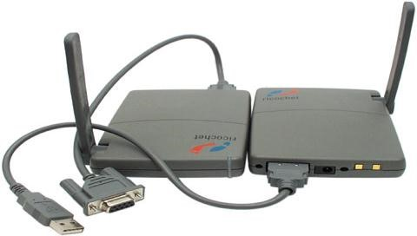

Another modem at the receiving end converts the analog signals back into digital signals (i.e demodulation) that can be understood by the receiving computer.

A modem can be external or internal.

**External Modem** is a standalone device that attaches to a serial port on a computer with a cable to a telephone outlet with a standard telephone cord.

**Internal Modem** is an expansion card that can be inserted into an expansion slot on a computers motherboard; and the modem then attaches to a telephone outlet with a standard telephone cord.

Most personal computers modems transmit data between 28.8kbps and 56kbps

Most modems today are also **fax modems** because they send computer prepared documents as faxes and also receive faxes.

#### 2. ISDN and DSL Modems

**ISDN** (Integrated Services Digital Network) is a set of standards for digital transmission of data over a standard telephone line. With ISDN, the same telephone line that could normally carry only one signal can now carry three or more signals at once using a technique called **Multiplexing.**

ISDN requires that both ends of the connection have an ISDN modem. ISDN lines also require a special ISDN telephone for voice communications.

##### Advantages of ISDN lines

* Provides faster transfer rates that dial-up Modems.
* Faster web page downloads and clearer video conferencing. - Produce very clear voice conversations.

**DSL (Digital Subscribe Lines**) provides high speed connections to the internet ove r a regular copper telephone line. The user must have a special network card or DSL modem to connect to digital subscriber line. It is much easier to install and can provide much faster data transfer rates than ISDN.

**ADSL (Asymmetric Digital Subscriber line**) is a type of DSL that supports faster transfer rates when receiving data (i.e **downstream rate**) than when sending data (i.e **upstream**). ASDL is ideal for internet access because most users download more information from the internet than they upload.

**3. CABLE MODEMS.**

A cable modem sends and receives data over the cable television (CATV) network. Cable modems can transmit data at speeds (500kbps to 2mbps) much faster than dial-up modems or ISDN. It can also be integrated with a set-to-box to provide faster viewing of multi-media websites.

#### 4. NETWORK INTERFACE CARDS

A network interface card (NIC) or LAN adapter is an expansion card that enable a computer or device to connect to a network. The Ethernet card is the most common type of network card. The transfer rate on Ethernet network can be 10mbps, 100mbps or 1,000mbps.

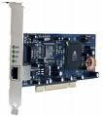

***Fig: Network interface card.***

### DEVICES USED TO INTERCONNECT NETWORKS

**5. MULIPLEXER**. A Multiplexer is a communication device that combines two or more input signals from various devices into a single stream of data and then transmits over a single transmission medium.

### N.B

***Transmission Media*** *consists of materials or techniques capable of carrying one or more signals. Transmission media can be physical or wireless.*

1. ***Physical transmission*** *media use wire, cable and other physical materials to send communication signals.*
2. ***Wireless transmission*** *media send communication signals through air or space using radio, microwave and infrared signals.*

A multiplexer increases the efficiency of communications and reduces the need for and the cost of using separate transmission media. Both the sending end and receiving ends need a multiplexer for data transmission to occur. At the sending end, a multiplexer combines separate data transmission into a single data stream and then compress the data and sends it over a communications channel. At the receiving end , the multiplexer separates the single stream of data into its original parts.

1. **AHUB.** A hub is also called a concentrator or multi-station access unit. It is a device that provides a central point for cables in a network. It allows devices to be connected to a server. 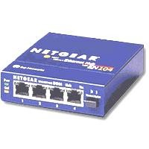
2. **A REPATER**. This is a device that accepts a signal from a transmission medium, amplifies it and retransmits it over a medium. As signals travel over a long distance, it undergoes a reduction in strength, an occurrence called **Attenuation**.

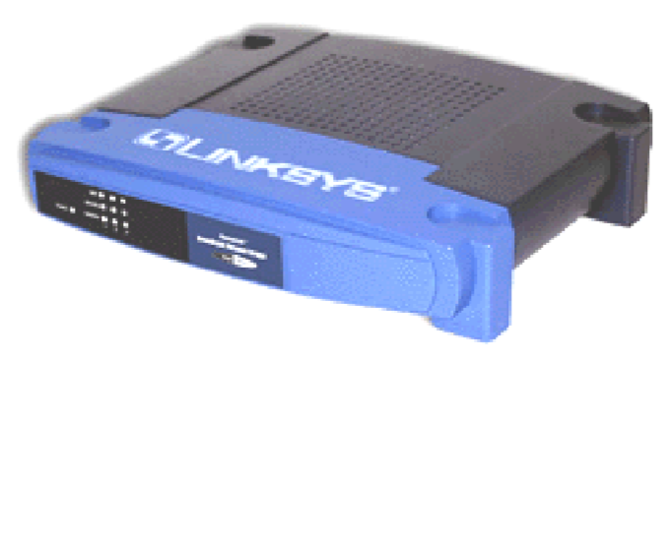

***Fig: A bridge***

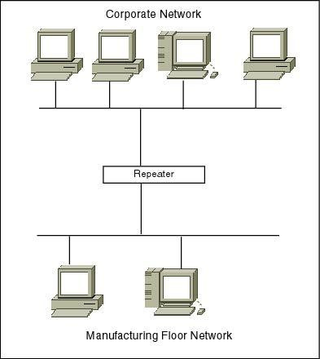

Repeaters are used in both copper wire cables carrying electrical signals and in fibre optics carrying light. Repeaters are also used extensively in broadcasting, where they are known as translators or booster.

1. **BRIDGE**. A bridge is a device that connects two LANS using the same protocol, such as the Ethernet. Bridges are uses to connect similar networks over a wide area communication links.

#### Advantages of bridges

* They are self configuring.
* Primitive bridges are often inexpensive.
* LANs interconnected are separate and physical constraints such as number of stations,

repeaters and segment length don‟t apply.

#### Disadvantages of bridges

* Bridges are more expensive than repeaters.
* Bridging of different MAC protocols introduces errors.
* Do not limit the scope of broadcasts.
* Because bridges do more than repeaters by viewing MAC address, the extra processing makes them slower than repeaters.

1. 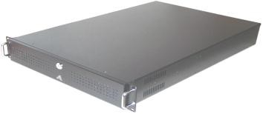**GATEWAY.** A gateway is a combination of hardware and software that connects networks that use different protocols.
2. **ROUTER**. A router is an intelligent communication device that sends 9routes) communication traffic to the appropriate network using the fastest available path.

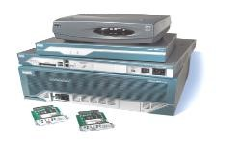

1. **SWITCH**. A switch is used to store address of every device down each cable connected to it. By delivering each message only to the connected device it was intended for, a network switch conserves network bandwidth and offers generally better performance than a hub. It is more intelligent. 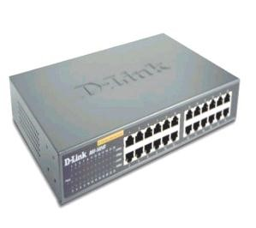

### COMMUNICATIONS PROTOCOL

A communications protocol is a set of rules and procedures for exchanging information among computers on a network. Protocols define how communications channel is established, how information is transmitted and how errors are detected and corrected.

Different kinds of computers can communicate with each other using the same protocol. Two widely used protocols for LANs are **Ethernet** and **Token ring**. The TCP/IP is a set of protocols widely used on the Internet.

**Ethernet** is a LAN protocol that allows personal computers to contend for access to the network. Ethernet was the first industry standard LAN protocol developed by Xerox in 1976.

#### Advantages of Ethernet

- It is relatively in expensive and easy to maintain and install. Some times it is more efficient and economical to use a bridge to connect two separate LANs instead of creating one large LAN that combines the two separate LANs.

#### COMMUNICATIONS CHANNELS

A Communications channel is the communications path between two devices. It is composed of one or more transmission media

The width of the communications channel is called **The Bandwidth**. The higher the bandwidth, the more data and information the channel can transmit.

For analog signals, bandwidth is expressed in hertz (Hz) or cycles per second. Foe digital signals, bandwidth is expressed in bits per second (bps)

#### FACTORS AFFECTING TRANSMISSION RATE OF A NETWORK

(a)**Transfer rate**. Is the speed of transmitting data and information. Transfer rates are usually expressed in bits per second (bps), kilobytes per second (kbps) or megabytes per second (mbps). The transfer rate of a transmission medium depends on the mediums bandwidth and its speed. The following contributes to the transfer rate of a network.

1. **Network topology**. Since data travels in both direction in a bus network, if data collides, then it as to be sent again, and slow the network down. On the other hand, start networks have fewer collisions and usually run faster
2. **Capacity of hardware**. Hubs, switches and network interface cards have their own maximum speeds.
3. **The server**. Amount of Ram and the speed of the hard disk.
4. **Location of software and files**. Storing software on the workstation hard disks reduce network traffic and speed up performance.

##### Transfer rates of various connection lines to the Internet

|  |  |
| --- | --- |
| **Types of lines** | **Transfer rates** |
| Dial up | Up to 56kbps |
| ISDN | Up to 128kbps |
| ADSL | 128kbps to 9mbps |
| Cable TV |  |
| T1 | 1.544mbps |
| T3 | 44mbps |
| ATM | 155mbps to 622mbps |

(a)**A dial up Line**. This is a temporary connection that uses one or more analog telephone lines for communication. Using a dial-up line to transmit data is similar to using the telephone to make a call.

##### Advantages of dial-up lines

* It cost no more than making a regular telephone call.
* Computers at any two locations can establish a connection using modems and the telephone network.

##### Disadvantages

- The user cannot control the quality of the connection because switching the telephone

company‟s switching office randomly selects the line for connection.

1. **ISDN (Integrated services Digital Network)** is a set of standards for digital transmission of data over standard copper telephone lines. It requires both ends of the connection to have an ISDN Modem.
2. **DSL (Digital subscriber lines**) provides high speed connections to the internet over a regular copper telephone line
3. **ADSL (Asymmetric Digital Subscriber line)** is a type of DSL that supports faster transfer rates when receiving data (i.e down stream rate) than when sending data (i.e upstream rate)
4. **Cable TV** network also provides high speed internet connections fro users equipped with cable modem.
5. **A T-carrierline** is a digital line that carries multiple signals over a single communication line using the multiplexing technique. T1 line can carry 24 separate signals at a transfer rate of 64kbps each for a transmission rate of 24mbps. A t3 can carry 672 individual signals at a transmission rate of 43mbps. **The internet backbone also use T-3 lines**

**Advantages**

▪T-carrier lines provide very fast transfer rates.

##### Disadvantages

▪T-carrier lines are so expensive that only medium to large companies can afford the investment.

(g)**ATM (Asynchronous Transfer mode**). This is a dedicated connection switching technology that organizes digital data into 53 bytes cell units and transmits them over a physical medium using digital signal technology.

#### TRANSFER RATE

This is the speed of transmitting data and information usually expressed in bits per second (bps) and kilobytes per second (kbps) or megabits per second (mbps)

**Transfer rates of various communications media.**

|  |  |  |
| --- | --- | --- |
| **Type of transmission media** | | **Transfer rate** |
| Twisted Pair cable | 10 Base-T (Ethernet) | 10mbps |
| 100 Base-T (Fast Ethernet) | 100mbps |
| 1000 Base-T (Gigabit Ethernet) | 1000mbps |
| Token ring | 4-16mbps |
| Coaxial | 10 Base 2 (Thin wire Ethernet) | 10mbps |
| Cable | 10 Base 5 (Thick wire Ethernet) | 10mbps |
| Fibre optic cable | 10 Base F (Ethernet) | 10mbps |
| 10 Base Fx (Fast Ethernet) | 100mbps |
| FDDI(Fibre Distributed Data Interface) | 100mbps |
| Broadcast radio | | Up to 2mbps |
| Micro wave | | 45 mbps |
| Communication satellites | | 50mbps |
| Cellular radio | | 9,600bps to 14.4kbps |
| Infrared | | 1-4mbps |

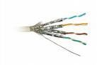

**1. TWISTED PAIR CABLE**. This consists of one or more twisted wires bundled together. Each twisted pair wire consists of two separate insulated copper wires of diameter o.4 – 0.8mm that are twisted together (to reduce noise). They are of two types.

*Fig: A twisted pair cable*

1. **Shielded twisted pair (STP)** has a metal wrapper around each twisted pair wire to further reduce noise. STP cables are used in environment susceptible to noise, such as local area network.
2. **Unshielded twisted pair (UTP)** cable doesn‟t have this metal wrapper for shielding noise. UTP cables are commonly used in telephone networks and data communication between computers because it is inexpensive and easy to install.

##### Advantages of twisted pair cable

* Data cannot be easily distorted due to reduced noise interface.
* Twisted pair wire is inexpensive.
* Easy to install.
* Used in transmission of data and voice

##### Disadvantages

* Susceptible to noise.
* Slows data transmission between devices.
* Limited to short distances.

**2. COAXIAL CABLE.** A coaxial is a high quality communication line that consists of a single copper wire conductor surrounded by atleast three layers;

* A non conducting insulating material
* A woven or braided metal outer conductor
* Plastic outer coating

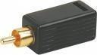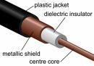

***Fig: Coaxial cables***

It is insulated more heavily than twisted-pair. It is not susceptible to electrical interferences and transmits data faster over longer distances. Cable TV wiring often uses coaxial cable because it can be cabled over long distances than twisted-pair cable.

##### Advantages of coaxial cables

* Can be cabled over long distances.
* Less susceptible to electric interference.
* Can transmit much more data at a time

##### Disadvantages

* More expensive than a twisted pair cable.
* Not easy to install
* Need boosters to transmit data.
* They are bulky

**3. FIBRE OPTIC CABLE**. This consists of dozens of hundreds of smooth thin strands of glass or plastic that use light to transmit signals. Each strand called an optical fibre is as thin as human hair. An insulating glass cladding and a protective coating surround each optic fibre. Each optic fibre can carry several hundred thousand-voice communications simultaneously. Fibre optic cables are used by many local and long distance telephone companies, cable Tv and in high traffic networks or as the main cable in the network.

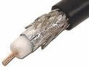

***Figure: Fibre optic cable***

##### Advantages of fibre optic cable

* Carry significantly more signals than wireless cables.
* Less susceptible to noise
* Better security for signals during transmission
* Smaller size and much thinner and lighter than wire cables.

##### Disadvantages

* Cost more than wire cables
* Difficult to install and modify.
* More fragile than other wire based communication channels.

**4. COMMUNICATION SATELITES**. These receive microwave signals from earth based communications facilities, amplify the signals and retransmit the signals back to the communications facilities. The earth based stations use large dish shaped antennas to transmit and receive data from satellites. The transmission to the satellites is called **uplink** and the transmission from the satellite is called a **down link**.

Communication satellites are usually placed about 22,300 miles above the earth‟s equator and moves at the same rate as the earth. 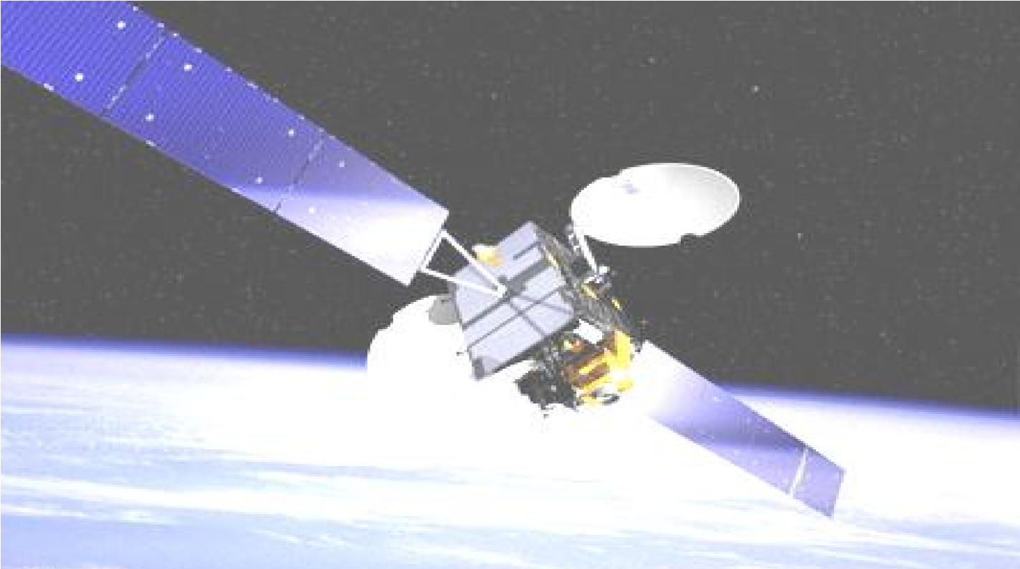

**Applications of communication satellite** ▪Television.

* Radio broadcast.
* Video conferencing.
* Paging and global positioning systems.

##### Advantages of Communications satellites

* Lots of data can be sent simultaneously
* Allow high quality broadband communication across continents. - Covers a large geographical area for data transmission.

-

##### Disadvantages of communication satellite

* The fee to launch a satellite is extremely expensive.
* The infrastructure needed to access satellite communications is also expensive.

**5. MICROWAVES.** These are radio waves that provide a high-speed transmission of both voice communications and data signals. Microwaves transmission involves sending signals from one earth based microwave station called **a terrestrial** microwave to another. It is fast (up to 4,500 times faster than a dial-up modem) but it limited to line of sight transmission, which means that the micro wave must transmit a straight line with no obstructions such as buildings between microwave antennas. To avoid obstructions, microwaves stations are often located on tops of buildings, towers or mountains to avoid possible obstructions.

##### Advantages of microwaves

* Provides high-speed communication transmission.
* No need to install cable.
* Lower installation and maintenance costs.

-

##### Disadvantages of microwaves

* Limited to line-of-sight transmission
* May be affected by temporary atmospheric disturbances

##### N.B

1. ***BASEBAND TRANSMISSION****. This transmits only one signal at a time.*
2. ***BROADBAND TRANSMISSION****. This can transmit multiple signals simultaneously. They transmit signals at a much faster speed. Two widespread applications of broadband transmission are;* -*Digital subscriber lines*

- *Cable television networks.*

1. ***SIMPLEX TRANSMISSION****. In simplex transmission, data flow in one direction from the sending device to the receiving device. It is used only when the sending device does not require a response from the receiving device.* Examples include:
   * *Security systems*
   * *Fire alarms*
   * *Temperature sensors that contain a sensor* ▪*Printing systems, pagers*.
2. ***HALF DUPLEX TRANSMISSION****. In half duplex transmission, data can flow in either direction, from the sending device to the receiving device and back but only in one direction at a time. Examples include:* 
   * *Fax machines*
   * *Radio calls*
   * *Credit card verification systems.*
   * *Automatic teller machines*
3. ***FULL DUPLEX TRANSMISSION.*** *In full duplex transmission, data can flow in both directions at the same time. A regular telephone line supports full duplex transmission so that both parties can talk at the same time. It is used for most interactive computer applications and for computer-to-computer data transmission i.e a regular telephone line.*

### A NET WORK

A network is a collection computers and devices connected together via communication devices and media. Communication devices enable two or more computers to exchange items such as data, instructions and information with each other.

The primary function of a communication device (e.g a modem) is to convert signals so that they become suitable for the communications channel or a receiving device.

A network can relatively small or extensively large.

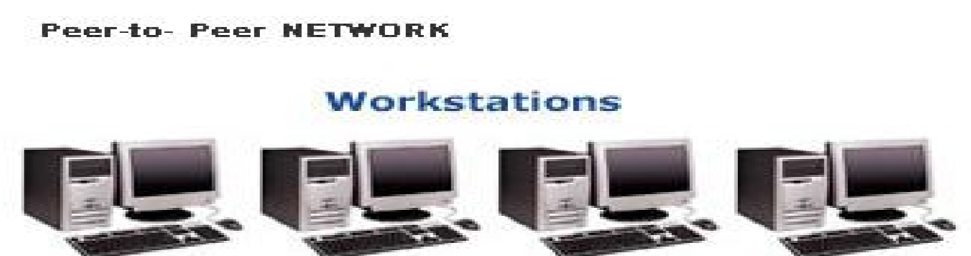

#### A LOCAL AREA NETWORK (LAN)

This is a network that connects computers in a limited geographical area such as a school computer laboratory, an office or a group of closely positioned buildings.

Each computer or a device on the network is called a node. The nodes are connected to the LAN via cables.

A wireless LAN is a local area network that uses no physical wires but wireless media such as radio waves.

A network operating system is the system software that organizes and coordinates the activities of a LAN.

**KINDS OF A LAN**

Two kinds of LAN are peer to peer and client/server network.

#### (a)PEER-TO-PEER NETWORK

* Each computer on a peer-to-peer network can share hardware, data or information located on any other computer on the network.
* Each computers stores files on its own storage devices.
* Each computer on the network contains both the network operating system and application software.
* A peer-to-peer network is a simple, inexpensive network that generally connects less than 10 computers together.
* Ideal for home and small business.

***Fig: Illustration of a peer-to-peer network***

##### Advantages of peer-to-peer network

* Less expensive to implement.
* Does not require additional specialized network administration software. - Does not require a dedicated network administrator.

##### Disadvantages

* Does not scale well to large networks and administration becomes unmanageable. - Each user must be trained to perform administrative tasks.
* Less secure.
* All machines sharing resources negatively impact the performance.

#### (b)CLIENT/SERVER NETWORK

A client/server network has one or more computers acting as a server while the other computers (i.e clients) on the network can request services from the server.

A client/server network typically provides an efficient means to connect 10 or more computers together.

Most client/server networks have a network administrator who is in charge of the network.

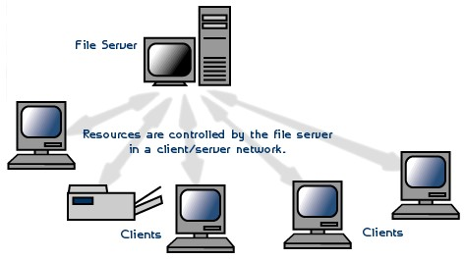

***Fig: Illustration of Client server network***

**Advantages of client/server network** - Provides for better security.

* Easier to administer when the network is large because administration is centralized. - All data can be backed up on one central location.

**Disadvantages**

* Requires expensive specialized network administrative and operational software.
* Requires expensive, more powerful hardware fro the server machine.
* Requires a professional administrator.
* Has a single point of failure, User data is un available if the server is down.

#### A WIDE AREA NETWORK (WAN)

This is a network that covers a large geographical area such as one that connects the district offices of an enterprise across the country or across several countries in the world.

**WANS are designed to:**

* Operate over a large geographical area
* Allow access over a serial interfaces operating at a slow speed.
* Provide full time and part-time connectivity.
* Connect devices separated over wide, even global areas.

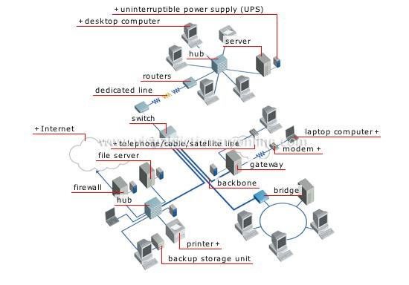

**INTERNET**

is the

world‟s largest WAN

.

**ADVANAT**

**A**

**GES OF USI**

**NG A NETWORK**

1. Facilitates communication because people can communicate efficiently and easily via e-mail, instant messaging, chat rooms, telephony and video conferencing.
2. Reduce costs by sharing hardware (e.g a printer) and software (e.g using a network version or site license of a program).
3. Sharing data and information stored on other computers on the network. (d)Allow tight control over who has access to what data.

##### DISADAVANTAGES OF USING A NETWORK

1. The hardware, software and expertise required to set up a network can be expensive.
2. Networks are vulnerable security problems.
3. If the server fails to work, the complete network may also fail to work.

##### COMPONENTS OF A LAN

Local area networks are made up of several standard components.

1. **Connecting or cabling system**. LANs do not use a telephone network, instead they use some other cabling or connection system either wired or wireless. Wired connection may be twisted pair wiring, coaxial or fibre optic cable. Wired connection may be infrared or radio wave transmission. Wireless network are especially useful if computers are portable and moved often. However, they are subject to interference.
2. **Microcomputers with interface cards**. Two or more computers are required along with network interface cards. A network card which is inserted into expansion slot in a micro computer enable the computer to send a nd receive messages on the LAN. Now days, newer computers come with network cards already embedded in the motherboard.
3. **Network operating systems**. The network operating system software manages the activity of the network. Depending on the type of a network, the operating system may be stored on a file server or on each microcomputer on the network. Examples of network operating systems include:
   * Novell‟s netware
   * Windows NT e.t.c
4. **Other shared devices**. Printers fax machine, scanners, storage devices and peripherals may be added to the network as necessary and shared by all users.
5. **Bridges and gateways**. A LAN many stand alone but it may also connect to other networks either similar or different in technology. Hardware and software devices are used as interfaces to make these connections.

**A Bridge** is an interface that enables similar networks to communicate.

**A gateway** is an interface that enables dissimilar networks to communicate such as a LAN with a WAN.

#### NETWORK TOPOLOGY

A network topology is the configuration or physical arrangement of the devices in a communications network. The commonly used network topologies are;

* + Bus
  + Ring
  + Star

(a)**BUS TOPOLOGY**. This is a network that consists of a single central cable that connects all computers and devices together. The physical cable that connects the computers and other devices is known as the **bus** or the backbone. Data, instructions and information in a bus can be transmitted in both directions.

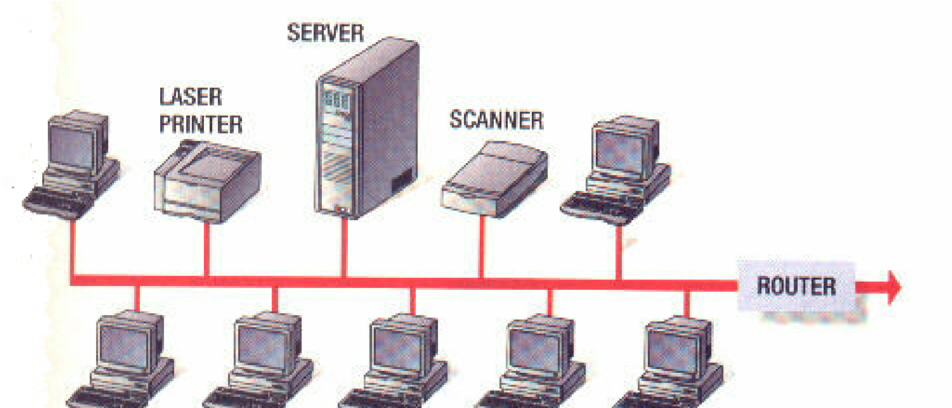

***Fig: Illustration of a bus topology***

**Advantages of a bus network** - Inexpensive and easy to install.

* Computers and devices can be attached and detached any point on the bus without disturbing the rest of the network.
* Failure one device usually does not affect the rest of the bus network. - Requires less cable length.

##### Disadvantages

* If the bus fails to work itself, the complete network remains inoperative.
* If many computers are attached, the amount of data flowing along the cable increases, data collision occur and the network slows down

(b)**RING TOPOLOGY**. This consists of a cable forming a closed ring or loop, with all the computers and devices in a network.

Data transmitted on a ring network travels from device to device around the entire ring in one direction only. If a device on a ring network fails, all devices before the failed device are unaffected but those after the failed device cannot function.

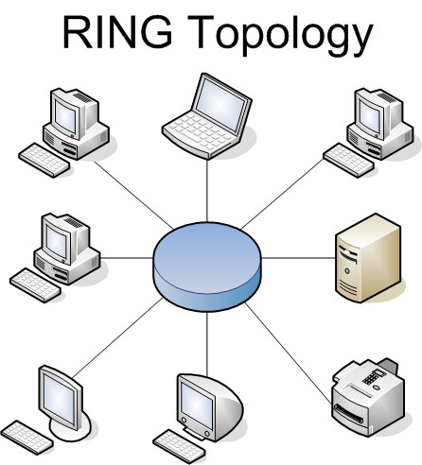

##### Advantages of ring topology

* Can span a larger distance than a bus.
* No collision occur (one direction only) so that the speed of data is high.

##### Disadvantages of ring topology

* If the cable fails, the whole network goes down.
* More difficult to install and troubleshoot the ring.
* Because all stations are wired together, to add a station, you must shut down the network temporarily.

(c)**STAR TOPOLOGY**. Star networks are one of the most common computer networks. In this all computers and devices connect to a central computer thus forming a star. The central computer that provides a connection point for devices in the network is called the **HUB** or **Switch**.

**Advantages of a Star network** - Easy to install and maintain.

* Computers and devices can be added to or removed from the network with little or no disruption to the network.
* It is reliable because each device connects directly to the hub. If one device fails, only that device is affected
* Good performance. Data packets are sent quickly as they do not have to travel through any unnecessary nodes.

##### Disadvantages of a star network

* If a hub fails, the entire network is inoperable.
* Lots of cable required so the installation cost is expensive. - If the central computer fails, the entire network fails.

Networks can use a combination of these topologies. Hybrid networks are a combination of star, ring and bus networks. They include:

* Extended star topology
* Hierarchical Topology
* Mesh topology

For example a small college campus might use a bus network to connect buildings and star and ring network with in certain buildings.

##### *N.B*

***FDDI (Fibre Distributed data Interface****) is a newer and higher speed network capable of transmitting 100megabits per second. A FDDI network uses fibre optic cable with an adaptation or ring topology. The FDDI network is being used for such high speed-tech purpose as electronic imaging, high-resolution graphics and digital video.*

**Considerations When Choosing a Topology:**

* **Money**. A linear bus network may be the least expensive way to install a network; you do not have to purchase concentrators.
* **Length of cable needed**. The linear bus network uses shorter lengths of cable.
* **Future growth**. With a star topology, expanding a network is easily done by adding another concentrator.
* **Cable type**. The most common cable in schools is unshielded twisted pair, which is most often used with star topologies.

##### FACTORS AFFECTING DATA TRANSMISSION

1. **Transmission rate**; **higher frequency, wider bandwidth, more data.**

**Higher frequency, wider bandwidth, more data**. The amount of data that can be transmitted on a channel depends on the wave frequency-cycle of waves per second. Frequency is expressed in hertz. As mentioned earlier, bandwidth is the difference between highest and lowest frequencies. Data may be sent not just on one frequency but on several frequencies within a particular bandwidth. The more frequencies it has , the more data that can be send through that channel.

1. **Line configuration**: **Point to point and multipoint.** There are two ways of connecting communication lines;

**Point to point** directly connects the sending and receiving devices such as a terminal with a central computer. This arrangement is appropriate for private line whose sole purpose is to keep data secure while transmitting it from one device to another.

**A multipoint** line is a single line that interconnects several communication devices to one computer. Often a multipoint line, only one communication device, such as a terminal, can transmit at any given time.

1. **Serial and parallel transmission**. Data is transmitted in two ways; serially and in parallel.

In serial data transmission, bits are transmitted sequentially, one after another. Serial transmission in the way most data flows over a twisted-pair telephone line. It is found in communication lines, Modems and mice.

In parallel data transmission, bits are transmitted through separate lines simultaneously. The arrangement resembles cars moving in separate lanes at the same speed on a multilane freeway. Parallel lines move faster than serial lines do e.g to transmit data from a computer‟s CPU to a printer.

###### (d)Direction of transmission flows; Simplex, half duplex and full duplex

In simplex, data can travel in only one direction e.g traditional TV antenna. There is no return signal.

In half duplex, data travels in both directions but only in one direction at a time. It is seen with police and marine radios in which both parties must take turns talking. It is also a common transmission method with computers.

In full duplex, data is transmitted back and forth at the same time. An example is two people on a telephone talking and listening simultaneously. Full duplex is used frequently between computers in communication system.

###### (e)Transmission mode; asynchronous versus synchronous

**(f)Packet switching: getting more data on the network.**

A packet is fixed-length block of data for transmission. The packet also contains instructions about destination of the packet. Packet switching is a technique for dividing electronic messages into packets for transmission over a network to their destination through the most expedient route. The benefit of packet switching is that it can handle high volume of traffic in a network. It also allows more users to share a network.

###### (g)Protocols; the rules of data communication

A protocol or a communication protocol is a set of conventions governing the exchange of data between hardware and or software components in a communications network. The protocol in your communications software will specify how receiving devices will acknowledge sending devices a matter called **handshaking.** Protocols will also specify the type of electrical connections used, the timing of message exchange, error-detection technique and so on.

#### COMMUNICATIONS PROTOCOL

A Communications protocol is a set of rules and procedures for exchanging information among computers on a network.

Protocols define how the communication channel is established, how information is transmitted and how errors are detected and corrected. The width of the communications channel is called **Bandwidth**. The higher the bandwidth, the more data and information the channel can transmit.

Different kinds of computers can communicate with each other using the same protocol.

***N.B: Without protocols, communication wouldn’t have been possible***

##### PROTOCOLS USED IN COMMUNICATION

1. **TCP (Transmission control Protocol).** TCP manages the transmission of data by breaking it into packets. It then provides routing information for sending the packets along the fastest available path to the recipient‟s computer and then reassembles the data at the receiving end.
2. **Ethernet**. Ethernet is a LAN that allows computers to contend for access to the network. It uses a coaxial cable that carries radio frequency signals between computers at a rate of 10megabytes per second.
3. **Token ring**. Token ring is a computer LAN arbitration scheme in which conflicts inn transmission of messages are avoided by granting of tokens, which give permission to send data to other computers.
4. **IP (Internet Protocol).** Internet protocol is a method by which data is transmitted from one computer to another over the internet. It employs the use of a four part numerical address which every computer has to send information e.g 326.478.570.888
5. **HTTP (Hyper Text Transfer Protocol).** HTTP is used for information exchange on the World Wide Web (WWW). It defines how messages are requested, formatted and transmitted over the Internet and what actions an HTTP server (browser) should take response on various messages.
6. **FTP (File transfer protocol).** File transfer protocol is a communication protocol that sends data and files and folders over the Internet.
7. **TELNET**. Telnet provides a fairly general bi-directional 8 bit oriented communication facility. Its primary goal is to allow a standard method of interfacing terminal devices to each other.
8. **IPX (Inter-network Packet Exchange).** IPX is a networking protocol that interconnects networks that

use Novell‟s network clients and servers.

1. **SPX (Sequenced Packet Exchange).** SPX is the protocol for handling packet sequencing in Novell Netware network. It prepares the sequence of packets that the message is divided into and manages the reassembling or received packets.
2. ATM (Asynchronous Transfer Mode). ATM is a dedicated connection switching technology that organises digital data into 53 bytes cell units and transmits them over a physical medium using digital signal technology.

##### NETWORK OPERATING SYSTEMS

A Network operating system is the system software that organizes and coordinates the activities on a local area network.

**Tasks performed by an Network Operating system** - Administration of system users.

* System maintenance tasks such as back up.
* File management tasks.
* Prioritising print jobs on the network.
* Monitoring security on network resources.

###### Operating systems that supports the Network

|  |  |  |
| --- | --- | --- |
| **Operating system** | **Requires separate OS** | **Network type** |
| IBM OS/2 Wrap | - | Client/server |
| Linux | - | Client/server |
| Microsoft Windows NT, 98,ME | - | Peer-to-peer / Client/server |
| Novell Netware | Dos | Client/server |
| Sparta Com LAN Tastic | Any Pc OS | Peer-to-peer |
| Sun Solaris | - | Client/server |
| Unix | - | Client/server |

##### COMMUNICATIONS SOFTWARE

This consists of programs that help to establish a connection to another computer or network, and manage the transmission of data, instruction and information between computers and other devices.

Communication software usually includes one or more of the following features.

1. **Dialing feature** that allows a user to store, review, select and dial telephone numbers to connect to another computer.
2. **File transfer feature** that allows a user to store, review, select and dial telephone numbers to connect to another computer.
3. **Terminal emulation feature** that allows a personal computer to act as a specific type of terminal so that the user can connect to and access data and resources on a mini computer or mainframe.
4. **Internet access feature** that allows a user to use the computer to connect to the internet to send e-mail, participate in chat rooms, visit world wide web sites and so on.

**Software related to communications include:**

* + E-mail
  + Web browser
  + Chat room software
  + News recorder
  + Instant messenger
  + Groupware
  + Video conferencing software

1. **E-mail** or electronic mail is the transmission of messages via a computer network such as a local area network or the Internet. The message can be simple text or can include an attachment such as a word processing document, a graphical image, an audio clip or a video clip. **E-mail software** creates, sends, receives, forwards, stores, prints and deletes e-mail addresses.
2. **Web browser** allows users to access and view web pages on the Internet. Most web browsers allow the use of other internet services such as e-mail and chat rooms. Two popular web browsers are Microsoft Internet explore and Netscape navigator.
3. **A chat room** is a location on an internet server that permits users to chat with each other by typing lines of text on the computer. Some chat rooms support video and video chats.
4. **A newsgroup** also called a discussion is an on line area where users conduct written discussions about a particular subject. To participate in a discussion, a user sends a message to the newsgroups and other users in the newsgroup read and reply the message. **A news reader program** is required to participate in a newsgroup, and most web browsers include a newsreader.
5. **Instant messaging** is a real time communication service that notifies a user when one or more people are on line and then allows the user to exchange messages of files with them.
6. **Groupware** is a software application that helps groups of people work together and share information over a network.
7. **A Videoconference** is a meeting between two or more geographically separated people who use a network or the Internet to transmit audio and video data. A videoconference conducted over the Internet using web browsers and web servers to deliver the service is called a **Web Conference**.

##### THE TELEPHONE NETWORK

The public switched telephone network (PSTN) is the worldwide telephone system that handles voice-oriented telephone calls. The telephone network is originally built to handle voice communications. However, it is also an integral part of the computer communication today.

Data, instructions and information can be sent over the telephone network using dial-up lines or dedicated lines.

**A dial-up line** is a temporary connection that uses one or more analog telephone lines for communications. Using a dial-up line to transmit data is similar to using a telephone to make a call.

###### Advantages of a dial-up line

* It costs no more than making a regular telephone call.
* Computers at any two locations can establish a connection using modems and the telephone network.

###### Disadvantages

-The user cannot control the quality of the connection because the telephone company‟s switching office randomly selects the line for connection.

**A dedicated line** is a permanent connection between two communication devices. **Advantages**

-The quality and consistency of the connection is better than a dial-up line because dedicated lines provide a constant connection.

**A leased line** is dedicated line leased from a telephone or communications service company.

###### Popular types of dedicated lines are;

* ISDN lines
* Digital Subscriber Lines
* Cable TV lines
* T-carrier lines
* ATM

###### Advantages of a telephone

* Immediate contact is available.
* Tone of voice helps communications

###### Disadvantages of a telephone

* It may take a long time to get some one on the phone.
* A call is successful only when the person to contact is present. - Time zone problems between different countries.

#### USES OF DATA COMMUNICATION

Uses of data communication include;

1. **VOICE MAIL**. Voice mail functions like answering machine and allows a caller to leave a voice message, which is stored in a voice mailbox for the called party. A called party can listen to the message, add comments to the message and reply or forward a message to another voice mailbox in the mail system.
2. **FAX**. A facsimile (fax) machine is a device that transmits and receives documents over telephone lines. Documents sent or received with a fax machine are known as **Faxes**. Fax capability can also be added to the computer using a fax modem.
3. **E-MAIL**. E-mail or electronic mail is the transmission of messages via a computer network such as a local area network or the Internet. E-mail software creates, sends, receives, forwards, stores, prints and deletes email

##### Popular E-mail software

* Microsoft outlook express
* Endora

**An e-mail address**. This is a combination of a user name and a domain name that identifies one specific user who sends or receives e-mail.

**A user name or User ID**. Is a unique combination of characters that identifies one specific user e.g for the email address katumbarich@yahoo.com katumbarich is a user name, and yahoo.com is the domain name.

Most e-mail programs allow users to create an address book which contains a list of names and e-mail addresses. Most ISP‟s provide their users with mail box which stores their e-mails on a special server called a mail server.

When an e-mail arrives at the recipient‟s mail server, the e-mail transfer to a POP or POP3 server until the recipient retrieves it with his or her e-mail software.

**A domain name**: (e.g [www.nkpublishinghouse.com)](http://www.nkpublishinghouse.com/) is the text version of an IP address e.g (**216.200.47.93**). The components of a domain name are also separated by periods.

Every domain name contains a top level domain (TLD) abbreviation that identifies the type of organization that is associated with the domain.

|  |  |  |  |
| --- | --- | --- | --- |
| **TLD Abbreviations** | **Type of Domain** |  |  |
| com | Commercial organizations, companies | business | and |
| org | Non-profit organization |  |  |
| net | Network providers |  |  |
| edu | Educational institutions |  |  |
| gov | Government agencies |  |  |
| mil | Military organisations |  |  |

The **Internet Corporation for assigned names and Numbers** (ICANN) is responsible for assigning and controlling TLDs

For international websites outside the United States, the domain name also includes the country code.

|  |  |
| --- | --- |
| **Country code** | **Country name** |
| hk | Hong Kong |
| cn | China |
| tw | Taiwan |
| uk | United Kingdom |
| au | Australia |
| jp | Japan |
| ug | Uganda |
| ke | Kenya |

The **Domain name system (DNS**) is the system on the internet that stores the domain names and their corresponding IP addresses.

The DNS server translates the domain name into its associated IP address, so that data can route to the correct computer.

##### TERMS IN RELATION TO E-MAIL

1. **Subject**: The name of the e-mail message.
2. **To**: carries the address of the recipient.
3. **cc**: Enables copies of the E-mail message to be sent to the third party while acknowledging other recipients.
4. **Bcc:** Enables copies of the e-mail message to be sent to the third party without acknowledging any other recipients (if present)

##### ADVANTAGES OF E-MAIL OVER ORDINARY MAIL

E-mail has many advantages over both ordinary mail and the telephone for example;

1. A message can be sent anywhere in the world at the price of a call without having to leave your desk.
2. Speed of delivery. The message will arrive in few minutes and can be picked up the next time recipient looks at their e-mail.
3. Ability to send multiple recipients. The message can be sent simultaneously to a group of people.
4. It is easy to send a reply to an e-mail as soon as it is received using a „reply‟ button. (e)Large files such as spread sheets and graphics can be sent as attachments.
5. An e-mail address is universal and ordinary mail, one has to change addresses wherever he or she is located.
6. Assurance of whether the mail has been sent.
7. No use of stamps.
8. Convenient when retrieving and delivering.
9. **BBS**. A bulletin board system (BBS) is a computer that maintains a centralized collection of electronic messages. The use of a BBS is declining because the Internet can be used to access many of the same services.
10. **GroupWare.** This is a software application that helps groups of people work together and share information over a network. Groupware enables members of the workgroup to communicate, manage projects, schedule meetings and make group discussions.
11. **Telecommunicating**. Telecommunicating is a work arrangement so that employees may work away from the standard workplace of a company, but communicate with the office using some kinds of communication technology.

###### Advantages of telecommunicating

* Reduces the time and expenses fro traveling to and from work.
* Allow a flexible work schedule for employees.
* Provide a convenient, comfortable work environment for disables employees or those recovering from injuries or illness.
* Reduces air pollution caused by vehicles driven to and from work.
* Employees reduce costs due to less office space and furniture is required.

###### Disadvantages

* Reduces human face-to-face interaction among working staff.
* Data security may be jeopardized.
* Work has to stop if any component of the communications system fails to work. - Leisure time at home may be replaced by work.

**6. Global Positioning system**. A Global positioning system (GPS) consists of one or more earth-based receivers that accept and analyse signals sent by satellites in order to determine the receiver‟s geographical location.

###### Uses of GPS

* To locate a person or an object.
* Ascertain the best route between two points.
* Monitor the movement of a person or object. - Create a map.

Many cars and ships also use GPS to provide directions to a destination and weather information.

**I N T E R N E T**

The internet is a world wide collection of networks linked together. The internet is a largest wide area network in the world.

The internet has its roots in networking project called the **ARPANE**T that became functional in 1969 started by the **Pentagon’s Advanced Research Agency** (ARPA)

The goal of the project was to build a network that;

1. Allowed scientists at different locations to share information and work together on military and scientific projects and
2. Could function even if part of the network were disabled or destroyed by a disaster such as a nuclear attack.

The ARPANET became functional in September 1969, linking Scientific and academic researcher in the United States.

In 1986, the National Science Foundation (NSF) connected its huge network of five supercomputer centers called NSFnet to the ARPANET and this configuration of complex networks and hosts became known as the Internet.

The NSFnet served as the major backbone on the internet until 1995 and then returned its status to a research network.

Today a variety of corporations provide networks to handle the internet traffic. These networks along with telephone companies, cable and satellite companies and the governments, all contribute towards the internal structure of internet.

The internet remains a public cooperative and independent network. However, the **World Wide Web Consortium (W3C)** is a group that overseas research and sets standards and guidelines for many areas on the internet.

People have different reasons for connecting to the internet and most of them connect to the internet through an Internet Service Provider.

##### FUNCTIONS OF THE INTERNET

1. **Communicate and collaborate.** The exchange of electronic messages with business associates and friends (sending and receiving electronic mail messages), transmit documents and data and participate in electronic conference e.g via yahoo messenger.
2. **Access information**. With the internet, you can browse a lot of information through website search e.g www.google.ug. A variety of information regarding academics, sports and entertainments is available on the internet.
3. **Downloading programs**. With the use of internet, you can download various programs and files to your personal disk from other computers elsewhere in the world.
4. **Participate in discussion**. You can conduct voice transmission and join discussions with people and friends from all over the world.
5. **Supply information**. This involves the transfer of computer files, programs, animations, graphics, sound, video to other computers via the internet.
6. **Find entertainments**. A variety of interactive video games, short video clips, sound and music clips are all available on the internet.
7. Reading news and listening to broadcasts e.g from BBC, Monitor ,Bukedde among others. (h)General information about a subject.

(i)Do research and take online courses

###### CONNECTING TO THE INTERNET

There are **three** requirements

* An access device e.g a personal computer with a modem.
* A physical connection e.g a telephone line.
* An internet service provider (ISP) The ISP offers options in three categories;
  + Use of a telephone line
  + Use of a server
  + Use of a protocol

#### AN INTERNET SERVICE PROVIDER

An internet service provider (ISP) is a company that supplies connections to the internet usually for a monthly fee. Users may connect to their ISP through a LAN or through dial-up-access. A dial-up access is a slow speed technology.

##### FACTORS CONSIDERED WHEN CHOOSING AN INTERNET SERVICE PROVIDER

1. **Services offered**. When choosing an ISP, one should ensure that the ISP supports the services you want to access on the internet. Some ISPs do not supports all services available on the internet.
2. **Costs for internet access**. It is important to ask the ISP for the detailed fee structure. Some ISPs charge depending on the services accessed, amount of time spend on the internet, standard fee per a given period say a month e.t.c… Most ISPs offer a flat rate fee for a certain number of hours.
3. **Type of communication offered**. This refers to the modes by which your computer connects to the ISP for the internet access. Some ISPs offer some of the methods an not others. Find out whether the mode of connection you are interested in is supported by the ISP.
4. **Technical support**. It is good to know how much (if nay) support you can expect from the ISP. Find out whether it is free or charged, whether it is available on phone and for how long. Some local ISPs send a service technician to your house when you have a problem installing software, dialing into their systems e.t.c…
5. **Security.** Security is very important to protect your activities on your system. I you do not want some one to access your e-mail box, ask for the ISP how they manage security and whether they support any kind of encryption, firewalls, virus guards e.t.c….
6. **Software**. If you are using an online service provider, you may need special software to access their systems. Although this software is free, you need to learn them. Some systems don‟t work well with common application packages. Check with the ISP and find out whether your applications work.

##### EXAMPLES OF ISPs

* Infocom
* Utl
* Mtn
* Celtel

-

The internet use an IP address system to send data to a computer at a specific destination.

**An IP (Internet Protocol) address** is a number that uniquely identifies each computer or device connected to the internet. Each IP address consists of four groups of umbers, each separated by a period (e.**g 216.200.47.93**)

The number in each group is between 255. In general, the first portion of each IP address identifies the network and the last portion identifies the specific computer.

##### A DOMAIN NAME

This is the text version of an IP address, which makes all the numeric IP address easier to remember and use.

A domain name name e.g [www.nkpublishing](http://www.nkpublishing/)house.com) is a text version of an IP address (e.**g**

**216.200.47.93)**

***N.B*** *The world wide web is one of the most popular services on the internet.*

#### INTRANET

Intranet is a small version of the internet used with in an organization. Intranet uses TCP/IP protocols, supports multimedia web pages and is accessible via a web browser. Intranet generally makes company information accessible to employees and facilitates working in groups.

An intranet that extends to authorize users outside the company is called an **Extranet.**

To prevent an authorized access to data and information, an internet or extranet is often protected by a Firewall. **A Firewall** is a general term that refers to both hardware and software used to restrict access to data and information on a network.

##### A HOME NETWORK

A home network connects all computers and devices together at home or in a home office. Common types of networks are;

* + Ethernet network
  + Home PLC
  + Phone line network
  + Home RF network

1. **Ethernet**. This is a LAN protocol that allows personal computers to contend for access to the network.
2. **A home PLC (Power line cable)** This is the network that uses the same lines that bring electricity and power into the house. The advantage is that, it requires no additional wiring because data simply transmits through existing power lines in the house.
3. **A phone line network**. This a network that uses existing telephone lines in a house. The phone line network does not interfere with voice and data transmissions on the telephone lines (i.e the ser can talk on the telephone and use the same line to connect to the internet.
4. **A home RF (Radio frequency) network**. This uses radio waves, rather than cables to transmit data.

###### Advantages of a home network

* All computers in the house can be connected to the internet at the same time.
* Each computer can access files and programs on the computers in the house. - All computers can share peripherals such as scanner or a printer.

##### UNDESIRBALE BEHAVIOURS INVOLVING THE INTERNET

* Spam (Containing un solicited messages) - Pirating (Illegal access to other users messages) - Watching immoral websites.
* Illicit material.
* Abusive and threatening messages.
* Hacking and cracking.
* Impersonation.

### THE WORLD WIDE WEB

The World Wide Web (WWW) also called the web consists of a worldwide collection of electronic documents. Each of these documents on the web is called a **Web Page.**

A web page can contain text, graphics, animations, audio (i.e. multi-media elements), as well as built-in connections called hyper links to other documents.

**A HYPERLINK** also called a link is a built-in connection to another related web page or part of a web page. A link can be a word, a phrase or an image. The shape of the pointer usually changes to a small hand with a pointing index finger when it is pointed on a link.

**A HOME PAGE.**  Is a starting page or a table of contents for a website and normally has a name called index.htm or index html.

**A WEBSITE**. This is a collection of related web pages.

(TYPES OF WEB SITES)

Affiliate

Affiliate agency

Achieve site

Attack site

Blog (web log)

Bland building site

Celebrity web site

Click to donate site

Community site

**A WEB BROWSER**. This is a software program used to access and view web pages. Examples of web browsers include;

* Internet explore
* Netscape navigator
* Mozilla fire fox

➢Konquerer

Google chrome

Arora

Dillo

Lynx

Amanya

Kazekhase

Netpostive

Flock

Avant

Lobo

K meleon

Safari

Opera

Lunar scape

Planet web

QNX voyager

Today‟s browsers also support push technology in which web based content is downloaded automatically to the computer at regular intervals or whenever the site is updated.

Each web page has a unique address called **Uniform Resource Locator (URL)** which tells the browser where to locate the document.

**A WEB SERVER**. This is a computer that delivers web pages requested by users. Multiple websites can be stored on the same web server.

**A WEB MASTER**. This is the individual for developing web pages and maintaining a website.

**SURFING THE WEB**. This is the activity of jumping from one web page to another.

#### THE UNIFORM RESOURCE LOCATOR (URL)

This is the unique address of a web page which tells the browser where to locate the document. The URL tells the browser where to locate the web page.

A URL consists of a protocol, a domain name and some times the path to a specific web page or location on the web page.

|  |  |
| --- | --- |
| **URL**: | http://www.nkpublishinghouse.com/internet/data |
| **Protocol**: | http |
| **Domain name**: | www.nkpublishinghouse.com |
| **Path**: | internet/data |

***N.B: http*** *stands for hyper text transfer Protocol, which is a standard that enables pages to transfer on the web.*

**WEB PUBLISHING**. This is the development and maintenance of web pages. The five steps to web publishing are;

* planning a website
* analyzing and designing a website
* creating a website
* deploying a website

#### A SEARCH ENGINE

A Search engine is a software program that can be used to find websites, web pages and files on the internet. To find a website, a user just enters a word or a phrase called the keywords or search text.

**The URLs of several Internet search engines are listed below.**

|  |  |
| --- | --- |
| **Search engine** | **URL** |
| Excite | [www.excite.com](http://www.excite.com/) |
| Google | [www.google.com](http://www.google.com/) |
| Hotbot | [www.hotbot.com](http://www.hotbot.com/) |
| Lycos | [www.lycos.com](http://www.lycos.com/) |
| Yahoo | [www.yahoo.com](http://www.yahoo.com/) |
| WebCrawler | [www.webcrawler.com](http://www.webcrawler.com/) |

**MULTIMEDIA**. This refers to using computers to integrate text, graphics, animation, audio and video into one application. A web page contains text graphic, animations. Audio and video (i.e multimedia elements) as well as built in connections called hyperlinks to other documents.

**A GRAPHIC**. This is a digital representation of information such as drawing, a chart or photgraph. Graphics were the first media to enhance the originally text based internet. Common graphical formats on the web are JPEG and GIF.

##### *N.B*

1. ***GIF stands for Graphics Interchange Format*** *which uses compression techniques to reduce file size.*
2. ***JPEG stands for Joint Photographic Experts*** *group which is a graphical image using compression techniques to reduce the file size. It often used for scanned photographs, artwork and other images that include smooth transition of colours.*

**ANIMATION**. Is the appearance of motion that is created by displaying a series of still images in rapid sequence.

**STREAMING.** This is the process of transferring data in a continuous and even flow, which allows users to access and use a file before it has been transmitted completely. An electronic music instrument such as a keyboard, synthesizer or drum machine is connected to a computer. The frequency or a pitch and other musical data received is converted to digital data that can be read and stored by the computer. The computer can in turn send signals back to the electronic music instrument.

Some websites use streaming Audio on the web which allows a user to listen to the sound as it downloads to the computer. Two accepted standards for streaming audio on the web are;

* + Windows media player
  + Real audio

***N.B****:* ***MPEG*** *is a popular video compression standard defined by the moving picture Experts group (MPEG)*

##### ELECTRONIC COMMERCE

Electronic commerce (E-commerce) is a financial business transaction that occurs over an electronic network such as the internet. Online shopping and banking are two popular types of E-commerce that uses either electronic money (e-money) or electronic data interchange (EDI)

**Electronic Money**. This is a means of paying for goods and services over the internet.

**EDI** (**Electronic data Interchange**) is a set of standards that control the transfer of business data and information among computers both with in and among companies.

E-commerce business can be grouped into three basic models:

1. **Business-to-consumer (B2C)** e-commerce consists of the sale of goods to the general public.
2. **Consumer to consumer (C2C)** e-commerce occurs when one consumer sells directly to another, such as in an online auction.
3. **Business to Business (B2B**) e-commerce consists of businesses providing goods and services to another r business.

##### ADVANTAGES OF E-COMMERCE

* Transactions can occur instantly and globally, thus save time for participants on both ends.
* Transactions can occur 24 hours per day.
* Businesses have access to millions of people over internet connects.
* Businesses have the ability to gather customer information, analyse it and react if appropriate.
* Information can be exchanged and be available quickly.
* Distribution costs for information is reduced or eliminated.
* Manufacturers can buy and sell directly avoiding the cost of middleman.
* Feedback can be immediate.
* Customers can compare prices easily.

##### COMPUTER BASED TRAINING

This allows students to learn and complete exercises with instructional software. CBT is also known as computer aided instruction (CAI). Related concepts include computer aided learning and computer aided assessment.

Interactive CBT training software, often called courseware is usually available on CD ROM, DVD-ROM or shared over a network.

##### ADVANTAGES OF COMPUTER BASED TRAINING

* Students can learn at any time and anywhere provided a computer system is available. - Students can receive instant feed back for their actions.
* Students can learn at their own pace.
* Materials provided by WBT can always be up-to-date.

###### Advantages of distance learning

* Save time and money for traveling to school.
* Students can learn and complete their coursework at home and at any time that fits their schedules.

### SOCIAL IMPACTS OF COMPUTERS AND INFORMATION TECHNOLOGY

#### COMPUTER SECURITY RISKS

A computer security risk is any event or action that could cause a loss or damage to computer hardware, software, data or information. Some breeches to computer security are accidental, but some are planned. Some of the more common computer security risks include;

* Computer virus
* An authorized access and use of computer systems.
* Hardware theft and software theft. ▪Information theft and information privacy ▪System failure.

#### COMPUTER VIRUSES

A computer virus is a program that copies itself onto other programs and spreads through multiple computers. Viruses are often designed to affect or infect a computer negatively by altering the way it normally works without the knowledge or permission of the owner.

##### TYPES OF VIRUES

1. **Boot sector virus**. This executes when a computer starts up because it resides in the boot sector of a floppy disc or the master boot record of a hard disk.
2. **File virus**. This attaches itself to program files, and is loaded into memory when the program is run.
3. **Macro virus**. This uses the macro language of an application (e.g word processor or spread sheet) to hide the virus code.
4. **A logic bomb**. This is a virus that activates when it detects a certain condition.
5. **A time bomb**. This is a kind of logic bomb that activates on a particular date.
6. **A worm**. This copies itself repeatedly in memory or on a disk drive until no disk space remains, which makes the computer stops working.
7. **A Trojan horse.** This is a program that hides within or looks like a legitimate program but executes when a certain condition or action is triggered.
8. **A polymorphic virus**. This modifies its program each time it attaches itself to another program or file, so that even an antivirus utility has difficult in detecting it.

**RISKS POSSED BY VIRUSES**

The range of threats posed by viruses can be broadly classified into:

##### (a)DESTRUCTIVE VIRUSES

|  |  |
| --- | --- |
| Massive destruction | Attacks the formats of disks whereby any program or damage will be unrecoverable. |
| Partial destruction | Erase and modification of a specific portion of a disk affecting any files stored in that location |
| Selective destruction | Erase and modification of specific files or file groups. |
| Random destruction | Randomly changing data on data or in memory during normal program execution or changing key stroke values or data from input/output. |
| Network saturation | Systematically using up memory or space to impede performance or cause the system to crash |

(b)**NON DESTRUCTIVE VIRUSES**.

These viruses do not cause any destruction but are annoying. They usually display messages, change display colours, change key stroke values (e,g changing the effect of shift keys and delete characters displayed.

##### VIRUS SYMPTOMS

The presence of a virus can be indicated if one or more of the following symptoms appear on your computer. Any evidence of these or similar events should be an immediate cause for concern to isolate the PC at once and investigate.

* Unfamiliar graphics or quizzical messages appearing on screens.
* Programs taking longer than usual to load.
* Disk access seeming excessive for simple tasks.
* Less memory available than unusual.
* Access lights turning on for non referred devices.

The spread of computer viruses is accelerated by the increased use of networks, internet and e-mail. Viruses are activated in three basic ways:

* + Opening an infected file.
  + Running an infected file.
  + Starting a computer with an infected floppy disk.

##### SOURCES OF VIRUSES

**Research has shown that viruses can be introduced into computer systems from a variety of sources. Some of the most common sources are;**

1. **Contact with contaminated systems**. Any diskettes used on a contaminated system could become a contaminated. If the same diskettes are used on another system, then the virus will spread.
2. **Pirated software**. The use of pirated software introduces the risk that the software may be contaminated by virus code or mended to perform some other destructive function which may affect your system.
3. **Fake games**. Many people like playing games on computers and for the same reason, games programs spread very fast. These games keep infecting the systems as they installed. It can take less than 2 hours for a game to spread to Australia, South America and Europe.
4. **Freeware and shareware**. Both freeware and shareware programs are commonly available from Bulletin Board systems (BBS). Such programs should be treated with care.
5. **Updates of software distributed via networks**. Software distributed via networks is fairly obvious targets for virus programmers as they provide a built in method for widespread and anonymous.

##### PRECAUTIONS TO PREVENT VIRUS INFECTION

* Install an antivirus utility and update its virus definitions frequently for detecting and removing viruses.
* Never start up a computer with a floppy disk I the drive.
* Ensure that the e-mail is from a trusted source before opening or executing any e-mail attachment.
* Scan all floppy disks and file for possible virus infections before opening them. ➢Back up data on a regular basis to avoid massive data loss.

##### AN ANTIVIRUS UTILITY

This a program that prevents, detects and removes viruses from a computer‟s memory or storage devices, one popular antivirus program is Norton Antivirus. Others include;

* Mcfee
* F secure
* Avira
* AVG
* Avast e.t.c ..

An antivirus utility scans for programs that attempt to modify the boot program, the operating system and other programs that are normally read from but not modified. It normally look for virus signatures to identify a virus.

**A Virus signature** or virus definition is a known specific pattern of virus code.

***N.B: A BACKUP.*** *This is a duplicate of a file, program or disk that can be used if the original is lost, damaged or destroyed. Backed files should be kept in a fire proof and heat proof safe or offsite.*

###### 2. UN AUTHORISED ACCESS AND USE OF COMPUTER SYSTEMS

Unauthorized access is the use of a computer or a network without permission. Unauthorized use is the use of a computer or its data for unapproved or possibly illegal activities.

**A Cracker or a Hacker** is someone who tries to access a computer or a network illegally.

Examples of unauthorized use of computers

* An employee using a company computer to send personal e-mail.
* Someone gaining access to a bank computer and performing an unauthorized transfer.

##### WAYS TO PREVENT UNAUTHORISED ACCESS

One way to prevent access and unauthorized use of computers is to utilize **access controls.**

**Access control** is a measure that defines;

* who can access a computer.
* When the suer can access the computer
* And what actions the user can take while accessing the computer

It is usually implemented using a two phase process.

1. Identifications verifies whether the user is a valid one.
2. Authentication verifies that the user is really the one he or she claims to be.

Four methods of identification and authentication exists, which include;

* + User names and passwords
  + Possessed objects
  + Biometric devices
  + Callback system

(a)**PASSWORD**. A password is a combination of characters associated with a user name that allows a user to access a computer or a network. Passwords should be easy to remember, but not too obvious so that others can guess it easily. Longer passwords provide greater security than shorter one.

###### Do use;

* Atleast 8 characters if supported by the system.
* A combination of mixed case letters and digits.
* A password that can be typed easily without looking at the keyboard.

###### Do not Use;

- your name, birth day, ID card number or telephone number - a password of all digits or all the same letter.

###### Tips for safeguarding your password

* Do not share your password with others.
* Do not write your password down. -Change your password frequently.

1. **POSSESSES OBJECTS**. A possessed object is any item that a user must carry to gain access to a computer or computer facility. Examples of possessed objects include; badges, cards, keys e.t.c. Possessed objects are often used in combination with personal identification numbers.

**A personal Identification number (PIN)** is a numeric passwords, either assigned by a company or selected by a user. PINs provide an additional level of security.

1. **BIOMETRIC DEVICES**. A biometric device authenticates a person‟s identity by verifying personal characteristics e.g finger prints. It translates a personal characteristic into a digital code that is compared with a digital code stored in the computer. Examples of biometric devices include.
   * **A finger print scanner**, which captures curves and indentations of a finger print.
   * **A hand geometry system**, which can measure the shape and size of a person‟s hand.
   * **A face recognition system**, which captures a live face image and compares it with a stored image.
   * **A voice recognition system**, which compares a person‟s live speech with the stored voice pattern.
   * **A signature verification system**, which recognizes the shape of a handwritten signature of a person.
   * **An iris recognition system**, which reads patterns in the tiny blood vessels in back of the eye, which are as unique as a finger print.

###### Advantages of Biometric devices

- Personal characteristics are unique and cannot be forgotten or misplaced.

-

###### Disadvantages of Biometric devices

* Most of the biometric devices are expensive.
* A finger print scanner might reject a legitimate user if the user cuts his or her finger.
* Hand geometry readers can transmit germs.
* A signature might not match the one on a file when the person is nervous.
* A voice recognition system might reject a legitimate user with a sore threat.

(d)**CALL BACK SYSTEM**. A call back system connects the user to a computer only after the computer calls the user back at a previously established telephone number. To initiate a callback system; -The user calls the computer and then enters the correct user name and password. -The computer instructs the user to hang up and then calls the user back.

**3. HARDWARE THEFT.**

This is the act of stealing computer equipment. The act of defacing or destroying computer equipment is known as **Hardware Vandalism**.

###### Precautions to prevent hardware theft

* Use physical access controls, such a locked doors and windows.
* Use cables to lock the equipment to desk cabinet or floor.
* Install alarm systems for additional security.
* Never leave a handbook computer or handheld computer unattended in a public place.
* Use passwords, possessed objects and biometric devices as a method of security. - Back up all the files stored on the computer regularly.

###### - 4. SOFTWARE THEFT

Two common forms of soft are;

(a)Physically stealing media (e.floppy disk or CD ROM) that contains software; and (b)Software piracy, which contains the most common form of software theft.

**Information theft**: This refers to someone stealing person or confidential information from others.

Reasons for Information theft

* A company may want to learn about a competitor.
* An individual steals credit card number to make fraudulent purchases. **Prevention**
* Implement access control to computers and networks - Use encryption techniques.

-

***N.B. Information Privacy refers to the right of individuals or organizations to deny or restrict the collection and use of information about them.***

**5. SYSTEM FAILURE:**

A System failure is a prolonged malfunction of a computer that can also cause hardware, software, data and information loss.

Common causes of system failure

* Aging hardware
* Natural disaster e.g fires, floods, storms or earthquakes
* Electrical power variations. Electrical power variations can cause loss of data or equipment. A single power disturbance can damage multiple systems in a computer network.

**Electrical Power disturbances include:**

* **Noise** is any unwanted signal, usually varying quickly, which is mixed with the normal voltage entering the computer.
* **An under voltage** occurs when the electrical supply drops i.e below 220 volts in Uganda
* **An over voltage** or power surge occurs when incoming electrical power increases significantly above the normal 220 volts.

A surge protector can be used to protect computer equipment against under voltage and over voltage. Many users also connect an **Uninterruptible power supply** to the computer for additional electrical protection.

#### COMPUTER AND HEALTH RISKS

Prolonged computer usage can lead to healthy risks such as;

1. **Repetitive stress injury**. This is a kind of musculoskeletal disorder of the muscles, nerves, tendons, ligaments and joints. Repeated and forceful bending of the wrist can cause carpal tunnel syndrome or tendonitis of the wrist.

**Tendonitis** is the inflammation of a tendon due to some repeated motion or stress on that tendon. **Carpal tunnel syndrome (CTS)** is inflammation of the nerve that connects the forearm to the palm of the wrist.

1. Eye strain
2. Lower back pain
3. Muscle fatigue
4. Emotional fatigue

##### Factors causing these disorders

* prolonged typing
* prolonged mouse usage
* continual shifting between the mouse and the keyboard

##### Precautions to prevent these types of injuries include;

* Take frequent breaks during the computer session to exercise the hands and arms.
* Place the wrist rest between the keyboard and the edge of the desk.
* Place the mouse atleast six inches from the edge of the desk.

##### Precautions to prevent such risks

* Pat attention to the sitting posture.
* Take a break to stand up, walk around or stretch every 30 minutes to 60 minutes.
* Place a display device about an arms length away from the eyes with the top of the screen at eye level or below.
* Adjust the lighting in the room
* Ensure that the work space is designed ergonomically.

**Ergonomics** means incorporating comfort, efficiency and safety into the design of items in the work place. Some keyboards have built-in-writ rests



Most display devices have a tilt and swivel base and controls to adjust the brightness , contrast, positioning, height and width of images.

Most CRT monitors today also adhere to MPR II standard which defines acceptable levels of electromagnetic radiation.

**Electromagnetic (EMR)** is a magnetic field that travels at the speed f light. It is the greatest on the sides and back of the monitor. EMR only travels a short distance (i.e a user should sit at an arms length from the monitor. However, no solid evidence to prove that EMR poses a healthy risk.

#### COMPUTER ETHICS

Computer ethics are the moral guidelines that govern the use of computers and information systems. Frequently concerned areas of computer ethics are;

* Unauthorized use and access of computer systems.
* Software piracy
* Information privacy
* Intellectual property rights
* Codes of conduct

1. **Unauthorised access and use of computer systems**. Unauthorised access is the use of a computer or a network without permission.

**A cracker** or a hacker is some one who tries to access a computer or a network illegally. Some hackers break into a computer for the challenge. However, others use or steal computer resources or corrupt a computers‟ data.

**Unauthorised use** is the use of a computer or its data for un approved or possibly illegal activities.

Examples of unauthorized use of computers include;

* + - An employee using a company computer to send personal e-mail.
    - Some one gaining access to a bank computer an performing an unauthorized transfer.

One way to prevent unauthorized access and unauthorized use of computers is to utilise access controls.

1. **Software piracy**. Software piracy refers to the unauthorized and illegal duplication of copyrighted software. Software piracy is the most common form of software theft. Purchasing a software only provides a consumer with a license agreement or the right to use the software.

**A single user license agreement or end**-user license agreement is the most common type of license included with software packages purchased by individual users. It usually permits a consumer to; - Install the software only on one computer and make one copy for back up. However, the consumer is usually not permitted to;

* + - * Install the software on a network
      * Give away copies of the software to others or - rent or lease the software

**A software site license** gives the buyer the right to install the software on multiple computers at a single site. (e.g a school computer laboratory)

**A network site license** allows network users to share a single copy of the software which resides on the network server.

##### Risks of software piracy

* Increase the chance of spreading computer viruses.
* No technical support for the software can be received. ▪Drive up the software cost for all legal users.

1. **Information privacy**. Information piracy refers to the right of individuals or organizations to deny or restrict the collection ad use of information about them.

**Information accuracy** becomes an important issue when it is necessary to access information by other people or companies such as that one on the internet.

**Inaccurate input** can result in erroneous information and incorrect decisions made based on that information. Never assume that information provided on the web is always correct.

1. Intellectual property rights. **Intellectual property(IP)** refers to work created by inventors, authors and artists.

**Intellectual property rights** are the rights to which creators are entitled for their work.

**A copyright** gives authors and artists exclusive rights to duplicate, publish and sell their materials. **A trade mark** protects a company‟s logos and brand names

1. **Codes of conduct**. A code of conduct is a written guideline that helps determine whether a specific action is ethical or unethical.

##### Sample IT codes of conduct

* Computers may not be used to harm other people.
* Users may not interfere with others‟ computer work.
* Users may not meddle in others computer files.
* Computers may not be used to steal.
* Computers may not be used to bear false witness. ▪Users may not copy or use software illegally.
* Users may not use others‟ computers resources without authorization. ▪Users may not use others output.
* Users should always use computers in a way that demonstrates consideration and respect for other people.

### THE FUTURE OF COMPUTERS AND THE INTERNET

Some technological advancements and trends are recognisable and can be predicted. It is easy to predict that the computers and related equipment will get faster in memory, smaller and cheaper. Computer technology will find new application and manufacturers will strive to make computing easier and cheaper. As costs decline and performance and ease of use rises, LAN‟s play a bigger role in corporate information systems.

Possible future trends in computer capabilities, physical size, price and software.

1. **Future computer capabilities**. On the capabilities fronts, computers are going to evolve. They; oare going to have more powerful, smaller processor and faster access to memory. oWill have operating systems that will handle real time data analysis and object oriented.
   * Will have improved user interfaces that offer users easier and more intuitive access to information.
   * Will have multi-media applications that will be fully incorporated into some information systems because data is easy to interprete when presented as a combination of sight, sound and motion.
2. **Physical size**. Most hardware components will get smaller and faster. This means computers will become smaller and do more.
3. **Price**. As technology advances, the price of computers will go down. Every sphere of ife will be permeated by computers, which will be common even among people of average earning.
4. **Software.** Software development will also develop to allow users easily operate computer systems. To facilitate document, the best programming and operating systems are moving towards objectoriented system. OS will play an integral part in giving the user more control over how data are linked and shared. New operating systems will focus on object linking, message passing and data sharing.
5. **Artificial intelligence**. Artificial intelligence is the process of building computer systems that simulate human thought processes and actions. The goal of artificial intelligence is not to replace human intelligence which is not replaceable; rather it is to help people to become more productive. In the past, computers used calculating power to solve structured problems. This field of artificial intelligence is moving in the mainstream of data processing.

Artificial intelligence attempts to develop computer systems that can mimic or simulate human thought processes and actions. This include reasoning and learning from past actions. True artificial intelligence that corresponds to human intelligence is still a long way off. However, several tools that emulate human problem solving and information processing have been developed. Many of these tools have practical applications for business. They include expert systems, natural language processing, artificial neural network and robots.

**Expert systems**. Expert systems are computer programs that essentially emulate the knowledge of human experts skilled in a particular field for example of a geologist or a medical doctor. They have both textbook knowledge and tricks of trade that an expert acquires after years of experience as a result of the programs that can be really complicated.

#### Areas of application

* Finance/Business planning
* Teaching field. They compliment teachers knowledge e.g typing tutor, project planning and monitoring.
* Special areas. Act as substitute for retiring human experts.

**Natural language processing**. Natural language processing is the capacity of computers to “understand” human language and translate it into actions upon which to act. For instance, you could create a list of students from a data base by typing print a list of students with outstanding balance of grater than 100,000. It is expected in future, language processing software will understand language from an speaker ad translate it into any other language upon which to act.

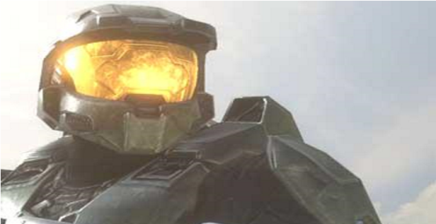**Artificial Neural Networks**. Present computers and super markets are relatively slow because of the build in structural limitations. The processor and the main memory are physically separated. Although joined by communication links, the processor spends most of its tie waiting for data to come from or go to memory. The arrangement is known as the Von Neuman Architecture after its originator John Von Neuman. With the scheme known as Neutral networks however, a computer will have a scheme resembling those in human brain and nervous system. It is believed that data will be transmitted to and from the processor at many times the speed of the old arrangements. This type of network is expected to help in image recognition, handwriting and speech recognition.

**Robots.** Robots is the field of study concerned with developing and building robots. Robots are machines that are used in factories and can be programmed to do more than one task. Robots are used in the manufacturing industry mainly to reduce costs and increase productivity. They are excellent in executing repetitive tasks that human beings find boring. Robots do not get tired. They are also ideal to replace human beings on hazardous jobs. They are different types of robots which include;

1. **Industrial Robots**. These are used in factories to perform certain assembly tasks. Examples are machines used in automobile plants to do welding, painting, loading and unloading. In the garment industry, robot pattern cuts and create pieces of fabric for clothing.
2. **Perception Robots**. Some Robots imitate human senses e.g a robot with television camera or vision system can be used for guiding machine tools for inspecting products and for identifying and sorting parts. Other types of perception robots rely on the sense of touch for example those used on micro-computer assembly lines to put parts in place.
3. **Mobile Robots**. Some robots act as transporters e.g mail mobiles which carry mail to offices following a pre-programmed route.

#### POSSIBLE FUTURE TRENDS OF THE INTERNET

* The internet will continue to expand and change in several ways; faster connections, more users, new multimedia and virtual reality services.
* More interactive services such as multimedia newspapers, livestock market tickers, automatic notification of when pre-destinated events take place anywhere on the internet.
* Internet as universal as a radio and television today.
* Learning will become any time anywhere.
* Impact of information technology to the society, morally unemployment vision, laxity and entertainment.

❖

#### USES OF COMPUTERS AND INFORMATION TECHNOLOGY (ROLE OF COMPUTERS AND INCFORMATION TECHNOLOGY IN OUR SOCIETY)

Since the development of computers nearly thirty five years, computers have now become the backbone of commercial and industrial activities, and permeated nearly every aspect of human endeavour, offices, factories hospitals, universities, homes e.t.c There can be very few people atleast in industrial countries of the world who have never had any contact with computers.

**Industry and commerce**. Computers have made the industry and commerce more efficient, productive and reliable. Almost every industry uses computers in its day to day operations. It is now difficult, if not impossible to manage a large organization efficiently without the use of computers. Leading companies are using computing technology as a competitive tool to develop new products and services, forge new relationships with suppliers and edge out competitors. Examples of commercial applications include:

* electricity bill generation
* railway and airway ticket booking ▪Generation of telephone bills.
* 24 hour customer telephone complaints registration
* Banking sector e.g 24 customer banking automated teller machines. ▪Paperless money through credit cards ▪Super markets.

**Process Control.** Computers are widely being used in the production environment to control chemical and mechanical processes. These are specialized applications and each computer system constructed to do a specific job. The computer systems are designed to respond very quickly in the input measurements.

**Healthy care**. Medical automation offers a great assistance in the areas of automatic diagnosis, electrocardiogram screening and monitoring. A doctor needing specialized opinions can now easily retrieve such information from computer storage. Medical records on patients are today stored and retrieved from computers for patients‟ management purposes. Computers also today allow for access to otherwise inaccessible or prohibitive expensive foreign expertise or labour and make it possible for hospital in one country to use consultants or even surgeons in another thereby reducing traveling for patients, businessmen and professionals.

**Government institutions**. Computers are heavily used in many Government Ministries such as finance and planning, Education e.t.c to store government records and improve the efficiency of work within civil services. Without the use of computers, the huge number of files in government agencies such as Tax departments, customs as well as utility companies such as power and lighting, Posts and telecommunications and city councils all use computers to keep records and produce bills and statements.

**Education and research**. Computers are also widely used in education as a teaching aid, and in research institutions. With the emerging of internet, many local institutions have linked up with those big universities and libraries over seas hence facilitating research and education. This has further led to the creation of Virtual Universities.

Scientists use computers to analyse experimental data. Engineers and architects use computers to design, test and redesign. Managed and unmanaged speace exploration would hardly be possible without the assistance of computers.

**Communications industry**. Computers play a big role today in the aspect of communication. In telecommunications industry, every telephone exchange today relies on computers to switch incoming and outgoing calls. Railway corporations rely on computers to coordinate the movement of their wagons and goods. In the airline industry, computers are heavily used in air traffic control and surveillance or airspace using radar equipment as well as for reservation purposes.

**Police and applications**. Computers are now days used in fighting crime. Police are now able to keep databases on fingerprints, which are automatically analysed by computers. The integration of computing technology and defense has today produced the modern military. In defense, computers are used in electronic news gathering, efficient communication, detection and tracking of targets, radar systems, warning systems and military laser and guided missile systems.

**Home and leisure**. Many people now days use computers for shopping purposes. The computer provides them with lists of shopping items as well prices and electronic money transfer facilities. There are also entertainment information for those looking for leisure as well as a host game for youngsters. Computer have been programmed to play games like chess, cards e.t.c..

**Employment.** Employment opportunities in the computing industry worldwide increased by 20% during 1980s from 3 million in 1980 to about 3.6 millions in 1991. In south East Asian countries, 60% of employment opportunities are today in the computing industry.

**Internet**. The internet is a worldwide computer network linking countless thousands of computer networks, through a mixture of private and public data telephone lines. Its component networks are individually run by government agencies, universities, commercial and voluntary organizations. No single organization owns or controls the internet, though thee is an internet society tat coordinate and sets standards for its use. Networks are connected by gateways that effectively remove barriers so that one type of network can „talk‟ to a different type of network. Internet provides emails, cht, fax services, conferencing, access to abundant information e.t.c. Virtually any information on a topic residing anywhere in the world can be accessed from anywhere.

##### NEGATIVE IMPACTS OF COMPUTERS ON SOCIETY

1. **Moral degeneration**. One finds that the youth spend most of the time glued on the Internet watching moral degeneration pictures, movies e.t.c. Amongst the friends they find on the net, some have acquired morals like lesbians, cults, hackers e.t.c
2. **Computers have affected our sights**. A bigger percentage of people who have been working with computers for years are now putting on glasses to support their sight and computers emit rays and heat which is not environmentally friendly to the surrounding and may be hazardous to human.
3. Computers also consume power although now modern computers consume less power.
4. Computers training and repair is very expensive and experts are few.
5. Internet is good for communication but in case of a virus, it can spread to millions of computers in just a second.
6. Hackers who usually work in groups can easily access and corrupt data records. Therefore computer owners must protect their computer systems, probably with some sort of passwords or a “firewall” which to a lay man is not easy because this beyond their understanding.
7. High rate of forgery. People use high quality printers to try and fake money notes and passports.
8. In case of the systems breakdown, a lot of information may be lost which might be very disastrous to the organization.

##### N.B

1. ***JOB REPLACEMENT****. This is a situation where by certain jobs disappears in an organization but reappears in another form requiring more and high skilled man power e.g copy typists using typewriters are still needed in organizations but now use computers word processors instead of typewriters. Computerization brings about elimination of jobs in most cases but these jobs are replaced with those that have greater responsibility requiring high level of training.*
2. ***JOB DISPLACEMENT****. This is the process of replacing man power with computerized machines either their own or with the help of a few skilled and highly trained people. In most cases, the eliminated jobs are those involving monotonous and unskilled labour for example factory jobs can be displaced by machines called robots.*

###### CAREER OPPORTUNITIES IN INFORMATION AND COMMMUNICATION TECHNOLOGY

Information and communications technology (ICT) has created new job tittles such as; •Computer operators.

* Computer technicians.
* System analysts
* Computer programmers
* Software engineers
* Information system manager
* Database administrator
* Computer trainer
* Website administrator
* Computer graphics designer
* Network administrators

This section explains some responsibilities of these professionals who are generally called information technology workers.

a)**Computer technician**. Given that all computers regular maintenance, upgrading as well emergency repairs, demand for computer technicians continue to grow as more and more computerize their work place and homes.

Responsibilities of a computer technician

* Troubleshooting computer hardware and software related problems.
* Ensuring that all computer related accessories such as printers, modems, storage media e.t.c working properly.
* Assembling and upgrading computers and their components.
* In developed countries, technicians help hardware engineers in designing and creating some computer components such as motherboards, storage devices e.t.c.

b)**System analyst**. The is a person who is responsible for analyzing a company‟s needs or problems then designs and develops a computer based information system. A good information systems analyst is one who has the following attributes.

* Good problem solving skills, creativity i.e must have experience in solving problems.
* Good communication skills; the analyst must be able to communicate clearly and precisely both in writing and in speech.
* He/she must be able to talk to different groups of people e.g managers, operators, attendant and general public.
* Must have business knowledge; the analyst must be well trained in relevant areas of computer science such as hardware, software and programming knowledge.

Responsibilities

* Reviewing the current manual or redundant information system and making recommendations on how to replace it with a more efficient one.
* Working with programmers to construct and test the system. ▪Coordinating training for users of the new system.

1. **Computer programmer**. Large organizations like insurance companies, banks, manufacturing firms and government agencies hire programmers to work together with system analyst in order to;
   * Write in-house applications programs or system programs
   * Customise commercial application package to suite the organization needs.
   * Test, debug, install and maintain programs developed or customized for the organization.
2. **Software engineer**. A software engineer is one who is skilled in software development and technical operation of computer hardware.

Responsibilities

* Developing system and application software.
* Developing user and technical documentations for the new software.
* Maintaining and updating the software to meet day to day requirements while overcoming challenges.

1. **Computer engineer**. Computer and electronic engineers are coming up with more efficient and communication technology almost daily. Since computers are electronic devices, hardware designers must be good in electronic engineering in order to be able to;
   * Design and develop computer components such as storage devices, motherboards and other electronic components.
   * Re-engineer computer components to enhance its functionality and efficiency.
   * Design and develop engineering an manufacturing computer controlled devices such as robots.
2. **Information system manager**. The information system manger controls, plans, staffs, schedules and monitors all activities of the ICT department in the organization. Using computerized management information systems (MIS), the manger can test the impact that an alternative course of action might have on the business.

Other responsibilities

* Making sure that all tasks in the IT department are done correctly and on time in order to support business planning, control and decision making processes.
* Preparing budgets for the department.
* Keeping the department inventory records up-to-date.
* Managing the human resource with in the department.

1. **Computer trainer**. Due to the dynamic nature of computers and information technology, there is a high demand for qualified ICT trainers. Some of the responsibilities of an ICT trainer are;
   * Training people on how to use a computer and various application programs.
   * Developing training reference materials.
   * Guide learners on how to acquire knowledge through carrying out research.
   * Advising learners on the best career opportunities in the broad field f ICT. ▪Preparing learners for ICT examinations.
2. **Database administrator**. The major purpose of computerising organizations or institutions is to store data in an organised way for easy access, retrieval and update. The organization requires a person who should be responsible for updating records in an information system database. For this reason, a database administrator is responsible for;
   * + Designing and developing database application for the organization.
     + Setting up security measures needed to control access to data and information.
     + Keeping the database up-to-date by adding new records, modifying or deleting unnecessary records.
3. **Website administrator/ Web master**. Internet is one of the areas of information and communication technology that has drawn the interests of most people. These people are able to exchange messages, search for information and business through the internet.

Business organizations, educational institutions and individuals put information on the internet by developing websites. Most organizations hire the services of a web developer who is given the role of a company‟s web administrator also referred to as a web master.

Responsibilities

* Developing and testing websites.
* Maintaining, updating and modifying information on the websites to meet new demands by the users.
* Monitoring the access and use of internet connection by enforcing security measures
* Downloading information needed by an organization or institution from internet websites.



###### @@@@@@@@@@@@@@@@@@@@@@@@@@@@@@@@@@@@@@@@@@@

**A bit**. This is a binary of either 0 or 1 and it represents the smallest unit of data the computer can handle.

**A byte** is eight bits grouped together as a unit and it provided enough different combinations of 0s and 1s to represent 28 = 256 individual characters that include numbers, letters and symbols.

**A server**. Is a computer that controls access to the hardware and software on a network and provides a centralized storage area fro programs, data and information.

**A workstation**. This is a computer connected to a server.

**Access time**: This is the amount of time it takes the processor to read data, instructions and information.

**An operating system**. This a set of computer instructions, called a computer program, that controls the allocation of computer hardware such as memory, disk drives, printers, CD drives and provides the capability for you to communicate with the computer.

**Analog signals**. Consists of a continuous electrical wave that varies within a predefined range e.g human speech.

**Bridge**: is device that connects two LANS using the same protocol such as the Ethernet.

**Bus**: This is an electric channel that allows various devices inside and attached to the system unit to communicate with each other.

**Communications protocol**. This a set of rules and procedures for exchanging information among computers on a network.

**Coprocessor**: This is a special processor chip or circuit board that assists the processor in performing specific tasks.

**Cursor**: Is a rectangular blinking bar on the screen showing the position where text should go or be placed.

**Data bus**. A data bus carries accrual data that is being processed.

**Debuggers**: These are programming tools which help programmers to detect, locate and remove routine, syntax or logical errors from a program being written.

**Decoding**. This is the process of translating the instruction into commands the computer can execute.

**Demodulation**. This is the process of converting analog signals into digital signals.

**Desktop**. This is the main graphical user interface (screen) that contains icons or folders. It is a work you see your programs.

**Digital signal**. This consists of individual electrical pulses that represent the bits grouped together into bytes e.g signals generated by a personal computer.

**Dump terminal**. This is a device with a keyboard and monitor but has no processing power.

**E-mail.** This is the transfer of electronic messages from one geographical location to another using computers and related computerized devices.

**Encryption**: This is a process of covering readable data into unreadable characters to prevent unreadable access.

**Ethernet**. This is a LAN protocol that allows personal computers to contend for access to the network.

**Fetching**: This is the process of obtaining an instruction or data item from memory.

**File Allocation table (FAT**) is a table of information that the operating system uses to allocate files on a disk.

**File.** Is a collection of data or information that when saved has a name called the file name.

**Firewal**l. Is a general term that refers to both hardware used to restrict access to data and information on a network.

**Firm ware**: Refers to ROM chips that contain permanently written data, instructions or information recorded by the manufacturer.

**Gateway**: is a combination of hardware and software that connects networks that use different protocols.

**Hotplugging or hot swapping**: This allows a user toad or remove devices while a computer is running.

**Hub**: is a device that provides a central point for cables in a network

**Icon**. This is a small picture that represents a program or object.

**Icon**: An icon is a little picture on your screen. Typical icons on the desktop include; my computer, recycle bin, my documents e.t.c.

**Information technology**. This includes all types of computing and networking techniques to process data into information.

**Integrated CPU**: This combines functions of a processor, memory and a video card on a single chip.

**Interne**t. This is a global network connecting millions of computers. The Internet is the world‟s largest information highway connected by wires, cables and signals through wireless technology.

**Internet**. This is a worldwide collection of networks linked together.

**Interrupt request (IRQ)** is a communication line between a device and the processor. Most computers have 16 IRQs numbered 0 through 15.

**Intranet.** This is a smaller version of the internet used with in an organsiation.

**IRC** stands for Internet Relay Chatting

**Lower case**. This is composed of small letters.

**Mechanical computers**. These are computers composed of movable parts and axles.

**MMX technology**: MMX (Multimedia extensions) technology is a set of instructions built into the processor that allows it to manipulate and process multimedia data more efficiently.

**Modulation**. This is the process of converting digital signals into analog signals.

**MP3** is a popular technology that compresses audio to about one tenths of its original size.

**Multi tasking**: This allows a single user to work on two or more applications that reside in memory at the same time.

**Multimedia**. Is a carefully integrated use of text, graphics, audio, animation and video to convey messages.

**Multiplexer**: is a device that combines two or more input sgnals from various devices into a single stream of data and then transmits it over a single transmission medium.

**Multiprocessing** involves the coordinated processing of programs by more than one processor.

**Network topologies** refer to the configuration or physical arrangement or the devices in a communication network.

**Pipelining**: With pipelining, the CPU begins executing a second instruction before it completes the first instruction, which results in faster processing.

**Programming languages**: These are sets of instructions which tell the software engineer what operations to do during the software development process e.g Basic, Cobol, C, C++, e.t.c

**Protocol** is a set of rules and procedures for exchange of information among computers.

**Query** is a request for specific data from the data base.

**Real time processing:** is one that processes data without significant delay e.g anti-missile defense systems, air plane landing control system, flight simulation systems, electronic funds transfer systems e.t.c

**Registers**: These are high-speed storage locations that temporarily hold data and instructions.

**Repeater**: is a device that accepts a signal from a transmission medium, amplifies it, and transmits it over the medium.

**Router**: is an intelligent communication device that sends(routes) communication traffic to the appropriate network using the fastest available path.

**Save as**: This is a command used to effect the process of saving documents from the temporal storage to a permanent storage or from one drive to another when changing a name of a document.

**Search Engine**. Is a software program that can be used to locate websites, web pages or files on the internet. E.g Google, excite e.t.c

**Telecommuting** is a work arrangement in which employees work away from a company‟s standard work place, and often communicate with the office using some type of communication technology.

**Upper case**. This is composed of capital letters.

**User ID** is a unique combination of characters that identifies a user.

**Window**. This is a user interface you use to manipulate a computer program. The window has title bar so that you can minimize, maximize and close the window.

#### Important websites

1. [http://www.teacherclick.com](http://www.teacherclick.com/)
2. [http://www.homeandlearn.co.uk](http://www.homeandlearn.co.uk/)
3. [http://www.free-training-tutorial.com](http://www.free-training-tutorial.com/)
4. [http://www.internet4classrooms.com](http://www.internet4classrooms.com/)
5. [http://www.wiseowl.co.uk](http://www.wiseowl.co.uk/)

REVISION QUESTIONS

1. (a) What is output?
   1. Discus the different output devices known to you.
2. (a) Mr. Mugisha wants to set up a computer laboratory at school and has purchased some computers already. He now wants to purchase software to install in his computers. How do you advise him? (b) Discus the bus network topology plus the advantages and disadvantages accompanying it.
3. Protocols are very important factors without which communication may

not be possible. Discus the different protocols involved in communication.

1. You are given an assignment to create, design and present a polio awareness presentation. How do carry the above?
2. “Computers have changed today‟s ways of life” Discus.
3. Computers are required both as a tool and as an occupation”. Discus.
4. What are the advantages and disadvantages of internet in business today?
5. Explain briefly five advantages and five disadvantages of using computers.
6. (a) What is a computer virus?
   1. Explain how viruses are spread.
7. “A world without computers is no world at all” Discus.
8. What are the merits and demerits of learning using internet over using a textbook learning?
9. Moses a village boy exclaimed “ Spread sheet programs are useless”. As a student of computer studies, convince him otherwise.
10. “Computers have destroyed our culture” What are your arguments for against this statement?
11. Outline what you expect the role of computers in future.
12. Information technology has done more good than harm to education. Give your arguments in favour and against this statement.
13. Explain why a school should have a website.
14. (a) Explain the different forms of secondary storage.
    1. Describe the characteristics of each of the above forms of storage.
15. Give your arguments in favour and against the impact of computers in our society today.
16. The Headteacher of your school wishes to buy computers for the school. As a student of computer studies, what type of computers would you advise the headteacher to buy and for what benefits are they to your school.
17. Suggest reasons why there is an increase in the use of computers in most organizations in Uganda today.
18. “Total data security is not possible today” Outline areas where this has been achieved and challenged.
19. A computer system comprises of hardware, software, user, data and communication. Describe the importance of each component.
20. “The internet is a harmful tool to man”. What is your opinion?
21. Suggest ways in which computers can be used in business and industry in Uganda.

………….xxxxx…………